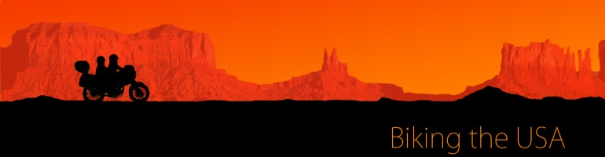
June 29, 2012 | Edit
The journey of a lifetime begins.
Hi there!
So 2 July is approaching very fast now. We are excited!! I hope you are as well. I haven’t started packing yet. Since we will be travelling on a motorcycle it is extremely hard to pack. Everything has to fit into a small box, and I’m used to carrying two big bags with me.
The plane takes off from Stockholm on Monday at 9 am, and I will be landing in New York at 12.05 pm (local time). John will have the task of retrieving the motorbike from the air cargo company and trying to get it out of its packing crate and making it go. We’re actually arriving at different airports so I need him to come and pick me up! Lets hope it all goes smoothly for him or I’m stranded!
Here is the planned route. Can you imagine how many places we will experience this month? I’m overwhelmed. I don’t think I will understand it until we’re actually there, on the motorcycle. I hope that you will follow us on this journey!
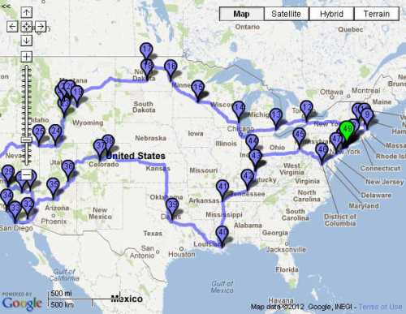
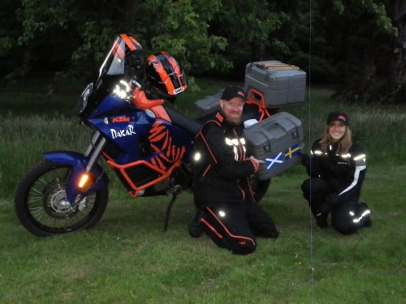
July 2, 2012 | Edit
We’re in New York!
We made it to New York! Right now I’m waiting for John to get the motorcycle and come and pick me up at Newark airport. Meanwhile I’m just sitting here outside, enjoying the sun!
Can’t wait to get back on that motorcycle though. John better hurry up!:)
July 3, 2012 | Edit
Too hot to handle
Hey there,
So, as you know we’ve made it to New York. It’s unbelievably hot here, we are really struggling when riding through New York in our motorcycle gear in 34 c. But we’ve made some progress! Today we visited the town where John grew up. It’s called Fords and it’s located in New Jersey (there should be some video footage of this on our YouTube account shortly!).
So far we’ve mostly been riding in and around New York, and the traffic has prevented us from experiencing what the motorcycle really can do. I’m really looking forward to get out of New York and on the road (wow, I can’t believe that I’m actually looking forward to LEAVE New York haha! It’s just too hot and too much traffic for a motorcycle). We’ve met a lot of people that are very interested in our project, and we even get stopped on the street by curious people who want to know where we are going and what we are doing.
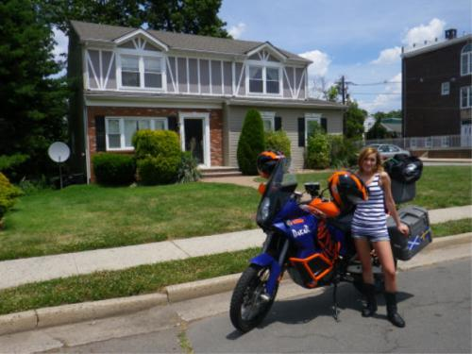
I wish I could ride the motorcycle without all the gear right now. :)
July 5, 2012 | Edit
Harvard University and electrical storms
We are on the move! Yesterday we left New York and headed up to New Haven to visit Louis Lunch, which is said to be the oldest hamburger restaurant still operation in the USA. However, when we reached New Haven it was nearly dinner time, and Louis Lunch was closed. We got some footage of it, but later decided to continue to the nearest motel to get some rest.
Today we woke up early since we had 300 miles to go, if we were to stick to the planned route. So we left New Haven and drove all the way to Boston where we visited Harvard University. Cambridge is such a pretty town! I would LOVE to live and study at Harvard. I actually bought the Harvard t-shirt, so I can say that I went there. In Cambridge we met a lot of interesting and talented people. This guy for example:
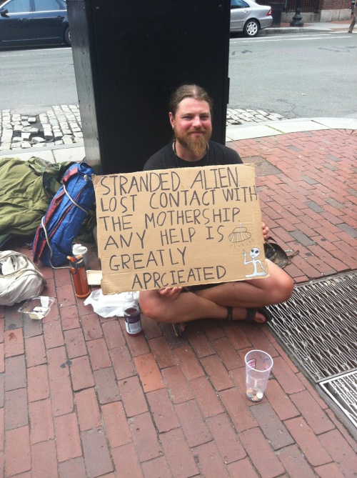
After having spent the day in the lovely town of Cambridge, we had to get going again. Before we went to the motel we wanted to visit one of the famous covered bridges in Swanzey, New Hampshire. When we got there we met a really nice American guy, who explained the history behind the bridge and what it was used for. The cover is part of the construction, and the bridges were used to protect livestock from the rain.
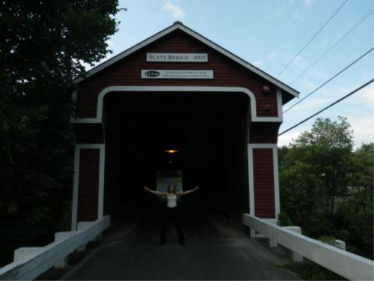
Here it is protecting me.
After visiting the covered bridges we were tired and just wanted to get to the motel. We started riding towards Albany, and as the evening was approaching we could hear and see fireworks everywhere, since it is 4th of July today. It was really nice, but after a while I started to think that the fireworks were too strong and frequent. And i didn’t hear any explosions! All of a sudden I realized that it wasn’t fireworks anymore – we were actually in an electrical storm! It was the weirdest weather I have ever encountered. Flashes of light filled the sky, but there was no thunder. I turned on ‘Riders on the storm’ by The Doors, and we rode through it. We were really riders on the storm! That must have been one of the coolest moments of my life.
Niagara Falls
This morning we left Albany and went west towards the Niagara Falls. On the way there we made a few stops, and met some very nice people. The thing I’ve come to love the most about the USA so far is how friendly and helpful people are. They are genuinely concerned about you, and would do whatever it takes to help you out if there’s any trouble.
After having spent 635 miles on the motorcycle the last two days it was a big relief to finally make it to the Falls. Our bums were really sore, but it was definitely worth it! We arrived around 7.30 pm, and as we checked in to the motel we found out that there was going to be a light display at the Falls at 9 pm. So we got ready and headed out. When we got there we were completely amazed. What a spectacular view! To see the falls at night, with all the colors of the rainbow illuminating it, was absolutely unbelievable. And right there on the other side of the Falls we could see Ontario, Canada. I’d like to go there some time as well!
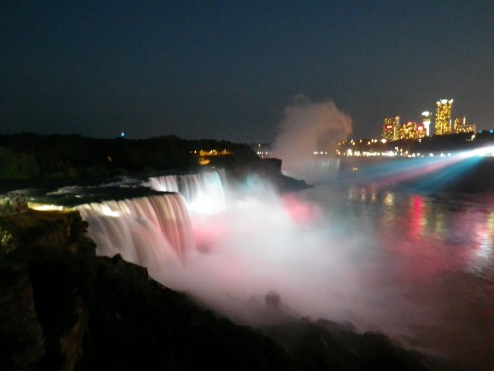
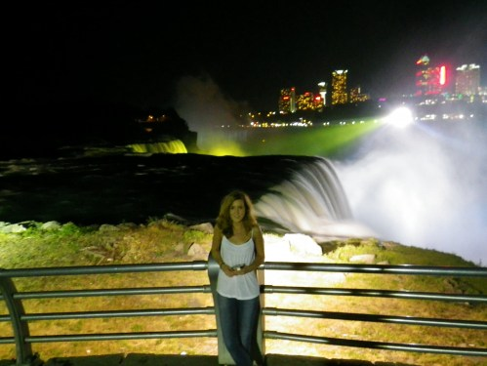
Tomorrow we’re leaving early, and continuing to the west!
July 7, 2012 | Edit
Leaving the Niagara Falls and heading west
We have left the beautiful sights of the Niagara Falls behind and continued to the west.
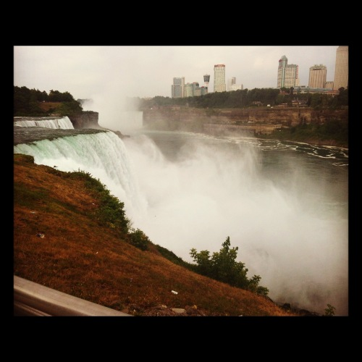
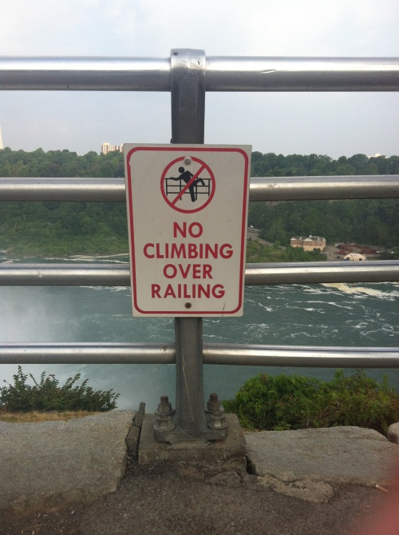
Today we went through Pennsylvania towards Cleveland, Ohio. We traveled along Lake Erie and the Canadian border. We had to make a stop at a motorcycle retailer to get some oil for the chain on our bike. On our way there we encountered some drama at a petrol station. As John was fueling up we suddenly noticed that petrol was dripping from the motorbike. My first though was: ‘We are screwed! The motorcycle is broken, and this is it. The journey is over.’ And the second thought that entered my mind was: ‘Should I run for cover? Will it explode?’. As I stood there, looking at the bike and contemplating if I should run away and take cover, a man came up to us. This was a real Texas ranger, he had the black cowboy hat and spoke with a strong southern dialect. He offered to help us out if anything was wrong with the bike. He told us that he was a truck driver, and that he had all the tools we would need to fix it. Eventually John figured out that the fuel tanks were overfilled, and he left the engine on for a while to get rid of some fuel. Meanwhile, we were talking to the Texas ranger who was a really nice guy. He told us that he started driving trucks on September 1 last year, and so far he had driven 80 000 (!) miles and been to 44 states. That made me think… Truck driver, maybe it’s not such a bad job. Imagine how much you get to see while just sitting there listening to your favorite music.
After the petrol station drama, we continued towards Cleveland, Ohio to go to the motorcycle store. Mind you, by this time in the afternoon it was 36 c (97 f) degrees and I was boiling up in my motorcycle gear. By the time we reached the store I just wanted to lay down and die. I don’t think I’ve ever been THAT exhausted. But when we got into the store all that long driving in the heat just disappeared. After today I’ve set up a goal – I will get a license to ride a motorbike. I just wanted to buy them all! Especially the cute little Honda.
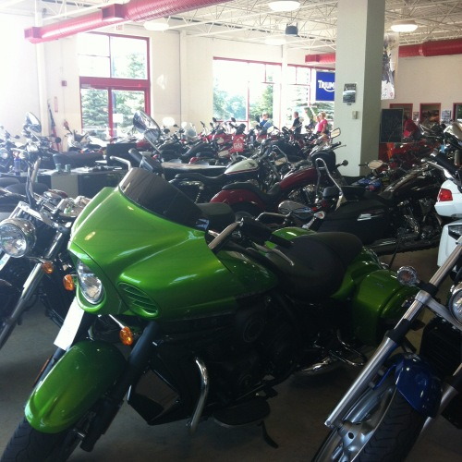
But the heat is becoming a real issue on this journey. We a really struggling with it! We heard that there have been thousands of heat records all over the US at the moment. We are therefore considering changing our route to avoid cooking ourselves so much. We’ll see what happens…
July 8, 2012 | Edit
Unrelenting heat
As you might now if you’ve followed the blog, there’s a massive heat wave in the whole of USA right now. The temperatures have soared over 42 c (107 f), and we’ve heard that over 30 people have died. We’re still struggling on with our motorcycle gear, and people look at us as if we’re crazy when we come down the road fully geared. Imagine sitting in a sauna with a skiing outfit on. That’s kind of how it feels. The fact that the motorcycle is extremely hot itself doesn’t make the situation better. Look at this! It’s so hot that it has burned a hole in my trousers!! Crazy.
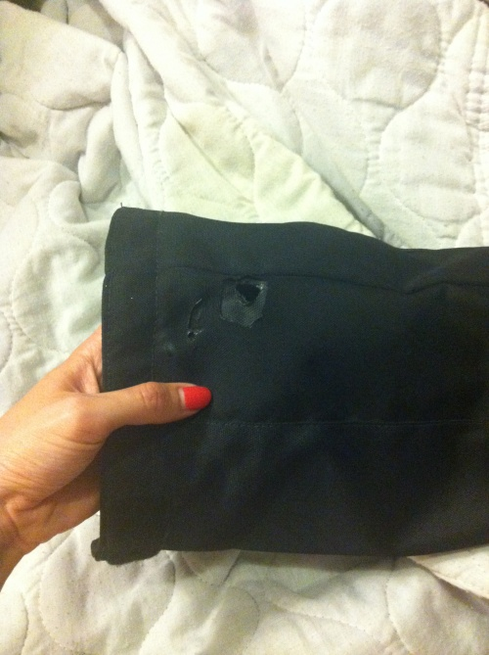
It is said that the heat will ease off a bit tomorrow. But right now the heat has caused railways to kink and motorways to BUCKLE. Can you imagine? Good thing John changed the tires just before the trip. If the roads will buckle the tires are going to be worn out very quickly.
Anyway. Despite the heat this morning we had to roll on. We left the motel and headed to the Armstrong Air and Space Museum in Wapakoneta, Ohio. This is actually the town where Neil Armstrong was born. The landscape surrounding it is often referred to as ‘the breadbasket of the world’, since it’s pretty much just corn fields everywhere. As we were riding through the vast landscape of corn fields I couldn’t help but thinking: how can people live in such deserted areas? The houses and farms could be several miles apart! What do you do if you need a big mac at four in the morning? It would however be a perfect setting for a horror movie... two Europeans get lost on a motorcycle and end up at this farm, far away from civilization... You work your way from there.
We eventually made it to the museum, and it was well worth the trip. I ate space candy, discovered that I’m tall enough to become an astronaut, drove a spaceship and learned how to fix a spaceship if it’s broken. I’m all set for a journey to outer space!
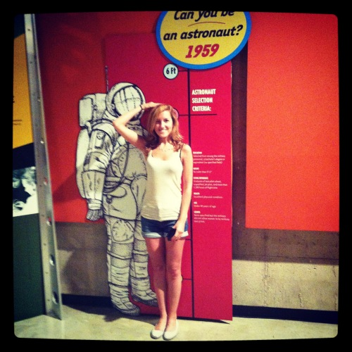
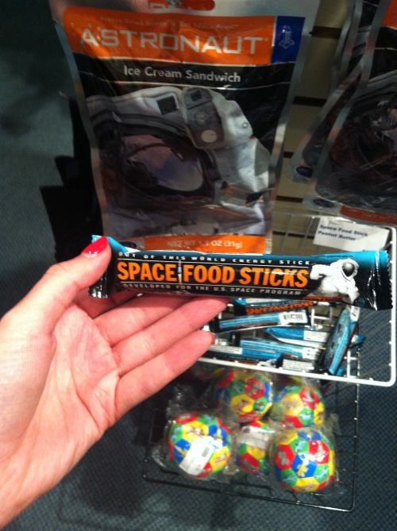
Tomorrow we’ll stop by a very cool place... stay tuned
Oh, and I should probably let you know that we’re now on Instagram as well! Follow us on BikingtheUSA.
July 9, 2012 | Edit
Chicago – The Windy City!
Let me just start off by correcting what I said in the last post. We are struggling to WEAR our motorcycle gear in the heat. We are not riding without it. We’re not crazy! However, we have seen a lot of motorcyclists without any gear – not even a helmet! What’s up with that America? Better be safe than sorry.
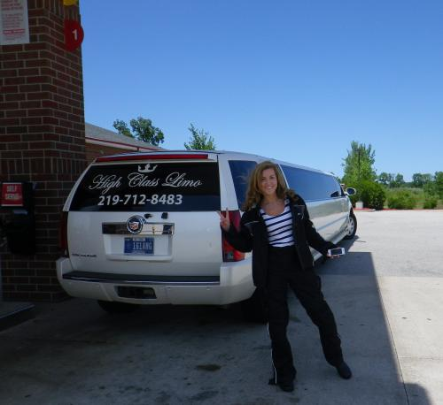
Here I am posing with my motorcycle gear on beside a limousine. It wasn’t as unbearable to wear it today, since the temperature dropped to around 25 c (77 f). That’s why I look so happy! And.. yes, i am excited about posing next to a limo as well.
Anyway. Today’s trip was relatively short, only 250 miles. We started off in Fort Wayne, Indiana and went on to Chicago, Illinois. After visiting The Windy City we continued to Milwaukee, Wisconsin.
After getting a good night’s sleep we were all set and ready to go this morning. When we got outside we were even more excited, since the weather conditions were perfect! We made our way to the petrol station and fueled up for our trip to Chicago. I’ve been wanting to go to this city forever, since everyone keep telling me that it is much better than New York. I don’t know if I agree, but we’ll come to that later.
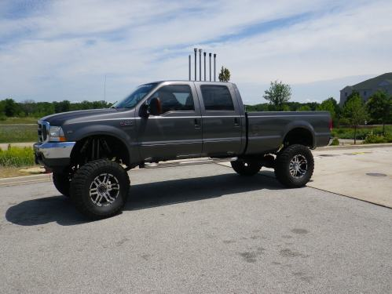
Btw, I should make a new category on this blog. ‘The things you see at petrol stations in the US‘. Look at the tires on this car! The lady inside needs to get a ladder to get down from that thing.
We left Fort Wayne quite late, around 11.15 am. That turned out to be a very smart move, since that was when the weather changed and became much cooler. It didn’t take long before we reached Illinois and Chicago. Let me tell you that there’s a reason this city is called The Windy City! Out of nowhere the wind started to pick up all of a sudden. It was bizarre.
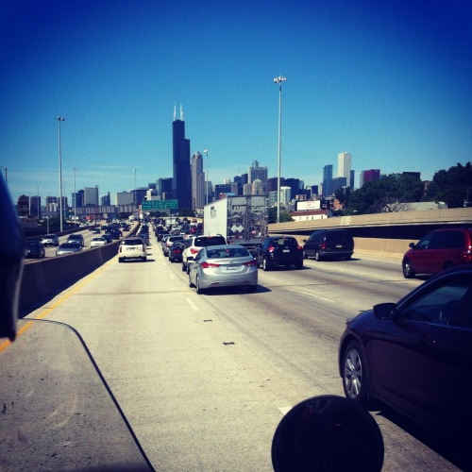
Here we are riding into Chicago! Can you see the tall black building? That’s the Willis Tower (or Sears tower) and it is the tallest building in the US. Our goal at this point was to make it to that building. Initially we weren’t planning on going into Chicago because of the weather, but since it was much cooler we decided to do it anyway. So we slowly cruised through the traffic and eventually made it into Chicago. What a weird city! It is absolutely beautiful, but soo quiet. Maybe it was because we visited on a Sunday afternoon, but I couldn’t hear anyone honking, no firetrucks, no police cars, no crazy people screaming and throwing milkshakes (this actually happened in New York once, haha!). Nothing. Not a sound. I had to ask John if we were really in the city center, or some suburb. But we were right by the Willis Tower! Strange.
When we were standing outside the tower I suggested that we should go up to the skydeck (all the way up at the top). I don’t know why I thought that was a good idea, what with my fear of heights and all. But we did make it to the top, even though I held on to the walls and was completely terrified. It was quite funny how people were looking at us, since we had our big bags with the motorcycle gear in it on us. One guy even came up to me and asked, nervously: ‘What do you have in the bag?’. I wanted to say: ‘A parachute.’ and then see his reaction when me and John would talk about how to best jump off the building
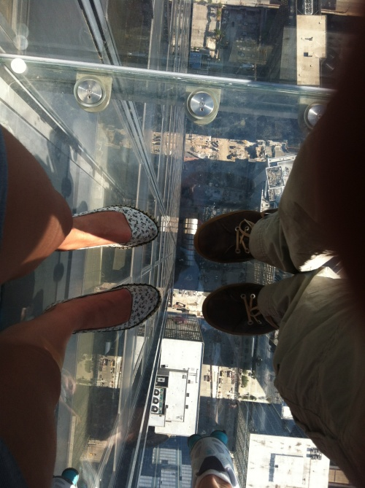.
Oh, and at the top there was of course a glass floor which you could stand on. 1353 feet (412 meters). What crazy person thought of that?!
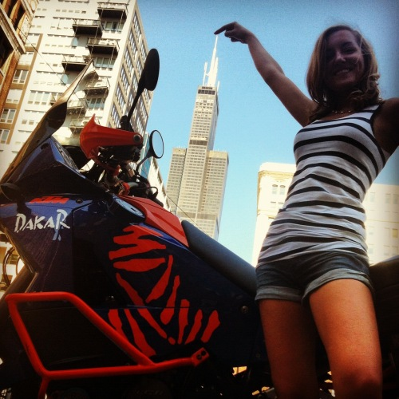
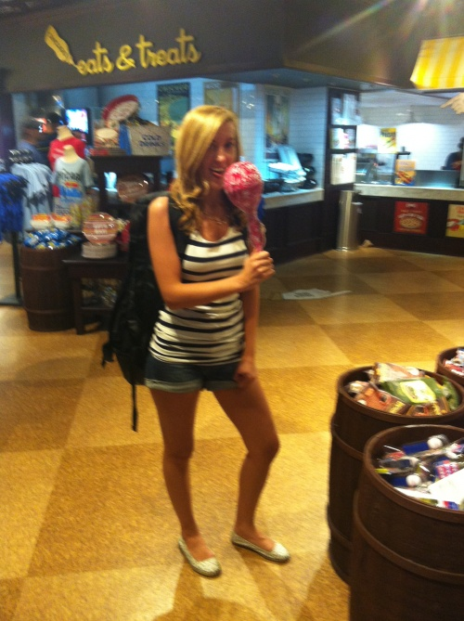
We finished up in Chicago by eating dinner at McDonalds and I had a tiny lollipop as well..
So, the big question: Is Chicago better than New York? According to John – yes! I don’t think so however. I miss the noise of a city.
DVD
I just want to remind you that we have four film cameras that are constantly rolling on this journey, and another that is used for specific scenes. The material will be included in the DVD, which will be available after New York is reached again!
That’s 1500 miles so far on this journey.
July 11, 2012 | Edit
The Harley Davidson Museum and a Geological Marker
It is amazing how time flies on a motorcycle when the weather conditions are good. We rode about 320 miles today, from Milwaukee to Eau Claire, Wisconsin. Our first stop was the Harley Davidson museum in Milwaukee. As we approached the museum we could see all the Harley bikes parked outside. This must be the Mecca for HD enthusiasts. We felt a little bit out of place when we got there with our KTM bike.
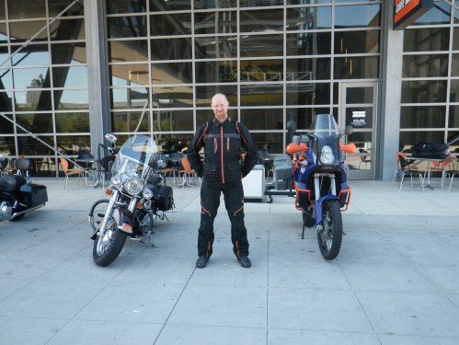
We made our way into the museum, and were really impressed by the architecture of the place. It was just perfect! It suited the brand perfectly. Everything was black and leather, and very modern. I learned how to ride a bike in theory, and then I tried it in practice.
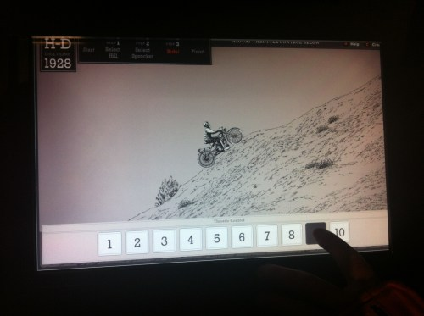
It’s very important to get the theory right before you try the real thing…
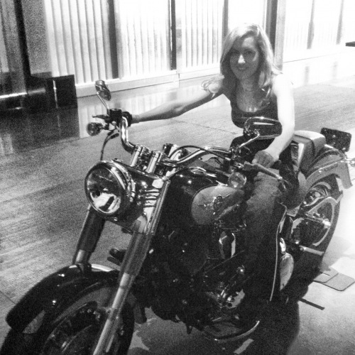
So I guess I’ll get that motorcycle license soon! There were some really cool old models of Harley Davidson bikes, of which the oldest one dated back to 1903. However, this one was definitely my favorite! Where can I get it?
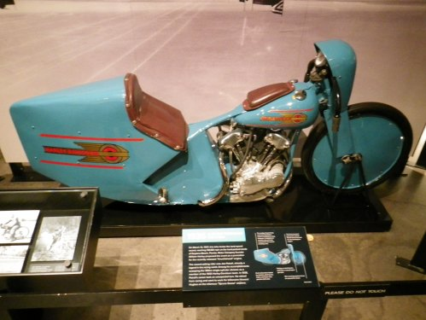
We stayed at the museum for about an hour and then we made our way to the restaurant and had lunch. There was also a shop, but since we are traveling on a motorcycle we don’t have any space. And I mean NO SPACE AT ALL. For the duration of one month I’ve only brought three pairs of tops, two pairs of trousers, one pair of shoes and like 5 pairs of underwear. I’ve never traveled this light before. I guess I’m living close to nature in a rugged manly way.
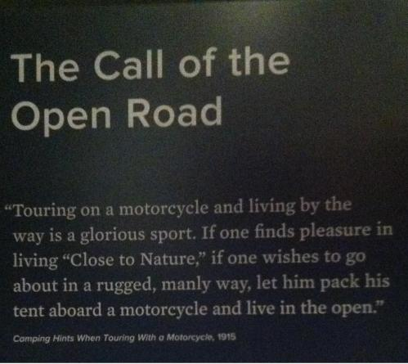
(From the Harley Davidson museum).
I’m a manly man, man. SO anyway we had to ride on after lunch. We had a long day ahead of us, and a very rare opportunity to stop at an extremely special place located in Wisconsin. The place I’m talking about is a Geological Marker in the town of Rietbrock, Wisconsin.
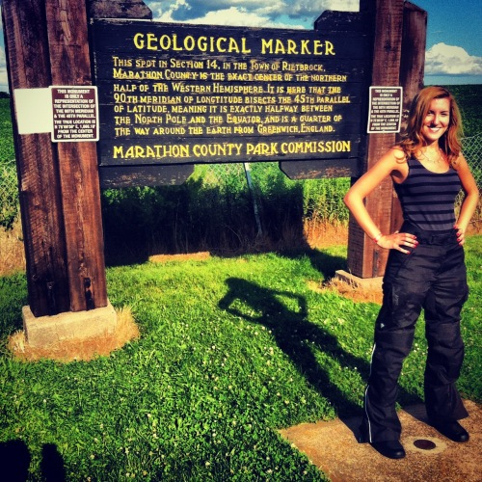
This spot is the exact center of the northern half of the western hemisphere. In other words: it is exactly halfway between the North Pole and the equator, and a quarter of the way around the earth from Greenwich, England. 90 degrees longitude and 45 degrees latitude. What a truly special place out in the middle of nowhere. And it was literally in the middle of nowhere. For a while I thought that our Sat Nav, Wendy, had tricked us. But she turned out to be right, as she usually is, good ol’ Wendy.
We’ve been having some difficulties without computer the last couple of days, hence no update yesterday. This blog post is therefore a bit old, and there will be a new one up shortly! Sorry about that.
July 11, 2012 | Edit
Charles Lindbergh’s historic site
I can’t believe how much distance we’ve covered in just about a week. The journey so far has included New York, Fords in New Jersey, New haven, Cambridge (Boston), Albany, Niagara Falls, Cleveland, North Ridgeville, Wapakoneta, Fort Wayne, Chicago, Milwaukee, Oshkosh, Eau Claire, Minneapolis, Little Falls and Detroit Lakes. Now, that’s a lot of places, and they have all been unique in their own way. We’ve gained so much experience by traveling like this, and met so many lovely people along the way!
Today we went all the way from Eau Clair, Wisconsin, to Detroit Lakes in Minnesota, and covered 313 miles. We are getting more acclimatized to the weather, which must be why we can do these kind of distances in one day now. The only things bothering us at the moment are our sore bums! Does anyone have any recommendations for how to avoid getting a sore butt when riding on a bike for long distances?
The landscape we rode through today was stunning! (As it is most of the time here in America). The central part of Minnesota is very flat and green, and there are miles upon miles of wind farms along the way. Running along just beside us nearly all the way today was a very busy railway. I don’t think I’ve ever seen such long freight trains before. Each train was nearly a mile long! It must take a very strong engine to pull all that rolling stock. Every one of them blasted away on their horns as they ran through the populated areas along the way. I can even hear them now! They make this muggy evening even more atmospheric!
We only had one stop today (apart from lunch and the petrol stations). Our mission was to go to Charles Lindbergh’s house in Little Falls, Minnesota. Charles Lindbergh is most famous for making the first solo nonstop flight across the Atlantic back in 1927. He was 25 years old at the time, and the flight lasted for 33 (!) hours. And, as you might notice, Charles has a Swedish surname. That is because he’s father, August Lindbergh, was born in Stockholm, Sweden. The story about the Lindberg’s is very interesting, and there’s actually a documentary about it on YouTube for anyone who is interested.
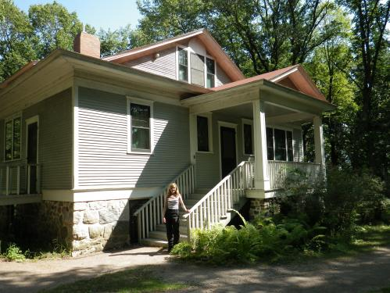
This is the house where Charles and his mother Evangeline lived after his parents separated. I fell in love with it even though it felt a bit haunted! Can you see any faces in the windows? The more we learned about Charles Lindbergh and his accomplishments, the more we started to really appreciate him! It was a proud moment for a Swede like myself! The guide at the site was absolutely lovely, and when I told her that I had come all the way from Sweden to visit this place she immediately gave us a special tour, and said that Charles would have been proud
This was a very special place to visit, since we owe this whole trip to Charles. Without his accomplishments and bravery there would probably not have been any transatlantic flights today, and we would not be where we are now. Thank you Charles! You are a legend.
We chilled out for a while by the Mississippi river, and got eaten by various insects, before we continued on our route.
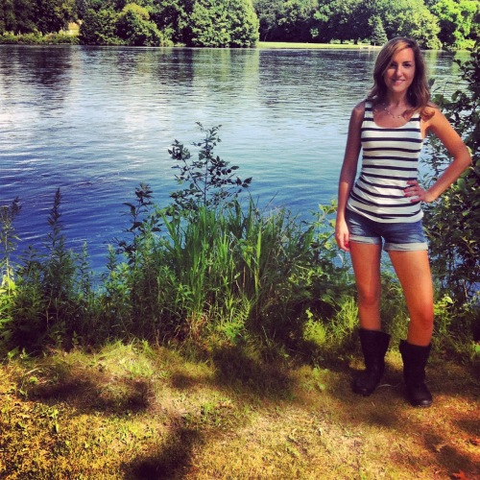
Standing in my motorcycle boots by the Mississippi river.
July 12, 2012 | Edit
A journey to the center of the...
We are making our way through the green, flat landscape of North Dakota. We started out in Detroit Lakes, Minnesota, and rode to Minot, North Dakota, which is a whopping 345 miles! We’ve set a new record for ourselves.
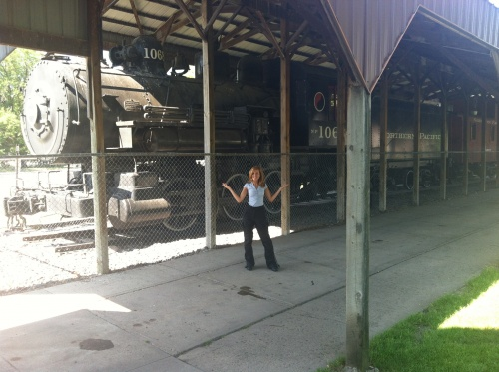
Our first stop today was in Dilworth, Minnesota. Dilworth is the largest railroad village in western Minnesota, which became very clear to us as we passed it. This was the epicenter for the long freight trains we saw yesterday. We tried to catch a train at the railway crossing, but oddly enough we never managed to see one cross. We heard the train though! John insisted on waiting for it to pass and the cars behind us must have thought that there was something wrong with us. Why the hell would someone wait for the lights to go red at the railway crossing?
After soaking up the atmosphere in Dilworth we hopped on to the motorcycle again and continued towards North Dakota. One of the towns I know in this state is Fargo, and that’s because Johnny Cash sings about it in one song – ‘I’ve Been Everywhere’. That song has actually become a soundtrack for our journey! No matter how tired or sweaty we are, that song always puts a smile on our face! John told me that there’s also a movie called Fargo which is very good. I have yet to see it.
The first thing I learned about North Dakota is that, since it is such a flat and enormous landscape, it is VERY windy. I had to hold on tight to the motorcycle to not blow off! I don’t know how many bugs died crashing into John and I and the front of the motorbike today. At the end of it the motorcycle looked like this:
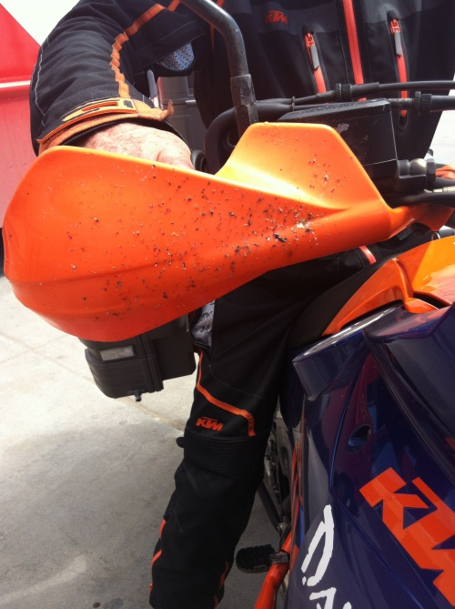
As we rode on through the enormous state that is North Dakota, we suddenly spotted a sign that said ‘Historical Marker’. We pulled off and found a stone monument located just beside the road. When we had a closer look we discovered that we had come across the old Fort Totten trail. Fort Totten is a town largely inhabited by Native Americans, and this trail was used by them to deliver mail to the government from fishers in the year 1879 – 1882.
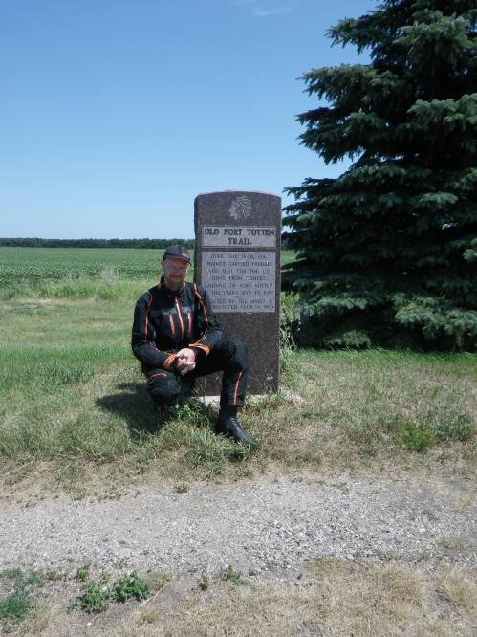
When we had a look around we also discovered that the marker was a spot for geocaching. We found various things that people had left, like this little book:
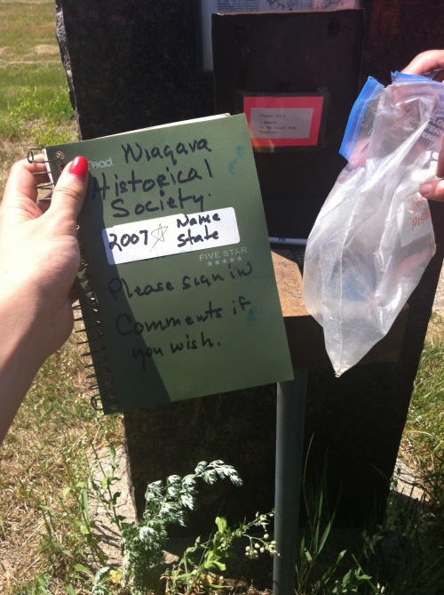
We left some comments, and of course we also wrote down the address to our blog in it Then I had to climb one of these... the things I do for this blog!
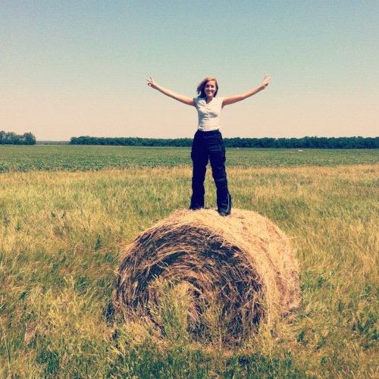
We got on the motorcycle again and cut through the wind, until we reached the town of Rugby, North Dakota. This town has a place which represents the geographical center of North America. This is about the furthest north we’ll go. Woho, let’s celebrate that by breaking the fence around the monument... which I clumsily did.
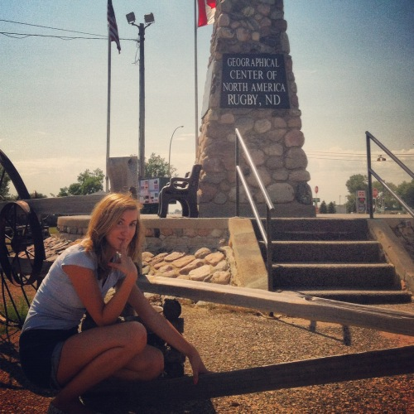
July 13, 2012 | Edit
Scandinavia is taking over North Dakota!
Okay, forget what I said about a new record in the last post. We have now exceeded that record again! Today we did 347 miles (which is approximate 558 kilometers). We began the day in Minot, North Dakota, and finished in Gettysburg, South Dakota.
This morning we had to ship some clothes home, since we need to make room in our boxes to store fuel for long distance traveling in deserted areas (like outside Las Vegas for instance). When we left the post office in Minot we spotted a sign that said ‘Scandinavian Heritage Center’. What a lucky coincidence, me being Swedish and all. We had to make a stop! John pulled out the camcorder, and I made a memorable appearance under this sign, which you will see when you get the DVD
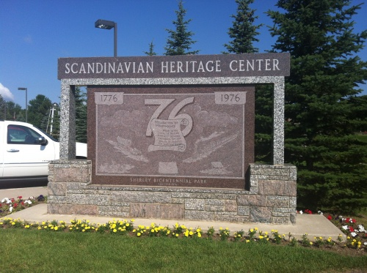
I took on the role as a Scandinavian guide, but I don’t think John was very impressed since I kept mixing up Åland’s and Iceland’s flag, and since I didn’t know the story behind the famous Dala Horse. I just know that it is a colorful horse that symbolizes Dalarna in Sweden, and that there’s a huge statue of it in a Swedish town. Oh, speaking of huge statues.. I will come back to that later in this post!
I must say that I feel right at home in North Dakota. The last couple of days have involved a lot of Scandinavian culture, both when it comes to places we have visited, but also the people we have met. People keep coming up to us and asking who’s from Sweden, since they notice the Swedish flag on our bike. I guess North Dakota is turning into Scandinavia.. that must be why they have a strong economy and a lower unemployment rate than the national average! We stayed on for a bit, and checked out the park and the shop.
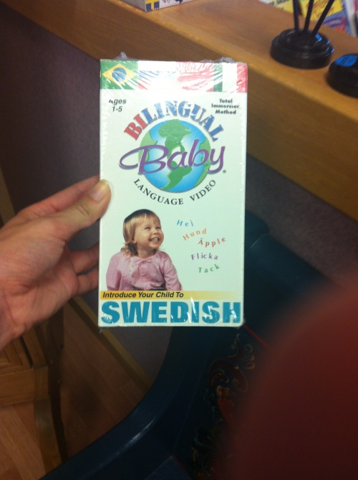
Eventually we had to get going, since we had a long day ahead of us. Our next stop was the petrol station.
As John was fueling up we suddenly heard a loud siren go off. I looked at John, but he didn’t know what was going on either. A guy pulled up beside us, and quite calmly said ‘Tornado warning!’, and then drove away. TORNADO? How could that be? The sky was all clear and there wasn’t a cloud in sight. Fortunately it turned out to be the town horn, and not a tornado warning. I bet that guy in the car just wanted to scare us, since he saw that we were Europeans. But what’s even stranger is the fact that Minot, North Dakota, has a town horn which goes off at noon every day for no apparent reason. It goes off just because it can.
We giggled a bit about that, and continued our journey to the south. Our main mission today was to find a cow. And not any cow, but THE cow. The largest cow in the world! (Almost as big as the Dala Horse I was talking about earlier). We felt quite silly driving down the road while listening to very cheerful tracks on the album ‘Nashville Skyline’ by Bob Dylan, in pursuit of a gigantic cow. It was just the perfect soundtrack for the trip! All of a sudden we saw an enormous silhouette of a cow at the top of a hill in the horizon. By this point we were too excited to contain ourselves, and we couldn’t wait for Wendy (our Sat Nav) to say: ‘Arriving at big cow, on left’.
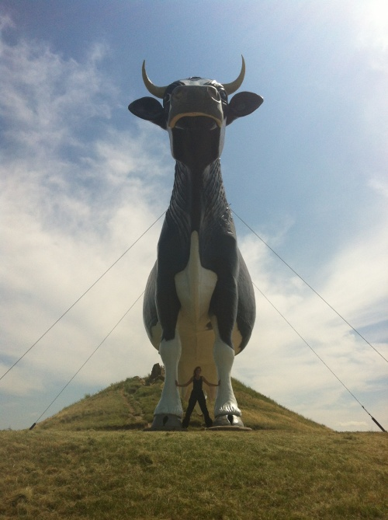
What a pleasantly bizarre thing. John remarked on the daft expression she had, and I guess that has to do with all the crazy people coming to the hill to take a photo of her. She must be fed up with it! Hence, the expression.
We met a lovely couple at the hill as well! And guess where they came from? Sweden! What are the odds? I guess Scandinavians are the only people crazy enough travel for miles to see a big cow! Haha!
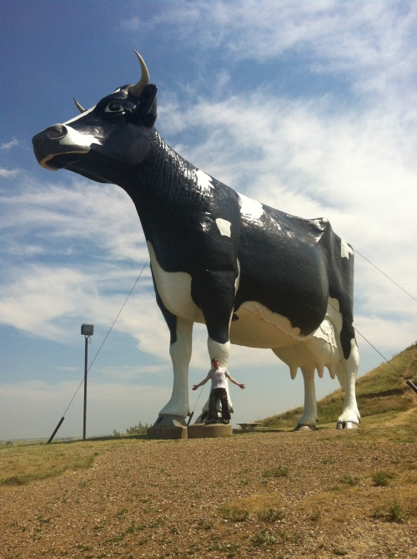
After visiting the largest cow in the world we decided to ride on all the way to our overnight stop. Nothing else could measure up to what we just had experienced, so we might as well just call it a day! We rode into South Dakota as the day slowly turned to evening. We could see the sun go down to the west as we rode due south while listening to Led Zeppelin..
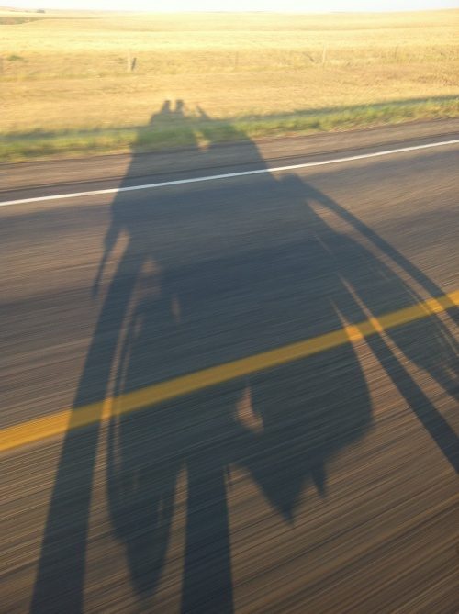
And as we wind on down the road, our shadows taller than our souls…
The journey was incredible. We rode at high speed for over 25 miles at a time without encountering the slightest deviation. John took care to look after the motorbike’s tyres as we often covered stretches of gravel, across flat farmland with our shadow stretching far to our left. We were amazed by the gigantic scale of the landscape, offering sight of the curvature of the earth in all directions. It went on and on and on…
July 15, 2012 | Edit
South Dakota; the state where it all happens!
Let me just start off by saying that we have been having some difficulties with the internet connection again, which have resulted in a day’s delay on the blog posting. Bear with me! I will try to give you a detailed update of what has happened the last two days... because, oh my, there has been a LOT going on!
Ok here we go. Yesterday, FRIDAY THE 13TH, we traveled from Gettysburg to Rapid City, both located in South Dakota. I’m sure there was a new distance record, but I’m not even gonna mention that anymore because it seems like we’re setting new records every day now. You might wonder why we are riding so far every day. The thing is that I have to reach Denver by August 1, since I have to go back to Sweden to sit an exam John will go on for three more weeks, and I will make sure that he keeps the blog as updated as it is now
So, back to yesterday’s big adventure. We sat off from Gettysburg in the early morning hours, and our goal was to reach ‘The Point of Inaccessibility’ sometime in the early afternoon, so that we could get to the overnight stop early to get some work done. Easy! Just before we were about to get going I reminded John that it was Friday The 13th. We laughed a bit about it, and together we wondered how the day would turn out.
It all started out great! It was sunny and of course a bit too hot but we’re getting used to that. We were riding along the highway when we suddenly spotted a sign that advertised an exhibition. It said that they were showing ‘General Lee’ (the car used in the TV show ‘The Dukes Of Hazzard’). Since John is a big fan of the show we decided to make a quick stop to have a look around. A quick stop turned out to be several hours, since the exhibition was enormous! It had everything from the 50′s – 60′s. We saw Elvis’ Harley Davidson, the car James Dean rode in ‘Rebel without a cause’, another car which Marilyn Monroe had been in etc. They had built up a whole city from the 50′s – 60′s. There was a bank, a school, a post office – you name it!
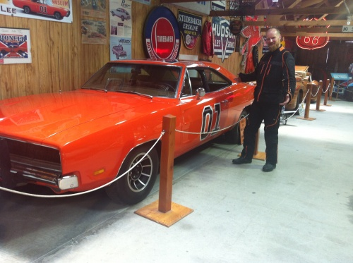
The General Lee
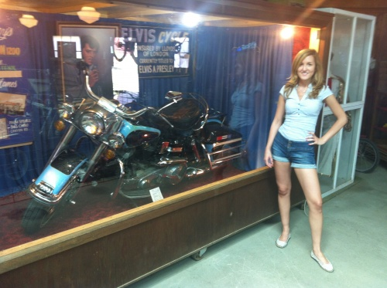
Elvis Presely’s Harley Davidson!
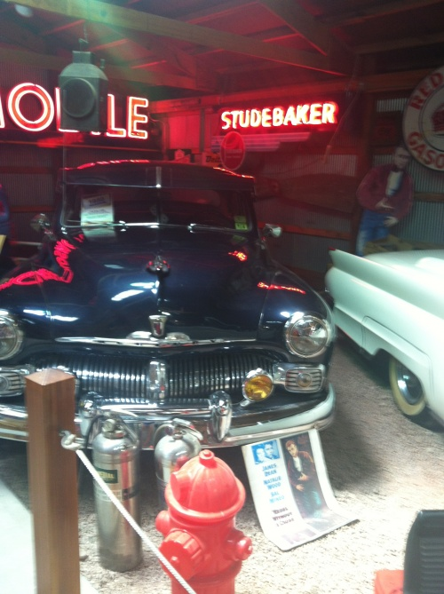
The car used in Rebel without a cause!
While at the exhibition I saw an unsinkable rock, rocked out with Elvis and I found a car which was the perfect size!
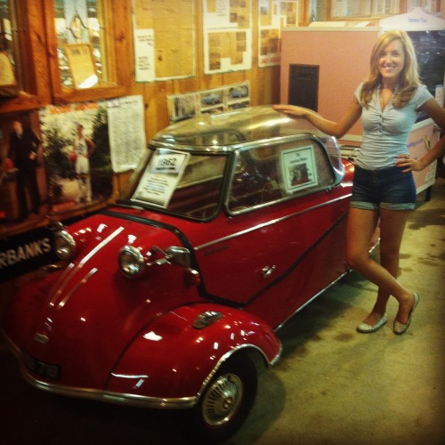
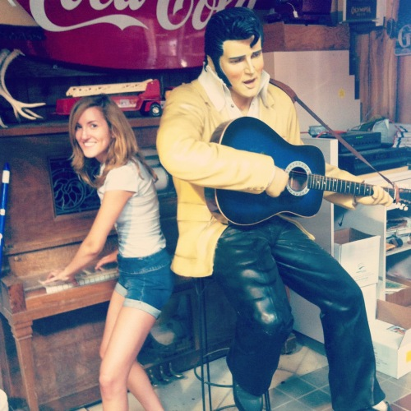
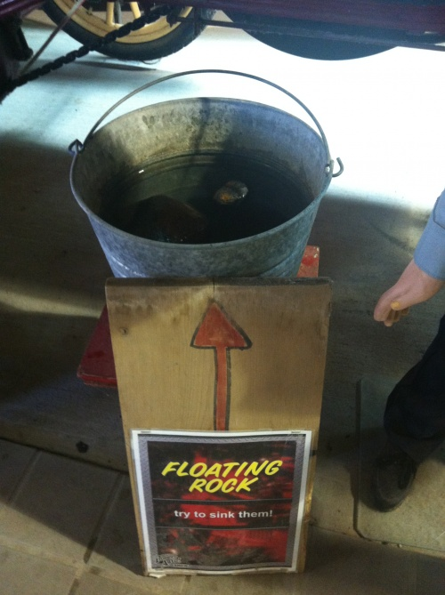
What a place! I recommend anyone to visit the Pioneer Auto Show, Murdo in South Dakota. I had such a hard time tearing myself away from the shop! They had the most spectacularly unnecessary things from the 50′s – 60′s, and I wanted them all. The only thing I managed to convince John to let me buy was this magnet.
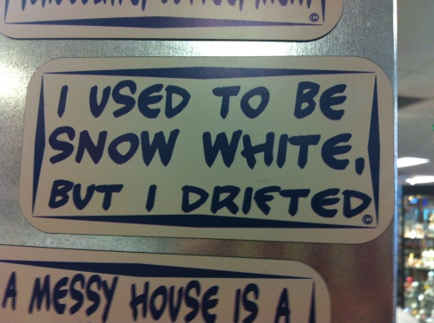
Anyway. after the ‘quick stop’ we were miles behind schedule. We had to reach ‘The Point of Inaccessibility’ soon now, if we were to have a nice evening where we could work AND get some time to relax as well. So we went to the petrol station to get some fuel. As I’ve mentioned in earlier posts, I should make a new category in this blog: ‘things you see at petrol stations in the US’.
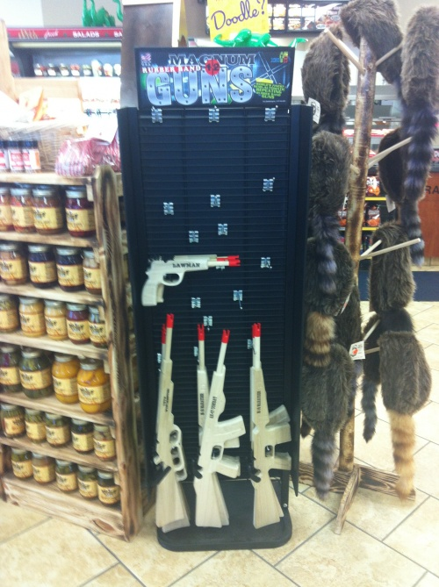
Just some machine guns for children..
We fueled up the bike and ourselves and went off! The Point of Inaccessibility – here we come! As we were riding along a deserted highway, in the pursuit of the place, Wendy (our Sat Nav) suddenly had a fit. She kept telling us to go to the left, but there were no roads. In fact, there was only one straight road for miles and miles. We were literally out in the middle of a very deserted place in South Dakota. No cars, no people, no Sat Nav… and almost no fuel. We decided to give up on finding The Point of Inaccessibility, since it apparently was inaccessible (oh, the irony!). Instead, we put all our focus on finding a way out of there without Wendy. After riding around for about 80 miles in the middle of nowhere, we suddenly found ourselves in The Badlands National Park. Aren’t we lucky after all? Just have a look at this.
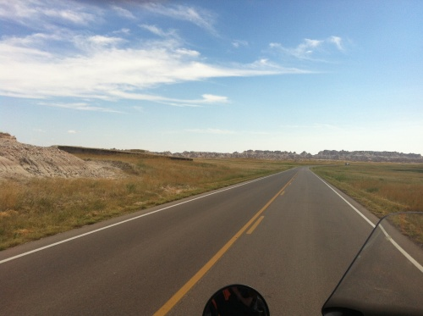
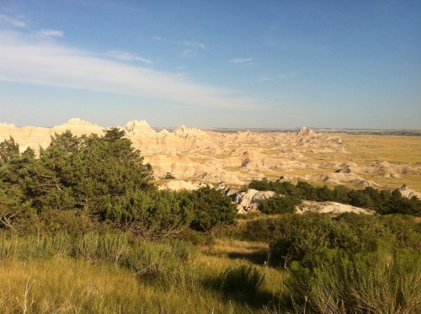
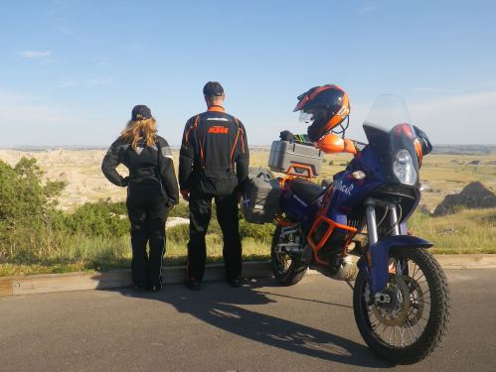
We were pretty pleased with this finishing our day. We had done loads apart from what we were supposed to do! So we started riding towards the motel in Rapid City. All of a sudden we saw that there was something going on at the side of the rode. After having a closer look we realized what we just had passed.. an all American RODEO. This opportunity would probably never manifest itself again, so we made a bold decision to turn around and try to get in. It was already late, but we just had to give it a try! And guess what? We got in.
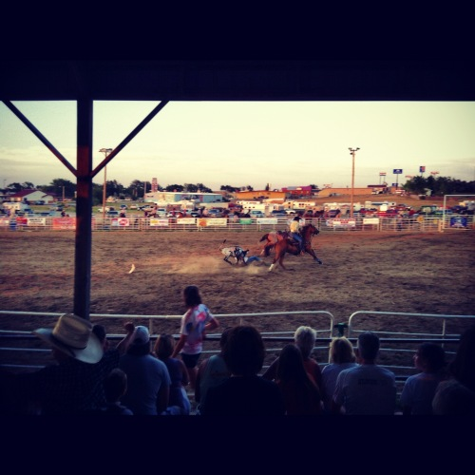
Oh my, what a day. To sum up Friday the 13th: apart from some minor setbacks, we had an amazing day. We saw the General Lee, got lost and ended up in The Badlands and saw a rodeo! What more can one ask for? Only in America.
July 15, 2012 | Edit
Mount Rushmore and pooping wildlife
Ah, so here we go. Since I have internet access right now I will post both this and yesterday’s postings at the same time. I’m sorry about that! A lot of information will have to be digested.
Today.. hmm, where did we start off? Oh yeah, in Rapid City, South Dakota. It is located only 20 minutes from Mount Rushmore, which was today’s planned activity. We left quite late today, since we only had that one thing to do. But, as you might have noticed, we usually end up doing ten other things as well. America just has so much to offer! And Mount Rushmore was no different. as we made our way there along a winding road we were bombarded with advertising signs, and we wanted to do it all! YES – I want to go to ‘Reptile Garden’, YES – I want to visit ‘Bear Land’, YES – please, can we go to ‘Christmas land’ as well? All these places, and no time! I will definitely come back to Mount Rushmore and do everything. But we had to go for the climax: the presidential heads carved in the mountain! Washington, Jefferson, Roosevelt and Lincoln.
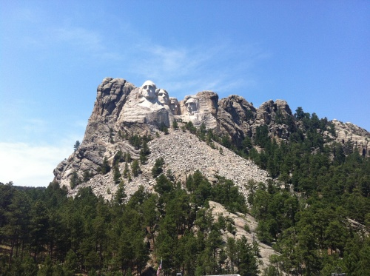
I could never imagine how HUGE this monument (or memorial as they call it) is. It is unbelievable! We started at it for a good 20 minutes, before we went to the exhibition. Afterwards we decided to visit some national parks which were said to have a lot of wildlife (I desperately wanted to see a bear!).
We met a really cool guy from California in the parking lot, who also was touring the USA on a motorcycle. He gave us some suggestions for our route which we definitely will check out! Just wanted to thank you, Puneet.
Anyway, we went out into the national parks. The first thing I saw as we entered was an ADORABLE deer. John missed it. He always misses these things! I’ve seen so much wildlife here, but I think the only thing John has managed to capture is a bird of prey. Our conversations usually go something like:
Me: Oh, did you see the turtle?
John: WHAT?
Me: Yeah, and right beside it there was an owl, and a grizzly bear. You missed that?
But this time we both got to experience a lot of wild animals. Or mostly deer and donkeys. And for some strange reason they were all doing their business as we passed. There was one deer which rushed up to us, looked us straight in the eyes and promptly took a huge dump. Right in front of us! Haha! It was as if it wanted to prove something. I got it all on video.
July 17, 2012 | Edit
Crazy Horse and Crazy Woman
In the last blog post about Mount Rushmore I forgot to mention that we also went to see another monument called ‘Crazy Horse’, which is located in the Black Hills. The monument is as of yet a work in progress, but when it is done it will be the largest mountain carving in the world! Much, much bigger than Mount Rushmore.
‘Crazy Horse’ was a native American war leader for the Lakota tribe, and he was a key leader in the famous Battle of the Little Bighorn (or Custer’s Last Stand, as it also is known). Why am I telling you this? Well, today’s trip had a lot to do with Crazy Horse.
Let me just start off by giving you some details on where we are and how far we’ve traveled. We started out in Gillette, Wyoming, this morning. Since we didn’t sleep at all last night because of a local disturbance, we came to the conclusion that we had better take a short trip today. So we went to Billings, Montana, which is about 240 miles from Gillette. That was more than enough today! Phew, it is 100 times harder to ride a motorcycle when you’re tired. Oh, by the way! We have now been traveling for exactly two weeks, and covered 3856 miles. Not bad, eh? but it also means that half of my time here is over.. let’s not bring that up now though!
Anyway, on our way to Billings today we visited the grounds where the Battle of the Little Bighorn took place back in 1876. The battle was part of a centuries-long conflict that began with the arrival of the first Europeans in North America.
While at the historical site we wanted to learn as much as we could about it. But since we were really, really tired that was a difficult task. We must have looked like complete idiots when we kept dozing off while watching a video about Crazy Horse. The park ranger glared at us, as if we were dishonoring the memory of Crazy Horse!
On our way to the next overnight stop we passed ‘Crazy Woman Creek’, and John was very happy since he had found a place to drop me off. Thank you, Goldie-locks!
For dinner I ordered a take-away. It came with a fortune cookie. Fortune cookies never lie do they?
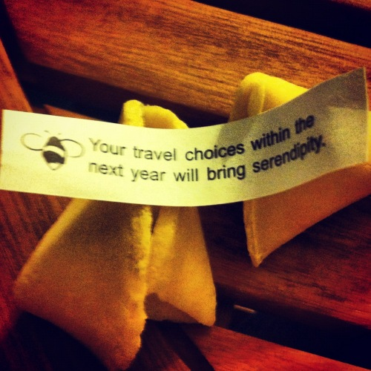
July 17, 2012 | Edit
Yellowstone and grizzly bears
We have now made it all the way from New York to Yellowstone on our KTM bike. Isn’t it amazing that we, just 2 weeks ago, started out at New York. To travel as a passenger on a motorcycle has turned out to be both extremely challenging and very rewarding. Nothing comes close to riding along the highway in the sunset and soaking in the different smells, while listening to Bob Dylan or Johnny Cash. In those moments I don’t care about my bum being sore, or the sun burning a whole in my trousers. I’m just so very pleased and thankful that I get to experience America in this unique way! I wish everyone could have this journey once in their lives, but since I know how privileged I am to have this opportunity, I’m doing my best to share it with you!
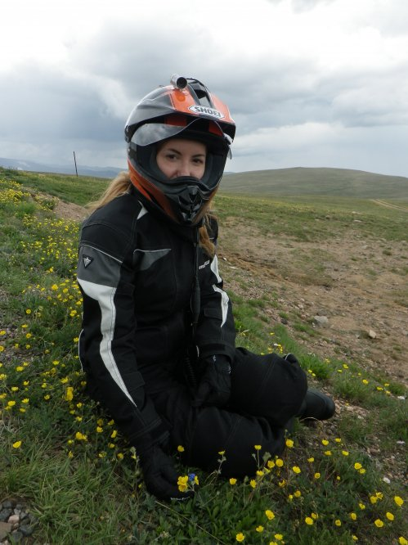
Okay, back to today’s route. We left Billings, Wyoming, to continue to Yellowstone. We had absolutely no idea what to expect, but we were extremely excited. We decided to take a route through a mountain pass, which was recommended to us. The pass is called ‘Beartooth byway’, and it takes you straight to a gate into Yellowstone. As we were climbing up the mountain roads I suddenly realised what I had gotten myself in to. I’ve mentioned before how I am terrified of heights.. well, the highest point on this route was 3334 meters! Climbing up the curvy roads was absolutely terrifying for me. I couldn’t look down the steep hills, so I tried to just focus on the road. We eventually made it all the way to the top, and guess what? We had a snowball fight. SNOW. COOL AIR. We were in heaven, as you can see:
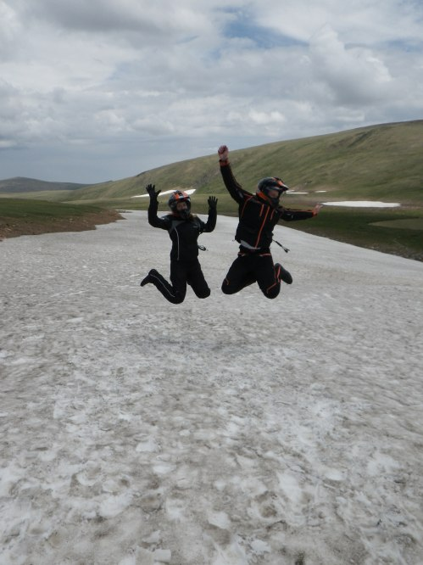
After our snowball fight and awesome photo shoot, we started to make our way down hill. Up next was Yellowstone. I have no words for this place. It is ABSOLUTELY stunning. The nature is so dramatic! It’s different around every corner. You can be driving though a field with bison at one moment:
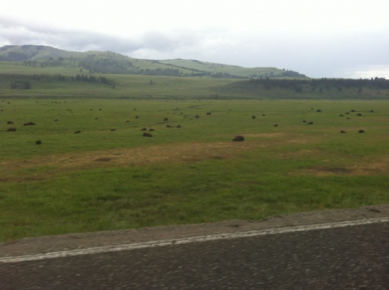
then standing amongst hot springs the next:
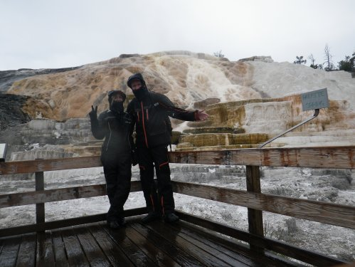
then there might be a moose or a bear popping up:
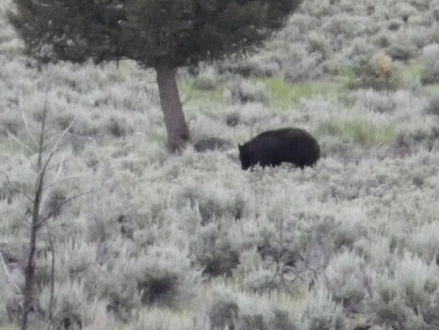
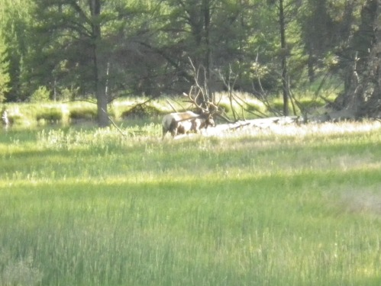
We actually got to see both a black bear and two grizzly bears. The grizzly bears were too far away to get a good picture of though. I am glad that they weren’t closer! The size of them! Phew! Oh, and we also saw mule deer, elks, moose, pika and pronghorn among other delights.
Yellowstone must be one of the most dramatic places on earth. I’m just so amazed of what nature can accomplish…
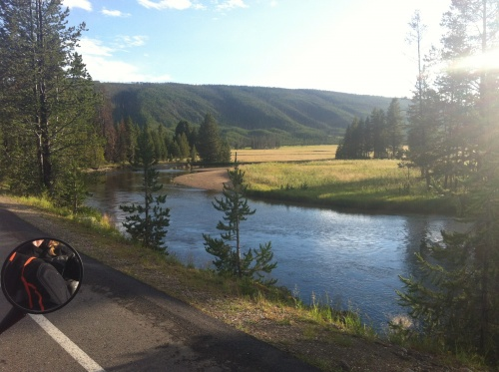
July 19, 2012 | Edit
Yellowstone revisited! Petrol station drama… once again!
We didn’t get the chance to do all the things we wanted in Yellowstone the first time, so we had to revisit it the next day.
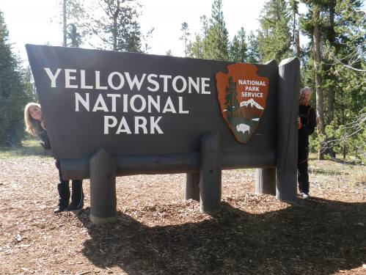
You could spend a month there without seeing everything! It is huge! But one of the things that we didn’t want to miss was the geyser ‘Old Faithful’. It’s often described as the most predictable geographical feature on Earth, as it erupts every 91 minutes – on the spot! We were extremely lucky since we got there just in time to see it do so:
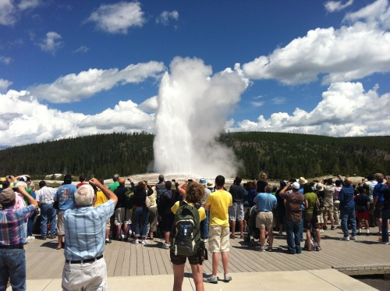
Isn’t that amazing?! Mother nature, you have outdone yourself once again. When we were about to leave we met a guy in the parking lot. He immediately recognized our motorcycle, and asked ‘Where is Charley Boorman and Ewan McGregor??’ It turns out he had been watching the documentary ‘Long Way Round‘ and was a big fan. I don’t think he expected to hear that John actually had been working with Charley Boorman on the DVD ‘Race to Dakar‘.
After this stop I started to feel a bit ill. I think I caught a stomach bug, but we still had 300 miles to cover! We had started out from West Yellowstone, Montana and had to get all the way to Evanston, Wyoming.
I must admit that it wasn’t the best experience in the world, being on a motorcycle for hours while feeling awful.
As the evening approached I started to feel a little bit better. We went through this really stunning landscape in Wyoming, just before we got crossed the border to Idaho. I can’t even describe it in words! Some places here in the US can only be transmitted through moving images. Good thing we have a camera on the bike and our helmets! The DVD will do this landscape much more justice.
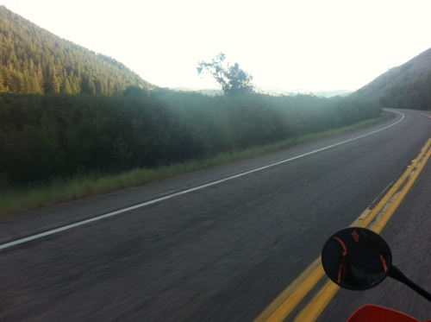
During this whole trip John is constantly giving me advice on how to keep safe on a motorcycle (since I’m planning on getting me license when I get back home). When we went into Idaho we had to stop for a crossing train. We were out in the deserted areas again, and there were no car or houses for miles. When we stood there, waiting for the train to pass, John kept the engine running. He said that in case something happened, like if the bike wouldn’t start again if he turned it off, we would be screwed. So: when in a deserted area – do NOT turn off the engine. This would prove to be a very wise decision. After the train had passed we had to find a petrol station to fill up. There was one just a couple of miles away. As we pulled in our Sat Nav, Wendy, suddenly stopped working. We thought this was pretty weird, but went on into the station and started to fill up. I went into the store to get something to eat. Suddenly John rushed into the store. He had a worried expression on his face, and said ‘Lucy... There’s a problem. The motorcycle will not start’. Mind you, this was about 9 pm, and we still had a long way to go to the motel.
There we were, at a petrol station somewhere in Idaho, with a motorcycle that wouldn’t start. It could have been worse though! What if we had turned off the engine at the train crossing?! Oh, the horror!
It turned out that the motorcycle’s battery had died. We think this was due to the amount of electricity we’ve used: with the cameras, music etc. We met a really nice guy who helped us charge the battery with his car, and we were off again! By this time darkness had fallen, and it was freezing. We were up at an altitude of about 2000 meters, and it was completely clear weather. I could see all the stars! Amazing.
July 19, 2012 | Edit
John sets a new record at Bonneville. And my butt is famous!
I am proud to announce that John has set a new record on his KTM Adventure 990 S at the Bonneville Salt Flats International Speedway. He is now the fastest mid-life-crisis in the world!
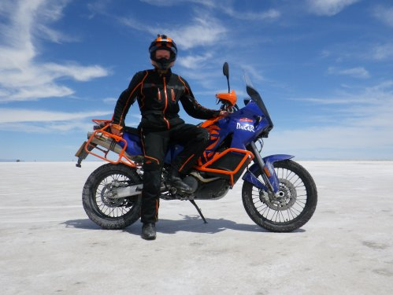
So, as you might have guessed, we went to the Bonneville Salt Flats in Utah today, west of Salt Lake City. This is one of the few places on earth where you can drive as fast as you want! It currently holds the land speed record, at about 750 miles per hour.
We were at the best place in the world for the KTM bike! It was so flat that you could actually see the curvature of the planet. I think this is the most incredibly place I’ve seen so far! Along the way there people had left messages by forming sentences with stones in the salt. It was very interesting and unique!
And we did get some amazing photos, don’t you think?
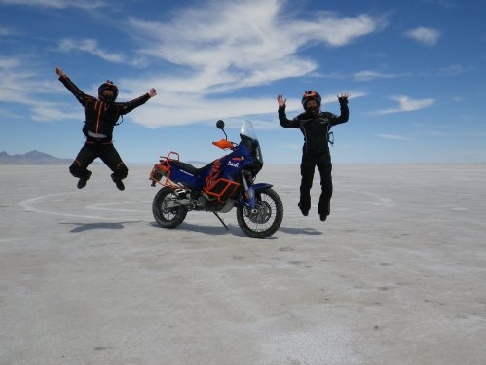
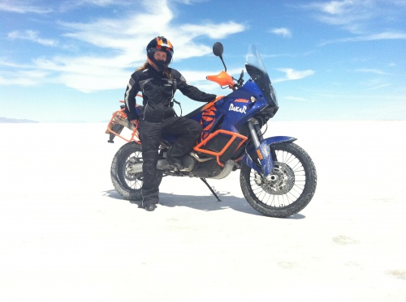
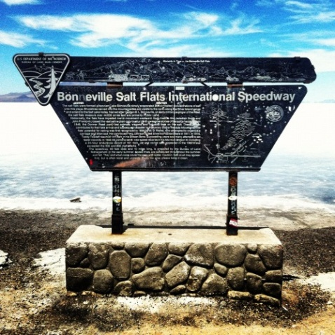
Funny story today by the way. We went to get fuel and I sat down on a newly painted seat. There were no signs that said it wasn’t dry!! To make a long story short: we ended up talking to a police officer who was fueling his car, and he helped us out by calling the painters and got them to come back with paint thinner to remove the paint from my motorcycle gear. Haha, you should have seen how frightened those poor painters were, as the police officer were watching them get the paint off my pants. He gave them a warning, and said that they always should put a sign up when they are painting, because you never know when someone will sit down on it with their expensive motorcycle gear.
July 20, 2012 | Edit
Two days in Reno
Here we are! We’ve traveled all the way from New York to Reno in 19 days, covering 5050 miles, and it is therefore time for the motorcycle to get some attention. John could look after it as much as it needs but it’s hard to do that with a mini toolkit in the parking area of a hot fuel station so John had it booked into a KTM workshop at Reno. Jobs to do are: replace rear tyre, replace chain and sprockets, change engine oil, oil screen and filter, investigate suspect fuel and engine oil leaks, make a set of spare light bulbs and wash it! Here’s the old tyre:
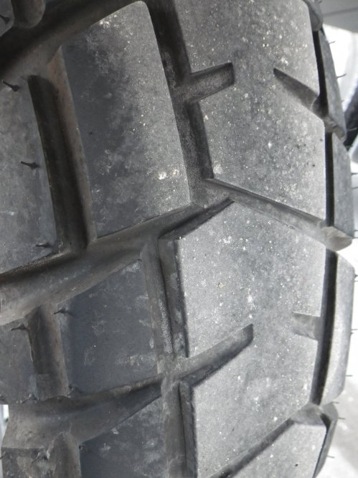
Yesterday we started off in Elko, Nevada. We got up very early, traveled 301 miles and made it to Reno by 2pm. Traveling through Nevada was quite an experience! What a deserted landscape. The only sign of civilization were prisons! And there were a lot of them. I guess it is the perfect place, since the prisoners have nowhere to run should they escape. Hitchhikers were also strictly forbidden in the prisons areas, since they could be mistaken for prisoners. Scary, isn’t it?? What if we got stranded in those areas.. the prison guards wouldn’t know what to make of us: ‘Hi! We are from Scotland and Sweden, and we’ve traveled all the way from New York on a KTM bike...’ Guard: ‘Have you now? Lock them up!’
It was also EXTREMELY windy, because of the open landscape. We even saw one truck that had fallen over because of the wind! I had to hold on hard to not get blown off the motorbike.
Anyway. We have a day to get a lot of work done here in Reno. But there’s also time to play! Last night we went to a casino and came out $1 down. That’s just because we weren’t sure how to place a bet. If we had known, we would probably have lost $100. It was amazing to see many elderly ladies sitting by the machines, smoking, while placing bet after bet. I can see myself being like that in about 60 years! Oh, and John had a very meaty meal.. on this plate you can see three different kinds of meat. Just to make sure that as many animals as possible died for the meal! Haha!
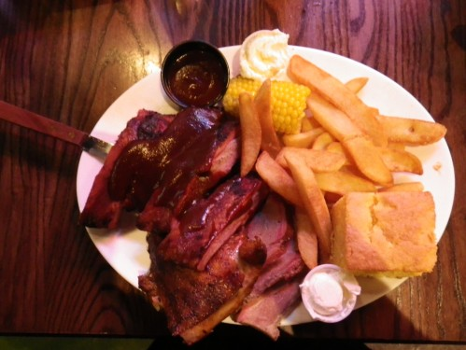
Today we will get the motorcycle from the workshop, and it will be as good as new! I will also have a look at the bikes in the KTM store...
July 22, 2012 | Edit
Lake Tahoe and SAN FRANSISCO
WE HAVE DONE IT! Half the journey is officially over. We started in New York on 2 July and now, 20 days later, we are in San Fransisco.
I am so proud of us. It has been a very challenging, but rewording journey! Early mornings, trying to escape the extreme heat, and late nights transferring film to the computer and writing the blog. But it has all been worth it. Nothing can compare to the feeling of riding into San Francisco over the Golden Gate Bridge. What a magnificent moment in life!
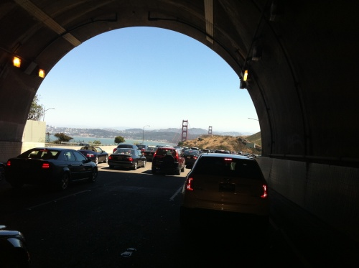
More on San Fransisco later in the blog post.
Today we started off in Reno and headed towards San Fransisco, California. We had to take it easy for the first 100miles or so because we were running on a new back tyre and it needed to have its tread scuffed before we could rely on it to grip properly.
We wanted to try a route that had been recommended to us, which would take us around Lake Tahoe, and then through Sacramento. I am really glad that we took this route! Lake Tahoe must be one of the most beautiful places on earth. John told me we had a little worry on the way when the motorbike’s low-fuel warning light showed after only 85 miles. He was intending to refuel after 100miles, which was deliberately early to be safe, but then was puzzled why he was needing to so soon. It turned out that the workshop in Reno had not re-opened a fuel tap on one of the motorbike’s two tanks (one of the two tanks was still full!). John thought he had worked out that was what had happened, opened the fuel tap and carried on. The same problem happened soon after and worried us again but then John found that it was because the other tank’s fuel tap had not been re-opened either! Problem sorted, thankfully!
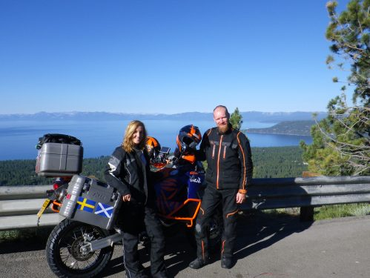
The weather was perfect! It was cool and sunny for once. We made our way through the curvy roads surrounding Lake Tahoe, and eventually ended up at the border to California. This was it! For me, this is the furthest away from Europe I’ve ever been. I’m on the other side of the earth! How cool is that?! Me and John were discussing California, and how scary it is that this state actually could disappear in the future, since it is located on a continental plate which could easily move.
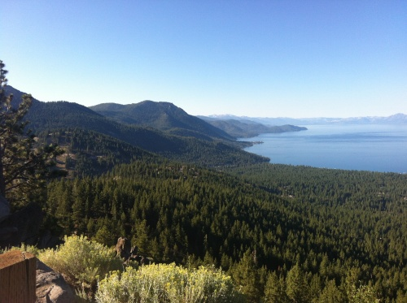
As we approached Sacramento the temperature all of a sudden skyrocketed! The cool air of Lake Tahoe just vanished, and was replaced with heat up to 100 Fahrenheit. Then, lo and behold, it dropped to 72 Fahrenheit just like that. When we got to San Francisco it was beautifully cool again. We’ve got some strange weather over here.
So there we were, finally approaching the Golden Gate Bridge. I have no words. San Francisco left me speechless! What a city. The bridge in itself was just the icing on the cake!
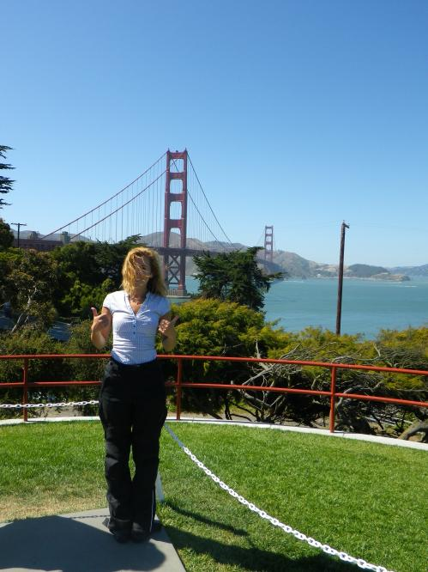
Epic picture hahah!
We made our way into the city. It was unreal to see all the hills that distinguish the city of San Francisco, which I’ve seen in so many movies. Now WE, a girl from Sweden and a guy from Scotland, were riding along the same hills. It was surreal!
We rode around for a while, trying to find a place to park the motorcycle. After about half an hour we spotted a place to park! Yes, San Francisco is very busy.
We packed up our helmets and went looking for a place to eat and do some shopping. I bought way too many things, and I think I will have a hard time trying to fit everything into my tiny box.
When we were about to leave we passed a building with a Swedish and Bulgarian flag. This was quite funny, both because John is sick and tired of being haunted by Scandinavia, but also because I am half Swedish and half Bulgarian. What are the odds of finding the two flags next to each other in California? Haha!
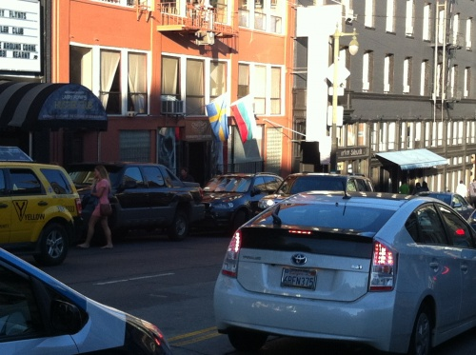
And so we say goodbye to San Francisco for now – but I can guarantee that we will be back!
July 23, 2012 | Edit
Yosemite National park, and upset ghosts..
We are starting to feel the effects of long distance traveling. Exhausted can’t begin to describe it!
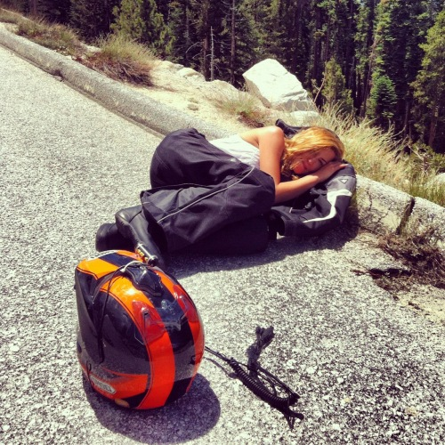
After leaving Castro Valley, California, this morning we set of for Yosemite National Park in the hope of seeing some of its famous waterfalls. The route from Castro Valley to Yosemite was very nice, with a lot of strawberry farms! There were also watermelon farms, blueberry farms, raspberry farms... you get the picture. I wanted to stop everywhere and just nick something to eat!
As we got closer to Yosemite we suddenly found ourselves at 2000m, and the elevation continued. I think the highest point we reached was over 3000m! Just look at these huge mountains! The cars seem so insignificant compared to the magnitude of them.
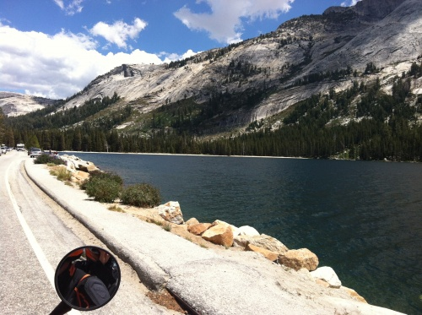
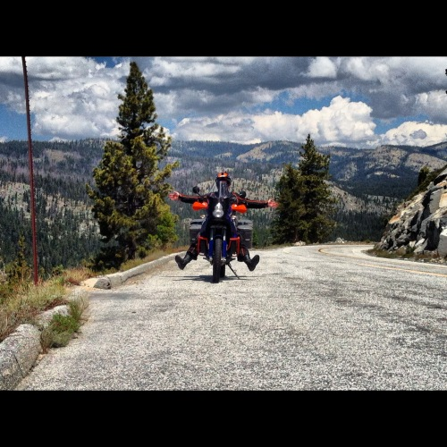
And here is John, looking like a bug, while climbing the steep hills of Yosemite.
However, we did not see any waterfalls. We think this might be due to the extreme heat. They must have dried out! We saw some puddles of water, but nothing like a waterfall.
It didn’t matter though! Yosemite is, just like Yellowstone, one of those places where Mother Earth clearly has put in an extra effort to make it stand out. The trees were tall as skyscrapers, and they stood steadily on the steep hills across Yosemite. We passed a section of the forest where there must have been a very hard gust of wind, since ten or more of these really tall and thick trees had been broken off by the root. It was actually a bit scary! I can just imagine how terrifying it must be to see one of those trees blow down!
We had lunch at an outdoor restaurant, and as we made our way to the parking lot this little boy came up to us and asked if he could take a picture of us :) We felt like celebrities.
After lunch, which I ate waay to fast, we headed off to our next destination for the day – Bodie, The Ghost Town. I was really excited!
I have been reading about this place, and it seemed very cool and even haunted, but I think it wasn’t meant to be for us. We encountered so many problems on the way there! As we turned onto the road that would lead us to the ghost town we suddenly saw that the road would take us straight in to what looked like a major storm. The sky was completely black in the direction of the town, and we could hear thunder and see lightening. We stopped for a while and waited for it to pass. We were about to give up and just head to our overnight stop, which would have been a good idea, but then we thought that the storm had eased a bit so we decided to try our luck. It had actually eased a lot, and we only got a little bit of rain. Then, obstacle number two appeared. All of a sudden I got a real stomach cramp! I felt really, really sick, and there was no place to go. We were on our way to a deserted ghost town, so of course the place was completely deserted. We just had to turn around! But that was easier said than done. We were on a rough dusty sandy gravel road, which was also wet because of the rain. When John tried a U-turn to head back it seemed that we were destined to be thrown from the motorbike as Mother Nature tried to claim it! We couldn’t really have expected an easy outcome given that we are so heavily loaded and top heavy but somehow we made it around! Good bike and good teamwork! John said it was a miracle we haven’t yet dropped the bike anyway. With all our emergency water and food provisions on board now we cannot even leave it on its side stand because it can’t hold it!
When we reached the nearest town again I felt fine. So, I think that some ghost in Bodie just didn’t want us to come there!
July 25, 2012 | Edit
Now we can truly say we’ve been to Hell and back..
Yesterday was very spectacular in the sense that we got to experience a lot of extremes. We left Mammoth Lakes, California, to go to Las Vegas! That in itself is pretty extreme, since it is the longest distance we’ve travelled in one day so far. 340 miles! But there were some contributing factors that made this trip even more extreme. Like travelling through one of the hottest places on earth in the middle of the day, with the hottest gear on without any prospect of sheltering in shade.
When we got to our first fuel stop we encountered some technical problems with the battery of the motorcycle again. Fortunately we found an Auto Parts store right across the street, which sold motorcycle batteries. We were really lucky, because they had a battery that was the perfect fit for our bike!
But the stop made us very late, and keeping in mind that we had to travel through Death Valley we were a bit worried that it would be too hot. But we decided to try it anyway, since we had plotted our route already. On our way there we passed the highest mountain in the contiguous United States – Mount Whitney! Yet another extreme to add to this journey Gorgeous views on our way to hell..
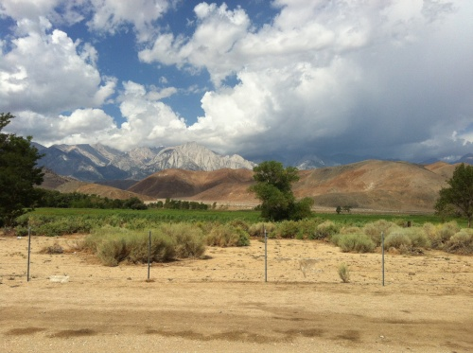
There must have been a military base nearby, because as we were riding along the beautiful scenery, this freighteningly loud noise hit us suddenly. I was sure we were going to die. I thought a truck had just run us over, but it turned out to be a fighter plane! It flew right over our heads, but John kept his cool. I told him that if I had been the one who was driving, we would probably have gone off the road and out in the desert somewhere.
As we approach Death Valley the pleasant cool air of Mount Whitney was replaced with gusts of VERY hot air. I quickly came to the conclusion that this would be the hottest day we’ve encountered so far. We made a quick stop to get some photos:
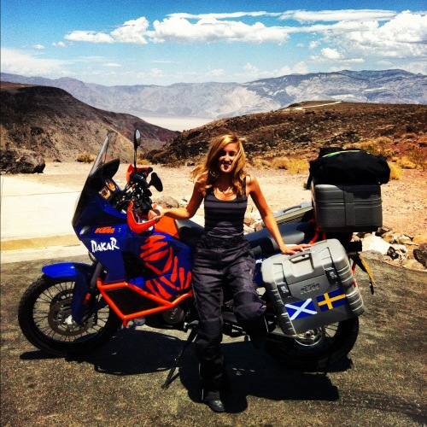
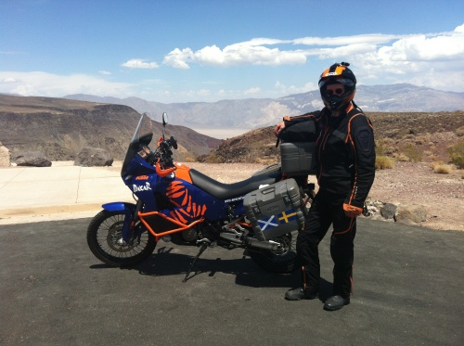
During the stop I drank a whole bottle of water in less than 5 minutes! John didn’t have a chance to stop me, but as we set off again I realized the seriousness of the situation when John asked: ‘So Lucy… how much water do you have left now? You should probably save it. You’re not dying‘.
There is a reason it is called Death Valley. Those first gusts of hot air were nothing compared to what was to come! Before we went to the deepest depths of Death Valley, we had to make another fuel stop. I bought a lollipop with a scorpion in it, and suddenly remembered that there probably are a lot of very poisons insects and snakes in this area. I asked the cashier about it, and he just said ‘Yes they’re all here, and they all can kill you. So be careful!’ Great, just what I needed to hear.
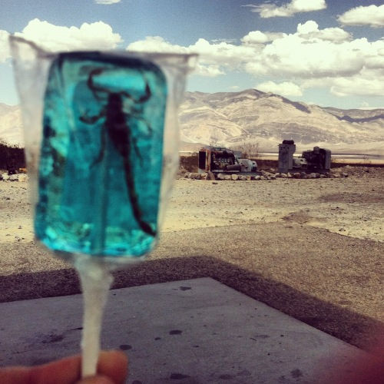
We left the petrol station and started to descend. We quickly went from 300m above sea level to just 20m, 10m.. and suddenly we were under sea level. The temperature was like nothing I’ve experienced in my life. It was as if someone was blowing hairdryers all over you right up against you! We were 10m under sea level.. 20m.. it was getting hotter by the meter! We were going straight to hell without stopping. We were laughing about the fact that we had actually chosen to come here. No one had forced us! There we were, in the middle of the day, trying to ride out in the open in an area where it was 50C in the shade! We daren’t think how hot is was in the blazing sun we were riding under!. We reached a depth of 70m below sea level. It was absolute torture! There was nowhere to escape it. We just had to stick it out for dozens of miles. I could feel my heart beating faster and faster, and I was sure I was going to faint. After what felt like an eternity we reached a remote fuel station. By this time I was completely out of it, I don’t even remember what I was doing. John later told me that I jumped off the motorcycle and vanished before he had stopped the motorbike and put the stand down, which he had to do before he could help me! I stumbled to a building to get inside, but it was locked!! Oh, what drama. John shouted that I should sit down, and rushed over to give me water. Just about then a guy opened the door and asked if everything was ok. It clearly wasn’t, so he let me in. I got to sit next to a fan, and he gave me two more bottles of cold water. When he realized that we just had driven though Death Valley he laughed and said that we must be crazy to go through that place in the middle of the day.
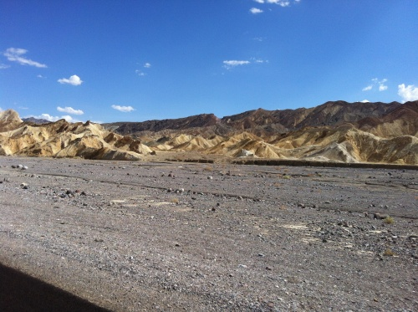
I managed to snap some photos of this extreme place…
We are crazy indeed. But the world needs crazy people! Otherwise it would be such a boring place. We left the site and carried on for a little while before the temperatures became less extreme.. like 40C or so. That felt like heaven at this point! We were now heading straight to Las Vegas, just as my birthday starts in Swedish time! It felt amazing to ride into civilization again.
Suddenly John was riding us along the Las Vegas Strip and pulled in right at Caesars Palace. We had a top hotel for my birthday night, with top views! What a day!
July 26, 2012 | Edit
Birthday celebrations in Las Vegas!
After our encounter with Death Valley yesterday we decided to spend two whole days in Las Vegas. One of the days just happened to be my birthday! What a lucky coincidence, don’t you think?
We are both tired and worn out after having travelled non-stop for such a long time, so we decided to make the most of it in Las Vegas. I got a well needed manicure and pedicure, and John desperately tried to find someone who could do a butt-massage on him, since he’s been struggling with a sore bum from riding the motorcycle for a long time now. He couldn’t find a specific butt-massage, so he had to settle for a regular Swedish massage. Yes, it is called a Swedish massage John! You will never escape Scandinavia
It felt so good to be pampered! We were very excited to see what Las Vegas had to offer as the night crept closer. John had already been out the night before, so he knew all the cool places to visit. We started off in Caesars Palace, where we had a really nice lunch and I did some window-shopping. They have absolutely EVENTYHING in that building. All the designer stores you can imagine! A big boat in WATER that turns into a dance floor at night. Yeah... you name it, they have it. And the architecture! Even if everything is just a replica of the original architecture of Italy, it looks amazing! Frankly, I don’t care if everything is copied. We both really enjoyed it, and that is what matters.
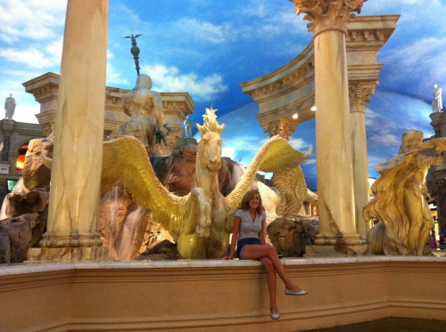
We left Caesars Palace and started heading down the Las Vegas strip. The things you see while walking down the Las Vegas strip at night! Or in the day. Did we see Alan from ‘The Hangover’ by any chance?
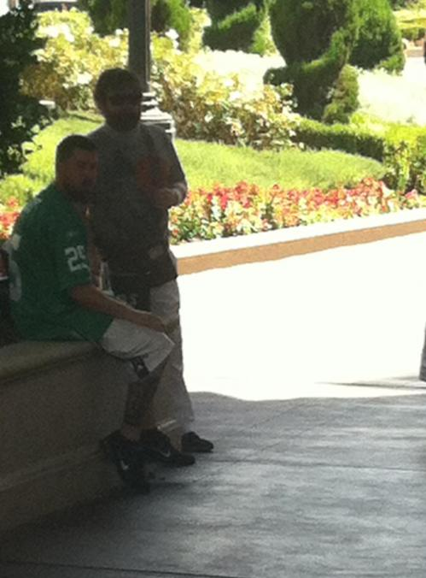
Anyway, back to my birthday night. We made our way through the random crowd of Las Vegas, and suddenly found ourselves outside the famous Bellagio Hotel. We really wanted to see the fountain show, so we went in. At this moment it dawned on us – how far we had come from Death Valley! Just the day before we were burning up in the desert and now we were standing inside this magnificent building in Las Vegas.
We strolled around for a bit, and finally decided that it was time to grab something to eat. We went down some stairs, and found ourselves outside a restaurant that looked very nice. A little bit too nice, maybe. But hey, it was my birthday after all, so we decided to try it. In these situations it’s all about confidence. We went straight to the waiter and asked for a table at the private terrace, like it was something we were very used to. Confidence my friends! The waiter led us out to the terrace, and placed us right beside the water. We were now sitting at the best table, in one of the best restaurants in Vegas, watching the best fountain show in the entire world! My eyes filled up with tears as they played Andrea Bocelli and Sarah Brightman, while the fountains displayed a perfectly synchronized show. I couldn’t have asked for a better birthday!
.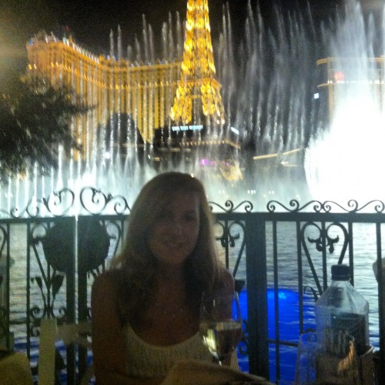
July 27, 2012 | Edit
From Las Vegas to Los Angeles!
Yes, we have now left the spectacular city of Las Vegas to continue our journey. Our next stop was Los Angeles! We left Las Vegas early in the morning, when most people were stumbling home after a long night. We did see some crazy things in the early morning hours in Las Vegas! I don’t think I will get into the details, because children might be reading this... haha!
Anyway. From one big city to another! We were really excited about Los Angeles – the city of celebrities! And I would finally get the chance to visit Elliott Smith‘s memorial wall.
When we were riding along the highway we suddenly spotted what looked like a KTM adventure bike parked on the side of the road. We drove along for a little bit, to see if the owner would catch up with us. After a while we saw a silhouette in the back mirror! This was not a Harley. It came towards us, and suddenly they were right beside us! Through sign language we understood that they were going all the way from Brazil to Alaska. They were four people on two bikes, one KTM adventure and one BMW. It was such a cool experience! Here were some people who truly understood what we are doing. We rode beside them for a good 50 miles before we all decided to pull off refuel.
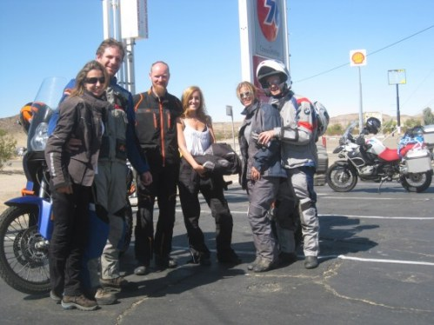
Such lovely people! They even have a blog! Check it out: http://www.comoserfeliz.com.br/
We stayed and chatted for a while, and just as we were about to leave something very funny happened (at least I thought it was funny). John was getting onto his bike, and all of a sudden it started to tip over, and before you knew it it fell! And John has been proud about not having dropped the bike during this whole journey. I guess there’s a first time for everything It was not serious, and the only thing that got damaged was John’s pannier, and that’s easy to repair. With some help from these nice people, we managed to get the bike off the ground again.
After the refuel we sat off towards Los Angeles! The first stop was Elliott Smith’s memorial wall. As we got closer to Los Angeles we saw a thick layer of what looked like dirty fog. It was smog! The whole city was covered with it. I guess it’s due to the amount of traffic and the warm weather. The traffic into LA was absolutely horrible but we finally made it into the city, and started to look for 4334 Sunset Blvd, and there it was.. I was completely speechless. This girl from Sweden had now made it all the way to the other side of the world, on a motorcycle, and was now standing beside her favorite singers memorial wall in Los Angeles.
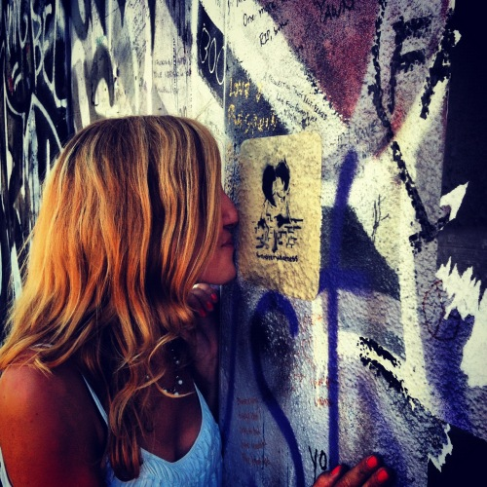
I left a message on the wall, and talked with the owner of the music shop just beside it. He said that a lot of people from all over the world come to visit this place. Even celebrities! Apparently, James Franco had been there just a couple of days ago. How cool is that?!
From one star to hundreds of others! After the wall we went to Hollywood’s walk of Fame. I must say that there are a lot of celebrities I don’t know, but we did find some stars that we were familiar with. John, for instance, found his beloved Shakira!
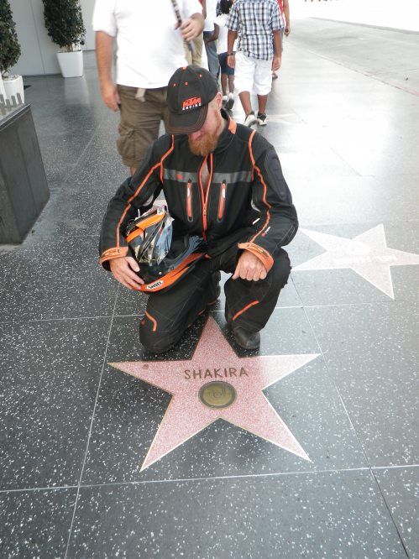
Yeah… it’s always very nice to travel with John, until he starts singing, because he always insists on singing ‘She Wolf’ by Shakira. It is not exactly what I want to hear when I’m traveling through Death Valley…
After the walk of fame, we passed Rodeo Drive. It was a good thing we drove through it, because we would have been there for way too long if we walked. All the stores! It was overwhelming. As we drove down Rodeo Drive we suddenly saw a gathering of people. They were all looking at a car which was parked outside a cafe. But this wasn’t just an ordinary car. This was THE car. The most expensive car in the world! A Bugatti Veyron.
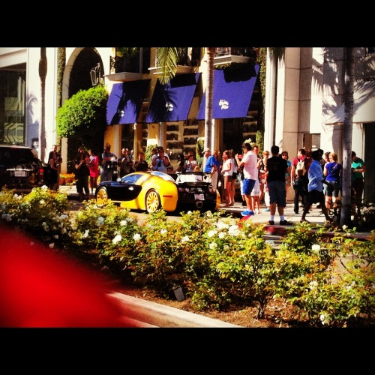
Hmm... I wonder who the owner was. Tom Cruise?
It was now getting late, and we had yet to visit the Hollywood sign. Wendy, our Sat Nav, took us through a curvy steep road, to get as close to the sign as possible. I think she did a great job! This view is nothing less than perfect.
July 29, 2012 | Edit
Days in the desert and scary immigration border control
The last couple of days have been hot, long and very challenging! We have been riding through the southwest corner of America, which means miles upon miles of desert.
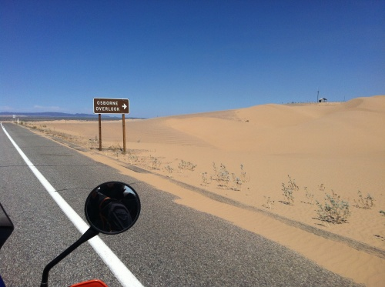
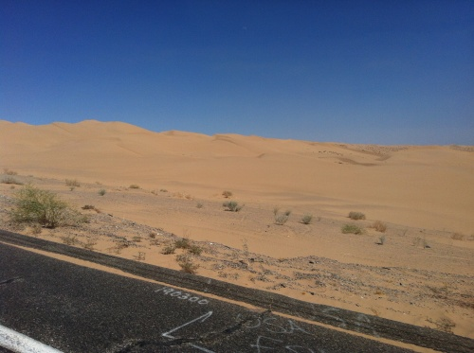
It’s been Death Valley all over again, and we have pretty much had enough of it. But to get to where we’re going this is what we have to do! That included riding through an region of giant sand dunes where John was tempted to do some of his Dakar style off-roading! Not with me on the back!
So we left LA to go to Blythe. Before we went there we wanted to visit a very special town. It is the lowest city in the western hemisphere, and it is located in the southern part of California. It’s called Calipatria, and is mostly known for three things: being the lowest city in the western hemisphere, having the highest unsupported flag pole in the world (so that the American flag will be above sea level) and consisting of a population of about 8000 people of which 4000 are prisoners.
Our aim was to go there and see the highest flag pole, and maybe see a prison or two. When we got there the only thing I wanted to see was an ice cream, water and air conditioning. At least one of my demands was met!
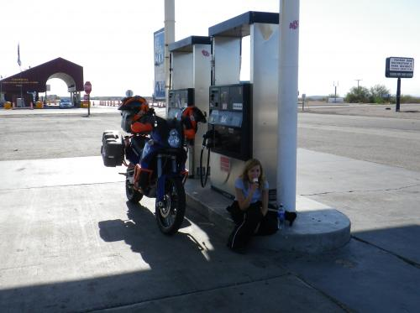
We decided that it was too hot to do anything in Calipatria, except for eating ice cream. So, without having seen the flag pole or the prisons, we drove away from Calipatria to our overnight stop in Blythe.
It was a very quiet ride, since the both of us were dying in the heat (about 43C). Just when I was thinking I had had enough, a sign appeared. It said something about ‘border control’, but I was too exhausted to care. John, however, realized that this was a serious matter, and asked me to ‘behave appropriately’. I might have to explain myself here. There are two occasions where I have no control over my behavior, and John has experienced them both here in the US. Scenario one: I’m Hungry. I will let everyone know, and I will not stop being a pain in the ass until I get something to eat. Scenario two: it is too hot. In this case it was a mix of both of them! Imagine. John slowed down, and the border officer asked us to pull over and show our passports. He forced us to pull over in the sun and get off the bike (while he himself stood in the shade watching us!). John asked me to stay on the bike and let him do the talking, but I was so scared that the bike would fall over with me on it so I jumped off. As soon as I got off I had to get my jacket off and try to find some shade. John said that I definitely shouldn’t do that, and that I should just stay there in the sun by the bike until he had talked with the border officer. I sighed loudly, and sat down by the bike. The border officer had already noticed the tense situation, and the first thing he asked John was if everything was ok with me. He was probably wondering why I was acting the way I was! Fortunately I didn’t cause enough commotion for him to inspect every inch of the bike, and after a while he let us go. I really need to chill in these situations! After what felt like two days we made it to Blythe, but I was too exhausted to write this blog post. So here it is now!
July 30, 2012 | Edit
Hoover dam; it’s a damn big dam!
We are still traveling through the desert. John said that it should be better by now, but it is worse. It’s even hot in the night time! But we will not give up. This heatwave must easy off sooner or later. Meanwhile, we will be carrying on like nothing has happened. John is still singing Shakria, and the latest edition to his soundtrack is every tune from ‘The Blues Brothers’, which however is more bearable. His excuse was that he sang to stop himself going around the twist as his right wrist was having to… The heat had caused the rubber grip on the throttle twist-grip to slip around and around like somebody had coated it with grease! John said it made the situation as daft as a spider trying to climb out of a bath. Fortunately he fixed it on one of our stops while I was buying yet more water!
We were going from Blythe to Mesquite, and on the way we would pass the famous Hoover Dam. We also passed some petrol stations, and as I always say.. the category ‘Things you see at US petrol stations’ is thriving. John spotted this:
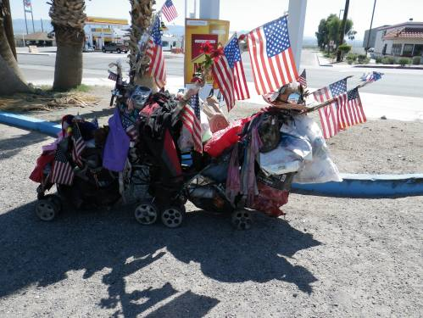
Moments later a guy pulled up with his truck and trailer:
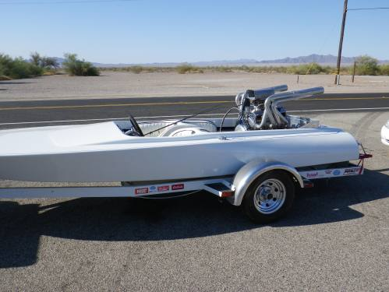
Have you ever seen such a big engine on such a small boat?
Meanwhile, I went into the store in the petrol station and bought some bullet earrings:
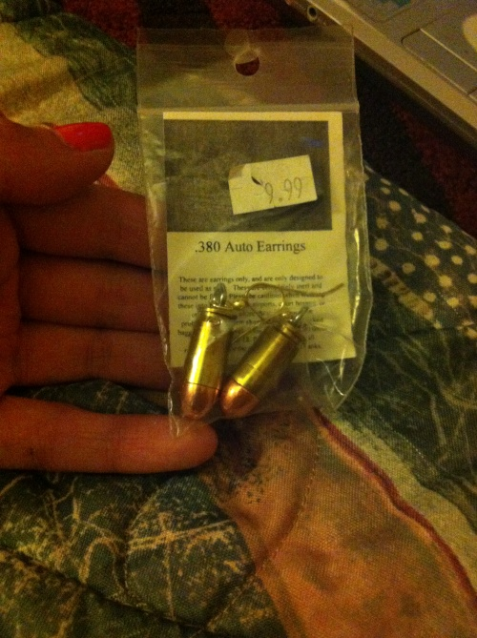
Now, Hoover Dam. I don’t think I’ve seen a dam before (honestly) so I didn’t know what to expect. We could never have imagined what we were about to see. Just look at the size of it!
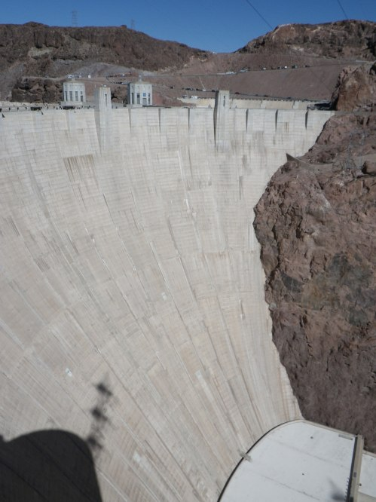
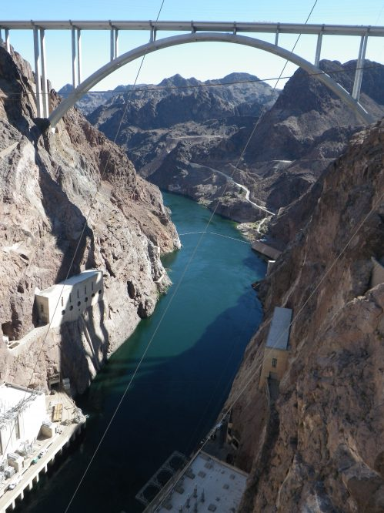
This is not a good place for someone who is terrified of heights, but John keeps insisting on taking me to such places.
We got a really nice guided tour around the dam, which included going down to the turbines inside it.
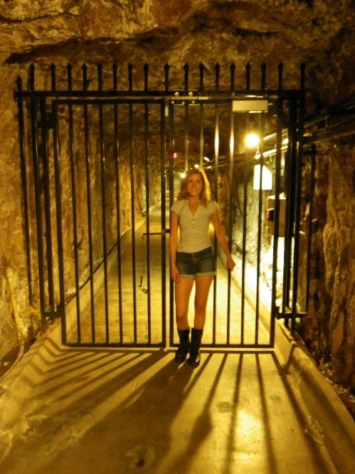
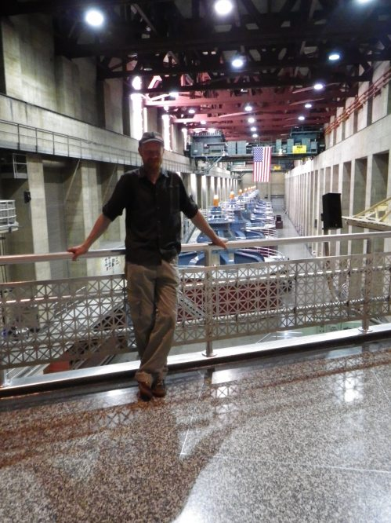
The guide was amazing! The best part was that he was half Swedish. As were the rest of the group we went on the tour with. I’m sorry John, Scotland doesn’t seem to be that big in the US! It was made clear when one member of the tour group boldly asked: ‘Is English the official language in Scotland?’
July 30, 2012 | Edit
Grand Canyon
The day finally arrived. We were going to Grand Canyon! We were beyond excited. It all started out so great. We had had a good night’s sleep for once, and felt well rested. So we went to get some petrol, and I ate a cake which I had saved from the day before. We got on the motorcycle and started heading off in the direction of Grand Canyon.
But just 10 minutes after we left the petrol station something happened. We had just entered Arizona, and I had a funny feeling that the cake I just ate was on its way up. I told John that I felt a bit sick… and then all of a sudden I felt very sick! John had to pull off right away. I jumped off the bike, threw away my helmet and made for the stones at the side of the rode. And since John is so sweet, he decided to take a photo of me being sick:
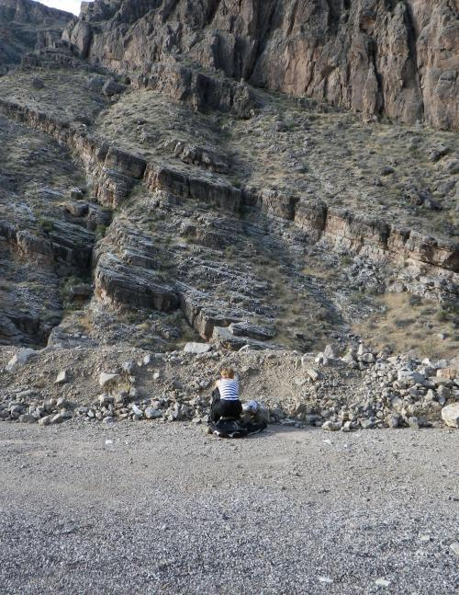
Thank you. I will always remember that the first thing I did in Arizona was to throw up! And I think that John always will remember that the first thing he did in Arizona was to watch a girl throw up, and take a picture of it.
After I was done being sick I felt a lot better and was ready to take on the world once again! We continued through the winding mountain roads. We were going to the North Rim of Grand Canyon, since we were aiming to get as far away from the heat as possible (we had been promised that the weather at north rim could get as cool as 20c – heaven!).
As we were getting closer to the national park the weather changed dramatically. Apparently it is also very common for there to be lightning storms at the north rim, which we encountered. We decided to stay by the sign for a bit, to wait for the weather to ease off.
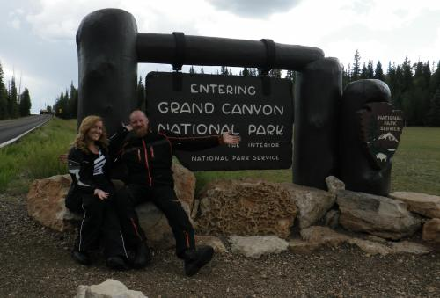
Although we got some heavy rainfall, we never rode through the lightening! And later on the weather changed again, and suddenly it was sunny. But not hot. The perfect combination!
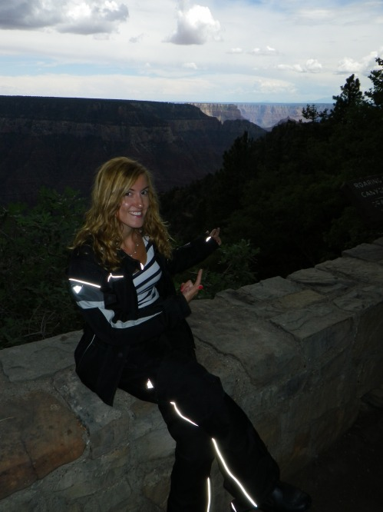
First we saw SPRING canyon, which is what you see on the picture above. I thought this was the actual Grand Canyon, and made John take about 20 pictures, until John told me that Grand Canyon was down the road. We thought that the Spring Canyon was pretty impressive, but when we made our way down the road we caught a glimpse of the real Grand Canyon…
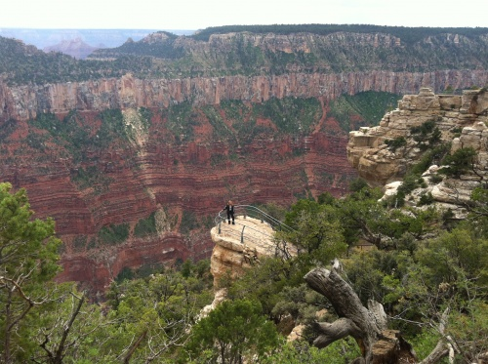
We tried to find the word to describe it, but ‘spectacular’, ‘magnificent’, ‘extraordinary’ just doesn’t cut it. We agreed that my task of trying to put this view into words would be very hard. And what can I say... We met a guy there who assured us that the North Rim is much prettier than the South one. And I think I’m ready to agree. It was like looking at a painting... It was unreal.
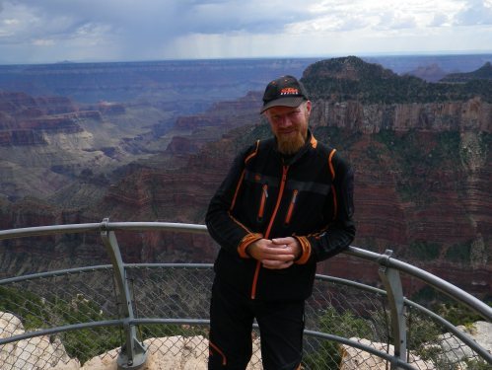
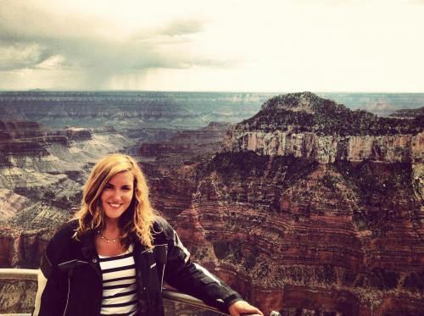
We had a great time at the North Rim! Except for all the big insects... The deadly canyon bug! Not really. It’s just a moth. It still made me scream like a little girl... which I am. So it’s ok.
July 31, 2012 | Edit
Monument Valley
Today’s main goal was to visit Monument Valley travelling through it from Arizona to Utah. This was quite a serious undertaking. Long stretches of uninhabited desert lay ahead of us. John, momentarily stepping out of his sense of responsibility, started out by riding through a hotel past bedroom doors, alongside its swimming pool and across its lawns. ‘Rock ‘n’ Roll’ exclaimed John! I managed to catch him at it on video, and even managed to continue filming when I was sure he was about to crash into a picnic bench past the swimming pool! I’ll ensure the video will be broadcast!
We did indeed cross long stretches of uninhabited desert. The most frequent signs of life seemed to be related to the protection of the Navajo Tribal Park that Monument Valley is within. The scale of the area was absolutely overwhelming. Interestingly we rode for some 100 miles across scenery that was already breathtaking, while contemplating how it could be possible for the ‘defined’ Monument Valley to be even more special.
Quite suddenly we came upon the beginning of many vast sandstone buttes. They were scattered everywhere thereafter and left us totally speechless. Some were huge, some were fabulous shapes and one was even shaped like a Mexican hat on its summit, leaving one in awe of how it had managed to become such a shape, wide and flat on top, above a skinny ‘stem’.
Here it was essential for us to try to video and photograph throughout the valley to try (hopefully) to capture some measure of what we were seeing with our own naked eyes. Right on cue our video recording system went bizzerk so we had to stop the bike where one really wouldn’t like to be stranded, while John tried to fix it. The problem (being electrical) made a good job of driving us bizzerk. I went from angry to stupid to delirious while John tried and failed to fix it, knowing that we also had yet to see if the bike would start again:
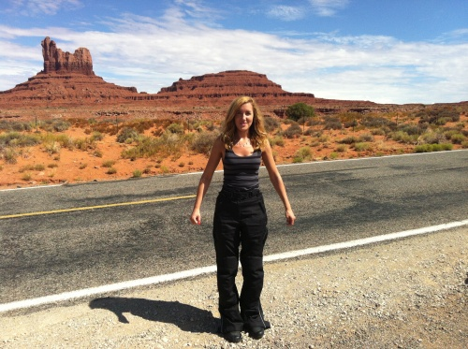
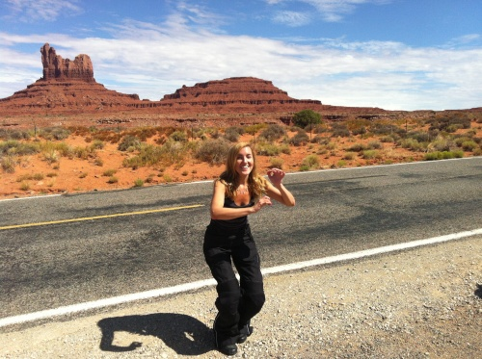
However, in increasingly irritatingly competent fashion John both fixed the camera and got the bike started again safely. You can see what I thought of that:
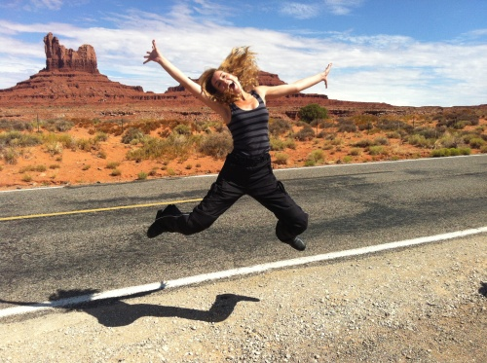
Back to our goal… We really couldn’t come anywhere close to capturing the beauty and awe of this precious area. May I offer you a couple of photos and hope that they will inspire you to come and see it all for yourself soon? You must! Its fabulous!
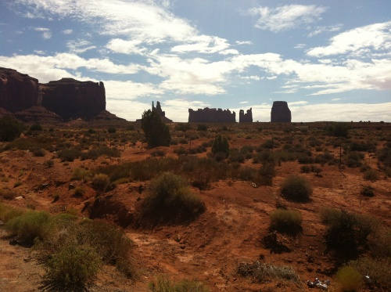
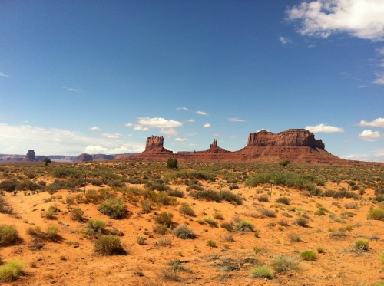
Today’s journey had to be long because of the distances between populated places. While we had the most amazing journey it was also a tough one. John was living off his pride from fixing the things he had and managing another safe day’s ‘piloting’ but I managed to bring him back down to earth by offering him a find I made in a desert petrol station towards the end of the day:
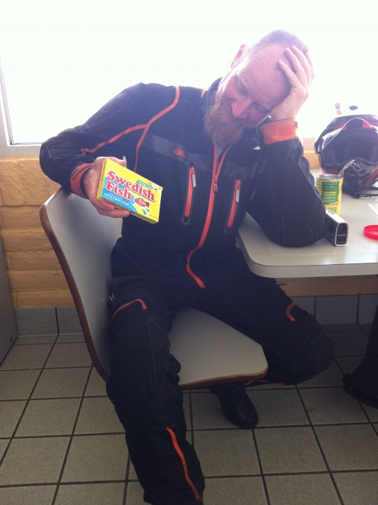
He still got us to ‘Fruita’ all the way into Colorado, 380 miles directly from his hotel patio!
August 1, 2012 | Edit
Lucy says: Goodbye for this time, America!
Wow, one month has passed so fast. It feels like it was just yesterday that John picked me up on the motorcycle at Newark, and drove us to Brooklyn. It has been an amazing experience to be a part of ‘Biking the USA’! I have done things that I NEVER in a million years thought I would do. We have driven through hot deserts and cold mountain tops and seen the most spectacular sights America has to offer. From the high, winding roads of Yellowstone, to the magnificent fountains of Bellagio, Las Vegas. We have been everywhere!
It is with both sadness and joy I leave America tomorrow to head back to Sweden. I will miss this great country a lot! All the warm and friendly people we have met during our trip will be something I will cherish for the rest of my days. Thank you all!
So, without further sentimentality, our last day of riding was better than we could have hoped for! We started out in Fruita, Colorado, and headed towards Denver. That’s not a very long distance, but as John put it: ‘We will have a little detour to visit this hill..’. ‘The hill’ turned out to be Mt Evans – the mountain with the highest road in America! See, that’s exactly what John did before we visited Death Valley as well: ‘We’re gonna go to this place.. and it might be a bit hot’. But I think it has been for the best! If I had known the extreme temperature of Death Valley it would probably have been a bit harder to convince me to go. Same goes for Mt Evans.
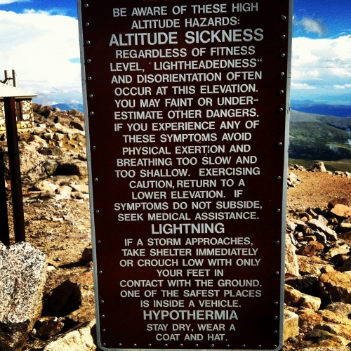
A sign at the top of the mountain..
But first things first. As we made our way to the rocky sights of Mt Evans we drove through colorful Colorado! For me, this was my favorite ride. Colorado is very, very pretty! We drove through a mountain pass with deep valleys and lakes, and high mountains.
This amazing landscape is perfect for ski resorts! We must have passed at least 10 resorts on our way. I think one of them was Aspen! We actually decided to stop for lunch in one of these places – Vail. It was the best decision so far! As we wandered around the town, we felt that we could have been anywhere in the world. In France, Canada, Italy, you name it. The atmosphere was very continental. People from all over the world had come to this place! And I can understand why. For future reference – if you want to ski go to Colorado!
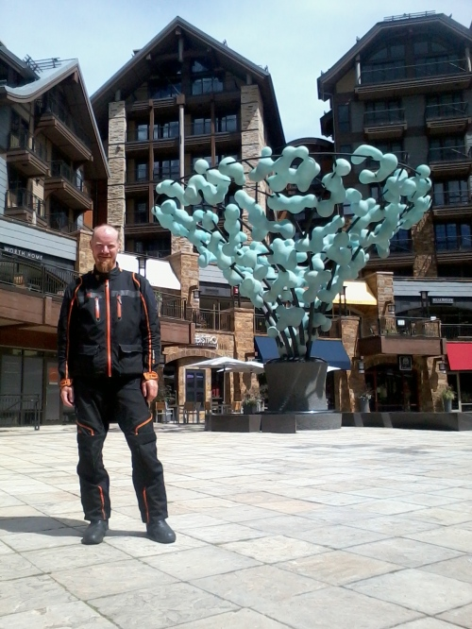
John by some artsy-looking thing in Vail.
After a great lunch we felt ready to take on this mountain! 4348m (14 258 feet) – how hard can it be?
However, we soon discovered the dramatic landscape of Colorado also had dramatic weather to match! After riding for a short while, we suddenly found ourselves in a monsoon! It was raining cats and dogs, and lightning struck over and over again. That’s not a very safe situation for a motorcyclist, so we pulled off and took shelter at a visitor’s center until the rain passed.
It took a while, but eventually John said that it looked like it was all clear in the direction of Mt Evans, so we continued. By now I have learned to trust his judgement, but it hasn’t been like that all the time! I have often given him advice on how to drive. That is; I have given a Dakar Rally expert advice on how to drive. But I’m right most of the time!
Anyway. We rode up the road towards Mt Evans, and passed Lake Echo, where I made some new friends.
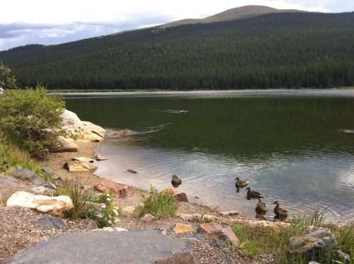
Here we started our climb to the top of the mountain. It became clear to me very early that I was in for something spectacularly terrifying. The roads were narrow, winding and in a very bad shape, and worse of all – there was no security fence!
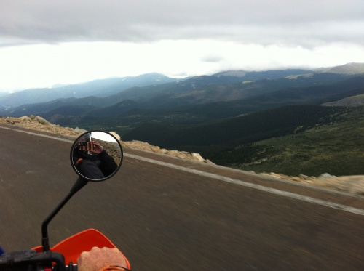
You could just drive off the edge and fall for miles. Fun times! Especially when we went down again, and the weather changed to this:
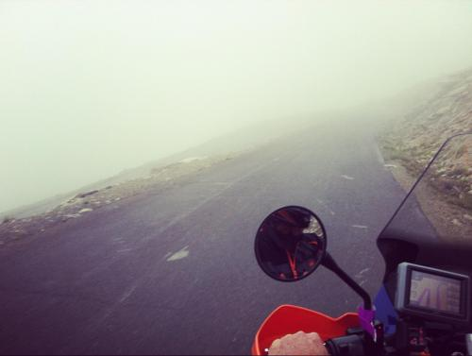
Imagine an edge somewhere in the fog, and if you go over it… you’re done. Great.
But we made it all the way to the top! What a feeling. We had to climb up the last 400 meters, but it was worth it.
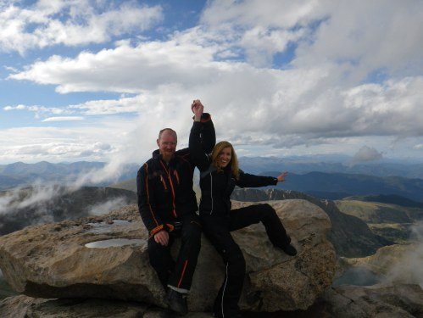
This was by far my proudest moment of ‘Biking the USA’. For me, the trip has been about overcoming a lot of fears – and this was the high point! Never in my life would I have thought that I was capable of something like this. But an important lesson has been learned: Fears hold you back. Let go of them and just live! You can do it!
And with that said I just want to thank John for putting up with me this month:) From now on you will get blog updates from John himself! I’m sure he will do the blog justice, although I can’t promise it will be as good as it had been so far
August 2, 2012 | Edit
Part 2
Part 2? Yes Biking the USA started part 2 today, the biking has gone solo, although the team is still in action. Lucy had to fly home as planned today to get on with other projects while I (John) will continue riding all the way to New York while trying to keep the photography, filming and social media going with help from Lucy remotely.
Lucy & I had a day in Denver yesterday which we spent mainly on the 16th street mall. Lucy bought some new clothes so she wouldn’t be ejected as a vagrant from Denver International Airport before her flight. I simply had a nice time enjoying seeing the mall and catching up on good eating! The atmosphere and facilities reminded me of Edinburgh’s city centre areas and I seemed to blend in invisibly. Not having my motorbike with me and just dressed normally I was quite unnoticeable. That was until a toothless character spotted my KTM cap as we rode a bus together. The cap prompted a conversation to evolve and when my new friend got to the question about where I am from, when I replied Scotland, he immediately returned ‘ah, I’m a Murphy, my family name is Murphy!’ and held his hand to his heart. Just as I was beginning a smile of satisfaction on the basis that I had last bumped into a Scottish connection he continued… ‘born in Stockholm, Sweden before I was adopted!’! LUCY! WHAT’S WITH ALL THIS SWEDISH STUFF!
I retired to a cafe for some comfort food and to cool off a bit (well, it was really hot!). Sat on a window/counter-stool I had the devilish delight of people watching all the busy city workers run for cover when the most unbelievably sudden and monsoon-like shower hit! Instant rivers in the roads and instant giant splashes on pedestrians as the traffic sped by! Good fun!
07:30 this morning Lucy and I had to say goodbye to each other so I could get going on Part 2. It was a terribly sad goodbye. Really awful. I left Denver on a motorbike suddenly empty of that companionship that had been glued together for 8000miles. Really really awful.
I had to get fuel right away and I just got on with that, alone, really wanting to get going at high speed fast, to psychologically put the sadness behind me. As I was filling another toothless character approached on a mountain bike and opened with ‘Great Britain?’. I really wasn’t in the mood to have a conversation so I didn’t encourage much to flow but I was quite impressed that he’d interpreted my nationality as British. After fine tuning the identifying process (in which he learned and understood my home is about 70miles north of Edinburgh) he told me he was from Stockholm, Sweden! Now I really really had to get going!
13 miles of traffic lights start the I-70 East out of Denver from where I had stayed… Stop, accelerate up to 30mph, slow, stop and repeat dozens and dozens of times. The bike was even more eager than ever to flash up to 75mph and help me sense that getting-away and moving-on feeling. It was feeling even more free and sprightly without the (tiny) weight of Lucy and her luggage. It felt very strange, like I had forgotten something incredibly important but couldn’t think what it was.
We all talk about ‘sense of direction’ and I guess we all have some sort of ability like pigeons to know where we are and what direction to go. We’re just nowhere near as talented as pigeons are, of course! I say this because I think a lot of my interest in long-distance overland travel comes from my own ‘pigeon’ sense which I can tell you I actually feel very strongly. I can’t explain it, but I can certainly feel it and love the feeling of travel across our planet and love how vehicle tyres revolve and push me forward to new experiences. I needed that kind of feeling to take over and help me deal with missing having Lucy with me.
Finally the road became junction-free and the 75mph speed limit appeared. In a flash the KTM had me at 75 again and took me on into Part 2 of this amazing experience. I put on music and out sounded ABBA’s ‘Take a chance on me’. Lucy and her loved ones had entrusted me with her safety for 8000miles and I was really proud that I had managed that. I was also really glad that I have this fantastic motorbike – one of the best vehicles in the world. We had 3 ‘feature’ scares but the responsiveness, power and general capability of this machine had certainly played a key part in keeping us safe, along with its general reliability and strength. Yes we have had three problems with the bike so far. First the leaking fuel – caused by me, not KTM. Secondly it wouldn’t start – caused by all the extra electronics we’ve put on the bike for the filming etc, not KTM. Thirdly the throttle grip started slipping – caused by the after-market heated-grips fitted, not KTM! Now what about these 3 ‘feature’ scares? The first as a black BMW with blacked-out windows nearly side-swiping us in LA – tearing through the traffic going for gaps that were not enough – especially the one we occupied! The second scare was an exceptionally surprising blast of wind that hit us instantly, totally ‘out of the blue’, where there had been no wind at all. It was actually like there had been a roadside explosion – both our helmets were nearly blown off our heads and their chin-straps tried to pull us off the seat by our necks! Again the fantastic responsiveness of the bike allowed me to throw the bike into the wind fast enough, despite the load, to stop us being blown over. The third scare was a sharp-edged brick on a road, right on our riding line, when we were riding at 75mph – it was hidden by other vehicles until we were upon it and once again the responsiveness of the bike, despite its load, made sure I was able to miss it. Cheers to KTM!
I worked hard for the first 100 miles or so today to get my mind more on what was ahead than missing being able to share the experience with Lucy. When I pulled in for my first fuel stop I happened upon the most magnificent finds! My luck was in!
First I saw a pink car perched high on a post – a car from the 70′s with ‘Diner’ painted on it – looking really iconic. Then beside it I saw a delivery truck for ‘Budweiser’. It looked simply fabulous. In fact I would not have been surprised if a camera crew appeared and used it to make a commercial! Next to that were two fabulous American trucks with the very square engine covers and loads of chrome, both ‘Oversized Loads’ piled high with hay. Beside them was the ‘holy grail’ – the most utterly iconic ‘Diner’ I could ever have imagined. It looked like it had just been built to film the movie ‘Grease’. It seemed too good to be true but in fact it was real, genuine and fully functioning! Perfect! Oh, and it had free password-free wifi too! Perfect place for a late breakfast – two cups of tea just how I have them at home, French toast and ordinary toast. Yum! I got a few photos but only video of the Oversized Loads (you’ll get to see them soon!). While taking them I noticed the pink car was actually revolving and had a turning ‘clockwork’ key turning on its roof! Perfect! Check it all out:
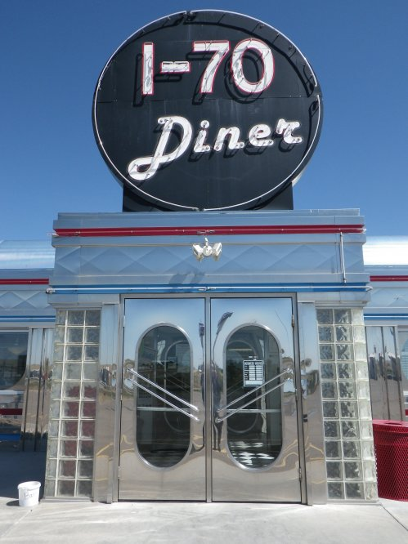
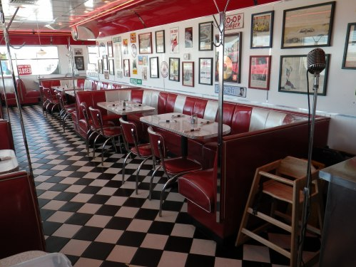
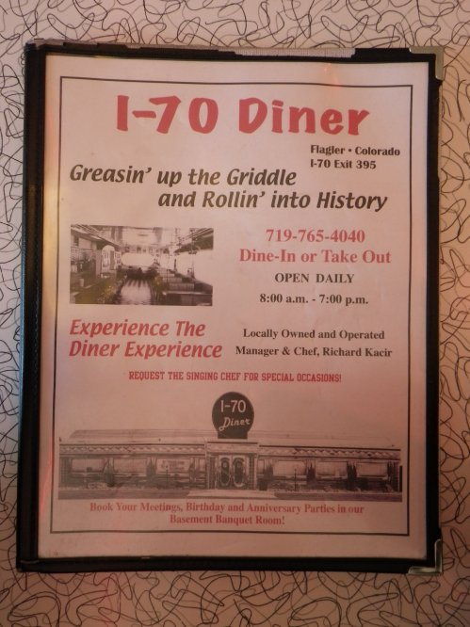
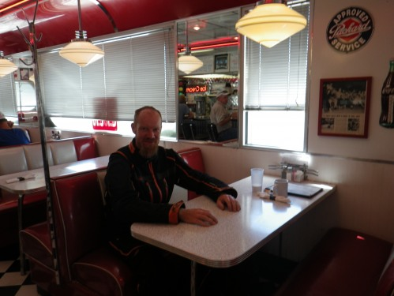
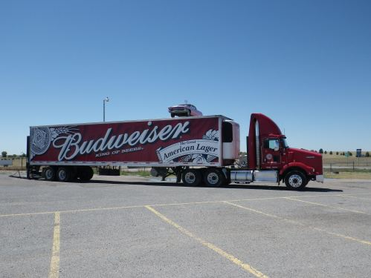
After that I had to get on into Kansas, former home of Buffalo Bill and birthplace of Amelia Earhart. My altitude dropped very slowly as I sped East through flat dry lands of dried-out brown grasses, before continuing in the same scenery south towards Oakley. I learned that Kansas has a population of a mere 2.8million and that the state was suffering from a drought and prolonged record-breaking heat wave. It became extremely hot again but I made it to Oakley OK. Now the sun is going down but it is still 37C!
August 3, 2012 | Edit
Buffalo Bill sends John to follow a Yellow Brick Road and find the way to Amarillo
I got going super-early today, just as the sun was lightening up Oakley in Kansas. I went straight to a tribute to Buffalo Bill and made a photo that I later noticed put me in a position that indicated I was about to have my head blown off! Knowing I would enter Texas today I wondered if this was a spirit warning that I would have my head blown off before the day was done. Well that’s what happens in the movies doesn’t it?
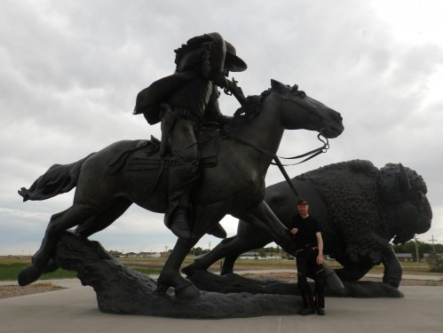
I started early today because I know I will be heading through a vast hot-zone (down into Texas) and want to get my body clock moved so I can ride in the earliest hours when it is coolest. I had not got to bed early enough last night so in no time at all I had to take a break from the riding after I noticed I was being sleepy. Fortunately this led me to come across some appreciation of GB, after all the Swedish worshiping! I found a Diner proudly displaying 3 Triumph Bonneville motorcycles. Brilliant machines built just before I was born, and still able to be the machines of choice for a ‘Biking the USA’ trip. Light, tough, powerful, simple and designed with a passenger in mind:
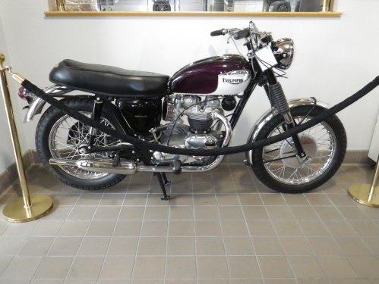
Then I found another British classic that was built just before I was born. It pulled up beside my motorbike in fact:
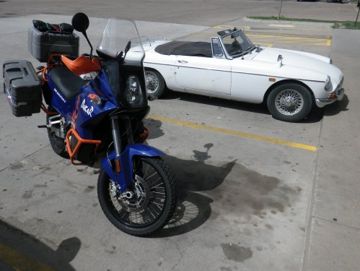
Excellent! I was doing well today, in a good mood, helped by the music I picked out – Johnny Cash, Bob Dilan and The Doors. Also helped because I had some contact with Lucy today. The temperature soared seriously high again – 40C! Such a temperature report is of course reporting the temperature in the shade, and today as usual there was no shade – just hundreds of miles of flat farmland. Dead-flat, and dead-dry. Heat builds up in the road and literally cooks anything on it while also reflecting the sun’s radiant heat. Meanwhile air at 74-84C pours out the sides of the motorbike right onto my shins, straight from the motorbike’s radiator! I actually had quite a laugh trying out lots of different poses on the motorbike in order to maximise cooling of me, or at least work on different areas. It was hard to make much difference though – the heat was so intense it was a situation in which you actually remained coolest by being covered! Usually I ride with my visor up but today it was actually cooler to ride with it down, such was the furnace like feel of the air. Ultimately I mused about writing a book called ‘Yoga for motorcyclists on the go’!
I couldn’t help being jolly though because I was foolishly chanting ‘I’m off to see the Wizard…’ etc. and looking forward to being on a Yellow Brick Road. Yes, I was heading to see the fictional location of Dorothy, and all associated features of ‘The Wizard of Oz’ which apparently is the most watched film ever!
I did find The Yellow Brick Road and it I rode on it right up to Dorothy standing by her (grounded) house:
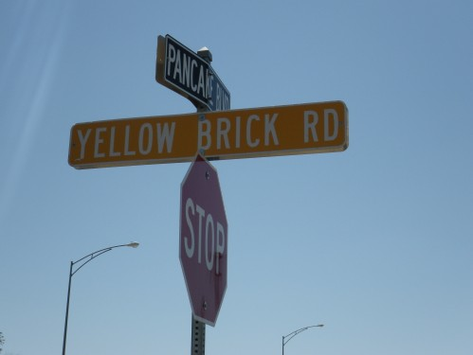
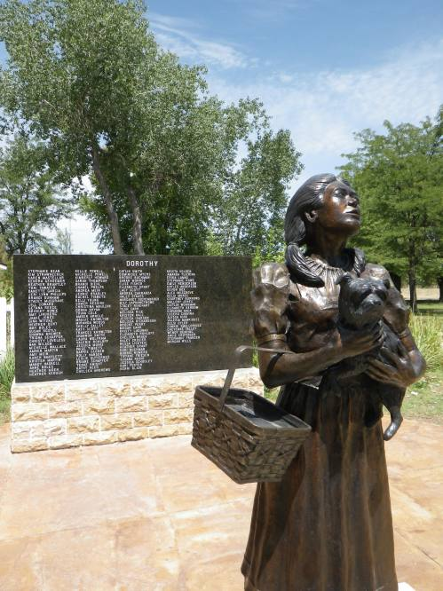
Inside I was thrilled to see the model of her house hung on a string and spun to film the tornado sequence in the movie:
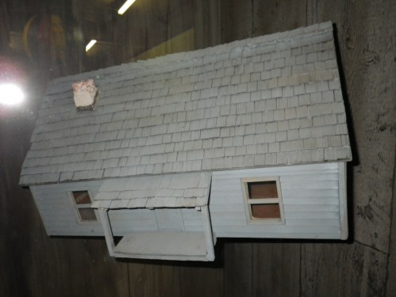
From there I headed down to Amarillo by slipping through Oklahoma into Texas. You can imagine the rest of the singing (?) that went on inside my helmet as I motored there in the heat, probably going a bit doolally! I made it though and now want to try to get to bed a bit earlier, so, goodnight ye-al’!
August 3, 2012 | Edit
De dee, de dee, de dee dah dah doo…
Today is really all about getting ready to hit Dallas. So, I’m on my way to stop just short of Dallas ready to go and see some very special sites and a very very fun place just outside the city. I’ve been looking forward to the ‘fun place’ for a long time, and now that I am on my way away from Amarillo I have started ‘de dee-ing’ a very well-known tune as I motor along. That’s helping me stop singing ‘the way to Amarillo’ too!
Today certainly isn’t missing some special experiences though, I’ve been to Cadillac Ranch already and done some Bill Posting:
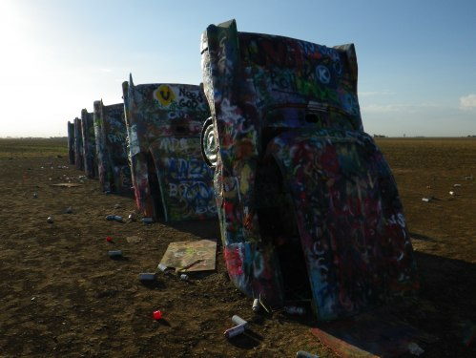
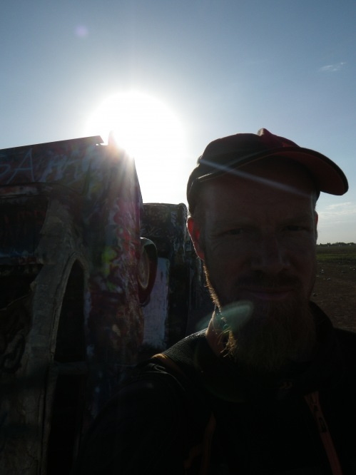
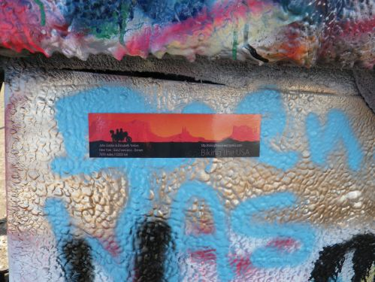
Later I got engulfed in a convoy of Italian tourists on hired Harleys and enjoyed the novelty factor of riding such a different machine uniquely among them. I also enjoyed seeing and hearing their reactions when they learned I was alone and on such a huge journey. They had a guide and were only on a small trip. They were all getting shaken to bits by the vibrating the Harleys are famous for. I wondered if any of them would like to continue with me to New York!
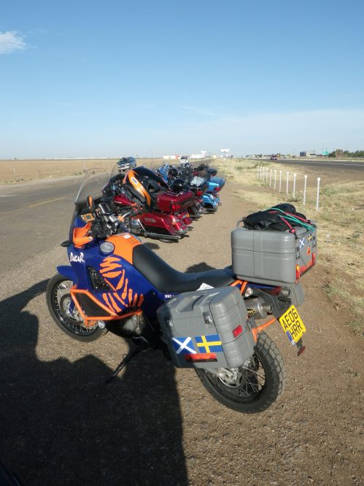
The next stop was at an amazing place I could see for miles before I was anywhere near it – a cross 61m high and a sculpture park representing the crucifixion of Jesus Christ:
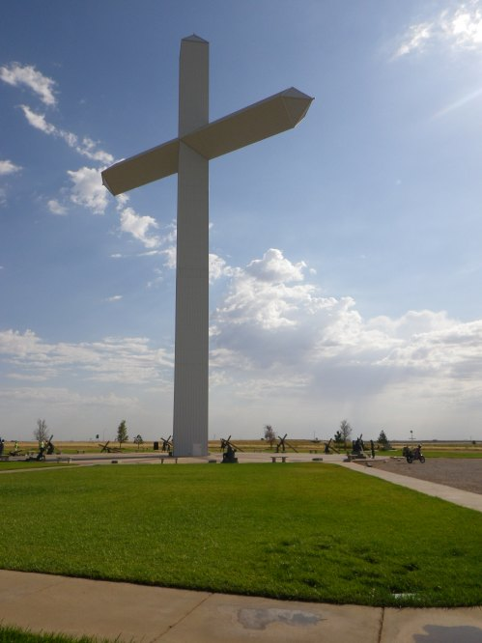
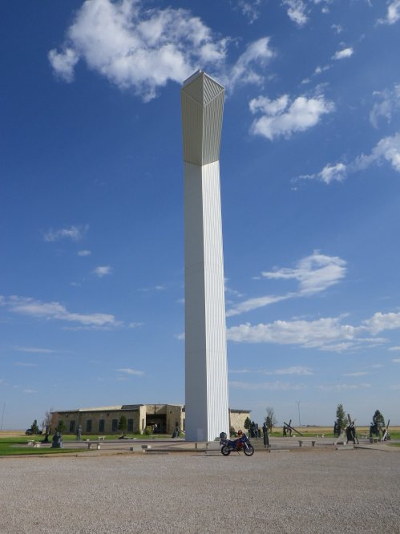
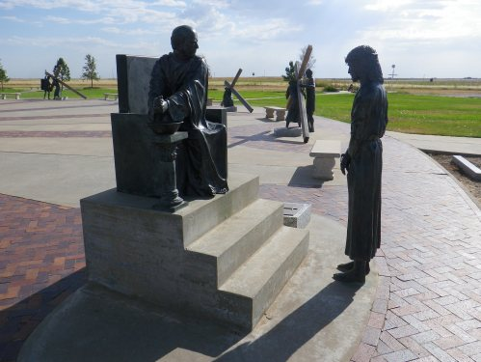
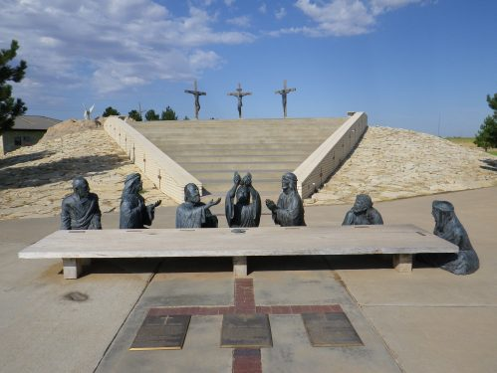
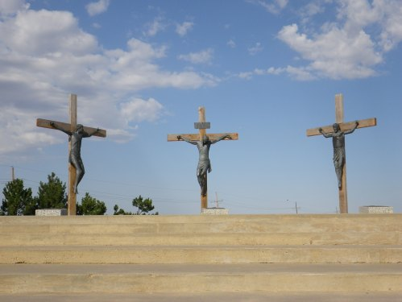
Moving on from there I managed a good 70 miles before a stop to take a break from the heat. I found a new friend who again was curious about KTM on my hat, and I was warned about other strangers I might meet:
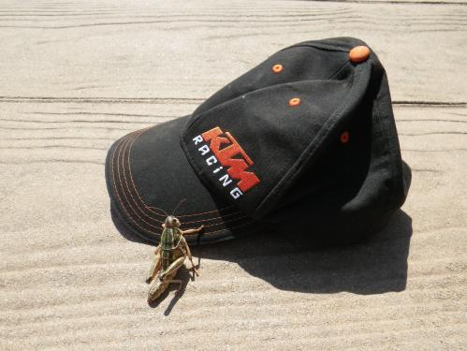
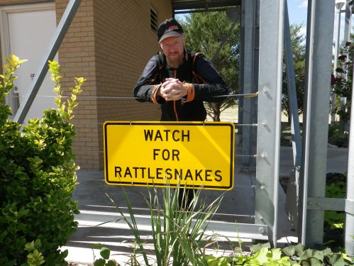
Got to get going now. More later today…
August 3, 2012 | Edit
Big state, big heat.
47C in the shade today. The shade had to be manufactured with one’s own body! There was no shade! Something about today made it the toughest day so far. I think it must be because the humidity was higher down here in Texas. Today really was a struggle! After the visits this morning I covered about 270 miles across flat furnace-land. I had to press on though because I need to build up some chance of motoring really early in the mornings, and also some time to have at least a full day in one or two places to come. I think part of the difficulty today was being so soaked in sweat which wouldn’t evaporate…yuck!
By 17:30 I was in a cool motel and could put all the discomfort of the day behind me and reflect on the great morning and look forward to tomorrow. Ooo I am so excited! Really, I have to laugh at myself! You’ll see why tomorrow!
August 4, 2012 | Edit
Sad & Surreal
I went into the centre of Dallas today, very early, before the city was stirring. I wanted to spend some time around the place where President Kennedy was shot (the Dealey Plaza), when I could have peace there and when it would not be too hot. I feel I have a connection with his impact on the world because I started out my life in the USA right after his period of history and because I love the ambition that was generated to ‘go to the moon’. I did not think I was going there to be nosey, and indeed I found I could visit out of respect. It was a great experience.
Dallas:
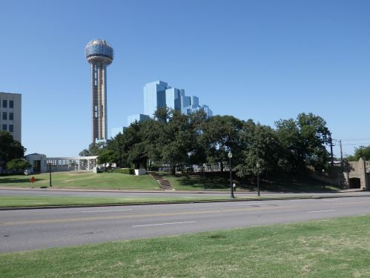
The Dealey Plaza:
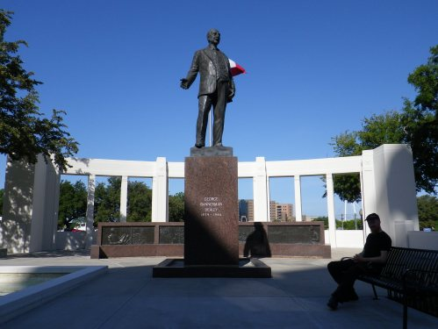
The Grassy Knoll:
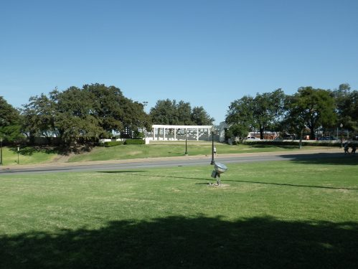
The former Texas School Book Depository:
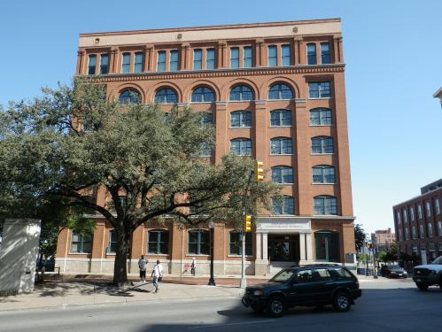
The Kennedy Memorial Plaza:
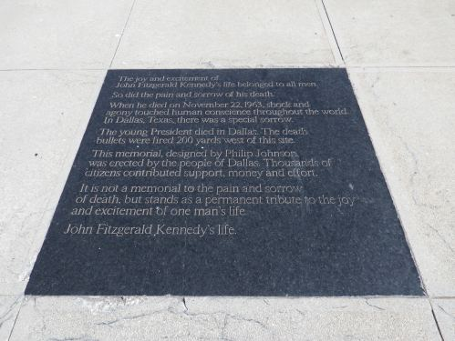
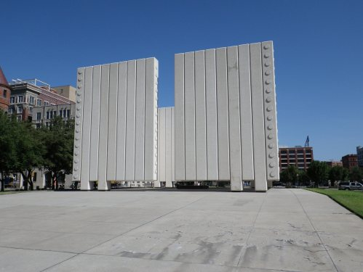
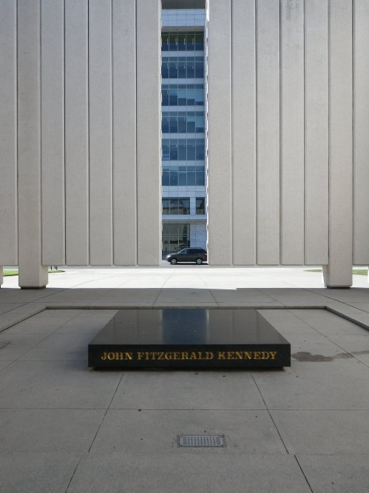
It had become so hot and humid already before I left Dallas I actually played with the idea that I would not wear my motorcycle jacket – just a T-shirt instead. That was a measure of the humidity level. I was drenched in sweat, even standing still in a T-shirt in the shade. After considerable deliberation I swopped my T-shirt for the motorcycle jacket and rode on, properly dressed for riding. I was pleased with myself for still keeping safe, and, I was managing the heat.
Now it was time to start singing again, or rather humming. I had felt quite sad at the Dealey Plaza and the prospect of my next destination, only a mere 30mins ride away, had me beaming and laughing at myself while I hummed a theme tune… Yes, I was going to ‘Southfork’, the Ranch that was the basis of the 80′s hit soap series ‘Dallas’!
Now I have to say I DO NOT watch soaps, but, er…but, when I was in my teens, in the 80′s, I did watch Dallas. It was a family routine. Really! Everyone does need to have some ‘brain-dead’ time in each day, don’t they? So, my mum, dad, my sisters and I did ‘tune-in’ to Dallas every week when we lived in South-West Scotland and watch each preposterous episode, keenly! Suddenly, equally preposterously, I was riding my motorbike right to the gate of Southfork, entering and having the ranch to myself, as if I owned it! Hilarious! Absolutely hilarious and completely surreal!
If you have watched or watch ‘Dallas’ you’ll get the idea. If not, check out some photos of a real and lovely ranch:
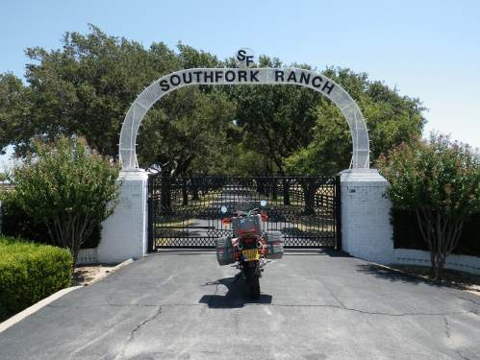
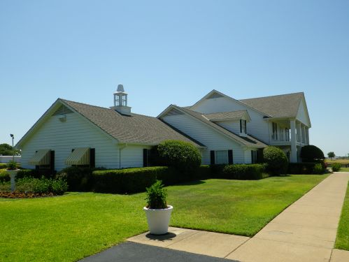
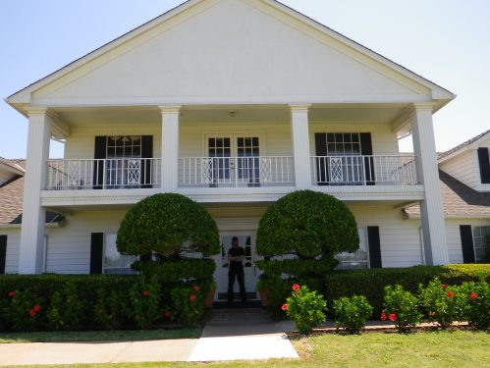
JR’s bathroom:
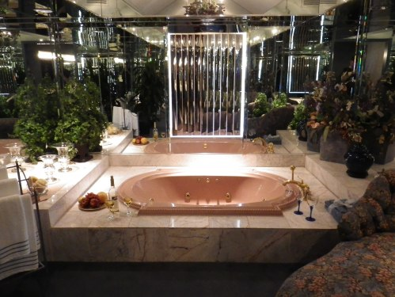
Oh I so-want to bomb off this balcony!
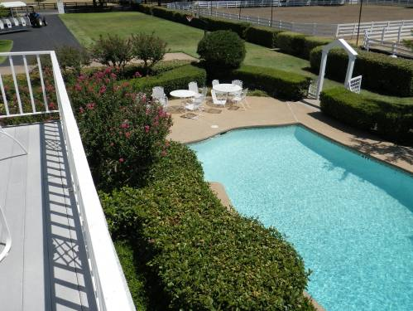
Remember all the pool scenes?
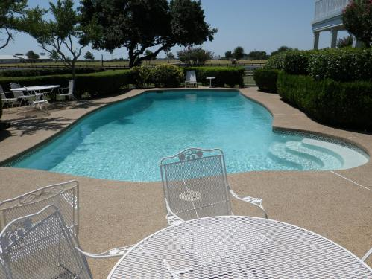
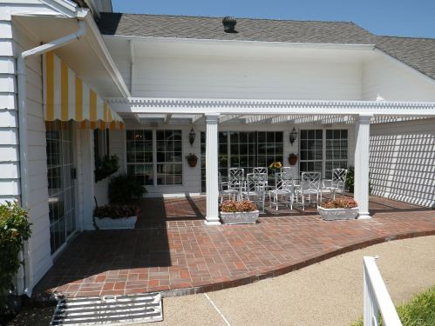
I have no mid-route destinations planned for tomorrow so I aim to get to bed very early tonight to do all my riding in the early hours of the morning tomorrow, when it is cooler! I better get going now though, right in the heat of the afternoon!
August 5, 2012 | Edit
Phew
So the afternoon turned out to be torture. Burning sunshine combined with unrelenting heat and heavy heavy hunidity. Its all the news here at the moment. Records being broken, everyone being warned, etc. So I made it to my hotel in shifts of 30-60 mins riding at a time. Spending long periods in the ‘shelter’ of air-conditioned living in-between. Phew. I was absolutely soaked in sweat and there was no relief. Wind-flow made no difference at all. Phew it was hard going. I managed to continue to resist the temptation not to wear my protective clothing and made it to my hotel for 8:30pm. Once checked in and so-on I wasn’t very happy with where I was able to park my motorbike. I phoned reception to ask if I could park it right outside the entrance where they could see it from above. Kindly they said that was fine, so before resting for the evening another job was to go and move it there. After I did they told me that, actually, it would block other arriving guests! Heck! But!… They suggested I bring it into the hotel!!! Were they serious? Yes! I set straight to is but as I walked to my motorbike I tried desperately to map out the route in my head without looking back. You see, I thought the only way to do that was to ride up some stairs! Did they really mean that? Was that the only way? Yes, it must be! I didn’t want to give an opportunity for a change of mind, so I didn’t pause and look about, or set up a camcorder on a tripod to film what I was about to do… I got on the bike, started it and immediately set to going up the stairs! Nobody rushed to me waving frantically to stop, and I could not see another other way (out of the corners of my eyes), so I went for it! Rock ‘n’ Roll! Rock ‘n’ Roll I say! Thank goodness I was on this KTM! I wish I could show you it! Hilarious! At least I can imagine Lucy imagining it – she’ll know what it’d be like! That’s good enough for me! Got to head for New Orleans tomorrow… Better get off to bed. Goodnight. John, rock-star.
August 6, 2012 | Edit
ZOob a do be dum de z z z dah da doo… y-e-a-h…
You have got to visit New Orleans! Don’t tell me you’ve been there before! Go again! What a fabulous characterful unique gem of a place. How was it that it flooded so badly? How was it that it seemed neglected at that great time of need? How is it that it has recovered so brilliantly? Well done New Orleans! You are amazing!
I was pretty amazing too (ok ok not quite as amazing as New Orleans)… I managed to get into New Orleans by 2pm after a 345mile ride. I only got pretty hot in the last hour or so because for the rest of the time the sun was hidden by clouds! Brilliant! So actually, it was only about 35C tops, and although it was certainly humid, it was more bearable.
I was pretty worried about staying overnight in New Orleans, in terms of the motorbike’s security. So, I had reserved a room in a hotel I selected largely by what I thought the parking arrangements would be. As it happens, I actually found something absolutely brilliant! The entrance to the hotel was really easy to get to and there were a plethora of patient Valley-staff who already had it in mind for me to park in the entrance, and monitor the bike 24/7! Luggage sorted easily, checked in swiftly, and within minutes I was in my hotel room. Moments later I developed a sickening worry that someone would suddenly realise a terrible mistake had been made! That’s because the price of the room was ridiculously low for what I was getting, coupled with the standard of the service! What luxury! (So well deserved might I add, given the struggle to ride here! ). This hotel was also right beside the most coolest heart of the city. I had really hit a jackpot here. What a lovely treat for me after all the hard work getting here!
Check out these photos of my room:
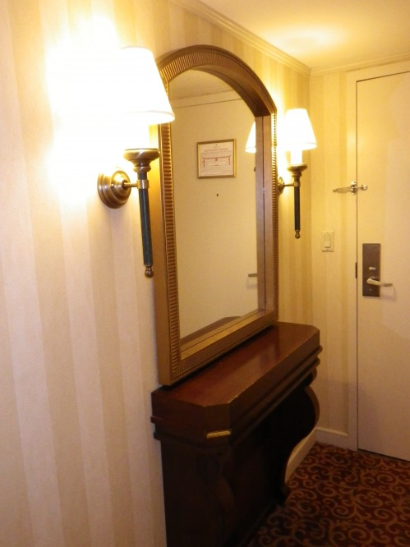
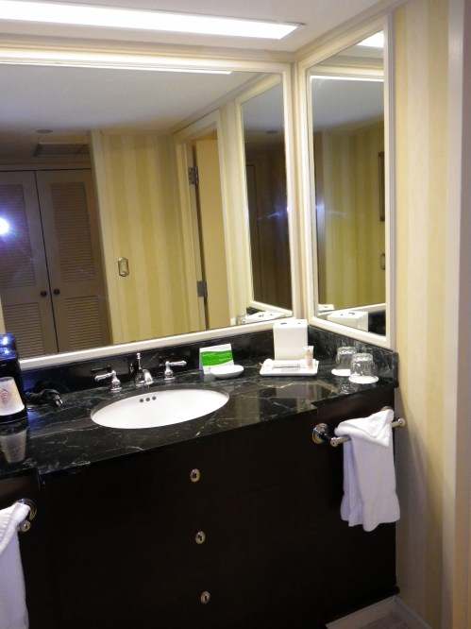
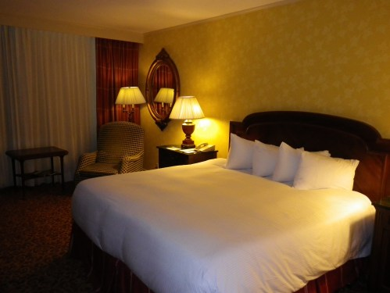
So I was able to relax and refresh nice and early on before hitting the sites. I even cut down my beard which was keeping me too ‘cosy’ in the recent humidity!
Now then, today was the final day of the Lewis Armstrong festival. I was here at exactly the best time of the year for experiencing the best of New Orleans culture. I got straight out to immerse meyself in it and already loving the manner of the people I had already met I set off in a really boyant frame of mind.
Immediately I was seeing and hearing the most fabulous things. What a city! The coolest jazz music playing in the streets, here, there and everywhere. The coolest people hanging out. The coolest landscaping and architecture. The most amazing and giant number of shopping opportunities (steady Lucy!). Actually, if Lucy had been here I don’t think we would ever have left! All the shops, all the music, all the city sounds and cool hang-outs! Its a Lucy-trap! Lucy beware! Don’t ever come here!
There is absolutely no way I can convey New Orleans in this blog in a way that really show’s what it is. It is definitely a case of ‘you had to be there’. I can at least show you a few photos:
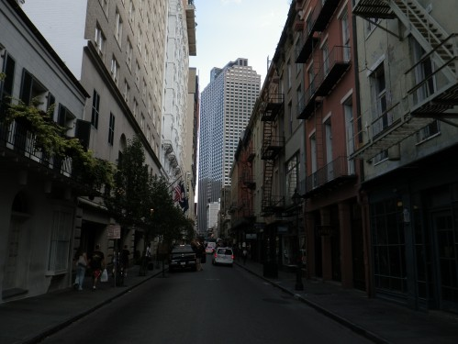
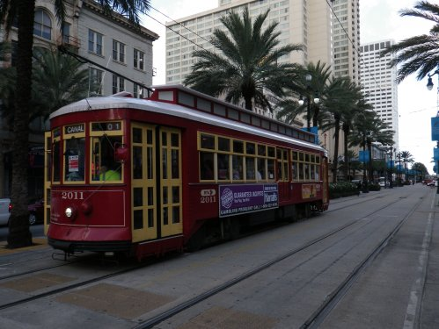
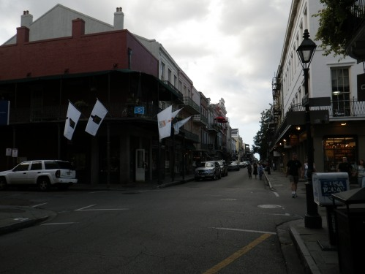
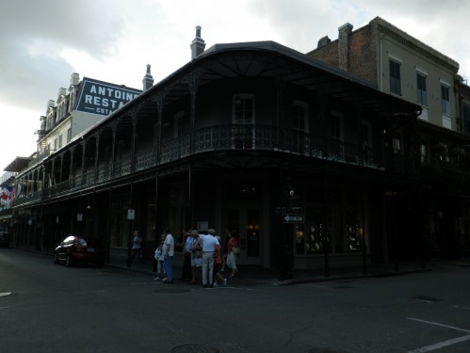
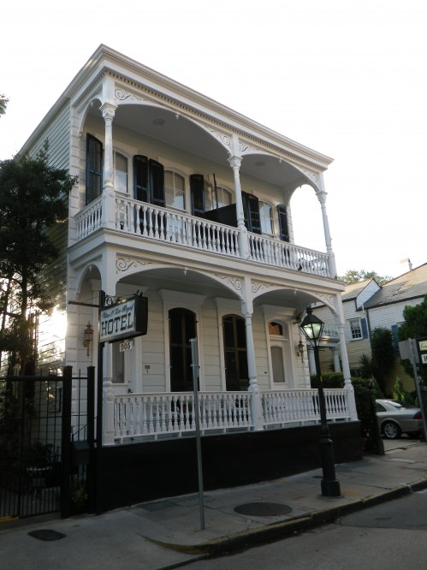
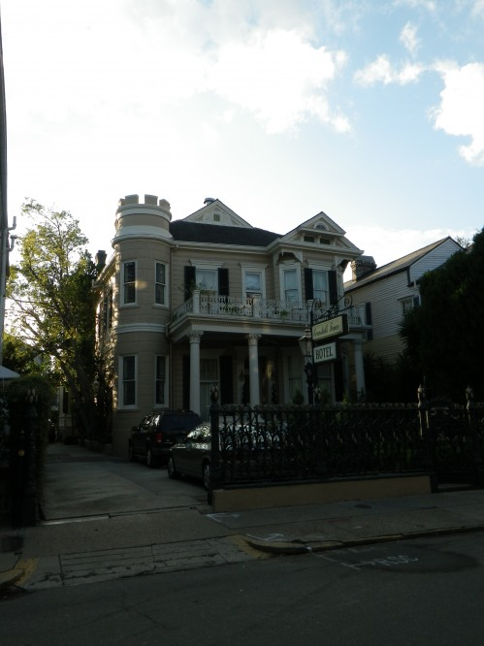
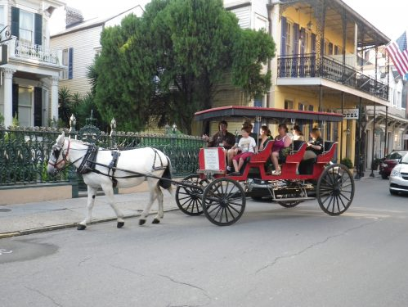
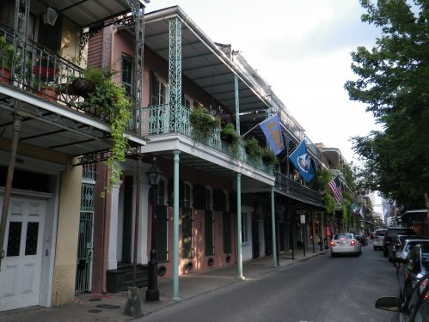
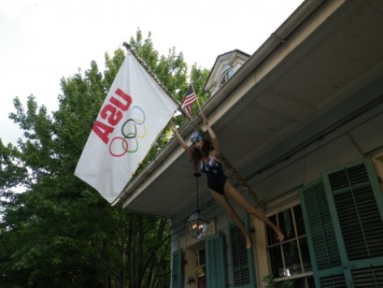
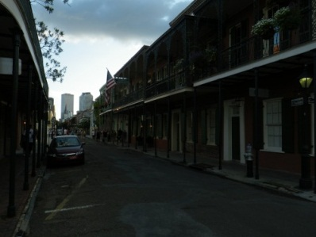
Apparently this is one of Brad Pitt and Angelina Jolie’s holiday homes!
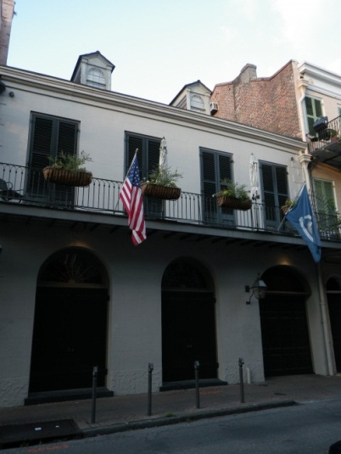
August 7, 2012 | Edit
Lovely en-route
All I thought today would be is a long hot ride to head to Memphis. Wrong!
Really today I just expected a long and straight-forward ride towards Memphis, directly from New Orleans. As it turned out I had the most lovely time with the riding. The whole route had great lush green growth everywhere, including the most fabulously varied and wild trees. The trees lined most of the route, as edges of huge forests, and probably contributed to helping keep the temperature down.
Coming out of New Orleans I passed the Mercedes Benz Superdome and huge stretches of raised highway that were both big features of the media coverage of the recent devastating flooding in New Orleans. I was highly impressed but wanted to know more about the circumstances of the flooding. I am still very puzzled about it.
Yes, the temperature was fine today. Even when stood-still it was quite bearable. Lovely. The roads were in great condition and generally sported 70mph speed limits. With some good music on the travelling was swift and I was very happy. Better still, I managed to share my lunch with a policewoman and shared my dinner with a young ‘All American’ Football College student, and I had a lovely conversation with a lady who I thought sounded just like Dolly Parton! What a treasure! I loved listening so much! I also motorcycled through a very heavy rain-storm. It was very cooling and very welcome! I loved it all! Brilliant!
I have planned and organised tomorrow and am super-excited about it. I just hope it all works out because it is rather special and arrangements are tight. It also means I have to start at something like 04:45 tomorrow! So, if you’ll excuse me, goodnight!
August 8, 2012 | Edit
The King of days
Yesterday was an enormous day! So gigantic that it was impossible to update this blog until now and even then I can only summarise what was involved until I get more time later today to write more.
I started out in Grenada, Mississippi. I had made a special arrangement to visit Elvis’ grave beside his Graceland Mansion in Memphis, alone, free from all the tourist traffic at Graceland. To do that I had to be there at 07:30 and Memphis is 90miles from Grenada. So, an early start yesterday morning.
My time at the grave and at Graceland was fabulous. That in itself is a big story. I can tell more later.
After my visit to Graceland I shot off to Nashville to see a concert at the legendary Grand Old Orpy. That was fabulous. It really blew my mind! Brilliant. More of that later too!
I went to a party after that to round of the day and start the next day (today) my usual routine has been knocked out of place. Fortunately I only have to ride a short distance today (good planning eh? ) so I’ll manage that now and add more to the blog later
August 9, 2012 | Edit
Extra, extra, read all about it! The King of days achieves 10195!
So I promised to write extra about yesterday, tonight. Were we are:
Yes I went to see Elvis’ grave yesterday morning. In fact, as arranged, I checked in at Graceland’s Gate, turned in my camera kit etc. and then made my way up the driveway (on foot) right up to the front door, all alone and without another soul in sight. It was an amazing experience, a fantastic privilege, very very special indeed. At the house I went around the right-hand-side to Elvis’ grave (outside). I’m merely interested in Elvis, and yes I certainly enjoy his music, but his life and times are not especially important to me. I do however have a huge amount of respect and admiration for the feature that Elvis has been in this world. I feel sad for him and his family, and for all others who miss him and/or want so badly for him to still be providing his talent. When I reached the grave I was immediately warmed by the site. I thought it was truly delightful. Elvis with his mum, dad and grandma. Relatively simple, pretty, modest yet properly identifying and completely welcoming to the visitor. It was a really special experience for me, to be so lucky as to be there all alone and in so much peace at somewhere so special and well-known.
I had parked my motorbike at the gate and when I returned to it two ladies approached me asking to take photographs of me with it. They seemed to consider me a worthy subject, a ‘Dakar star’(!). I obliged but I was more interested in finding out about them. I discovered they were English and come to Graceland every year and that they had been doing so for nine years. I was most impressed. Later I was remembering that I visit my mum’s grave many times each year, and would still do so if I lived far from her. I think some might think it is a bit OTT to visit Graceland over and over again, but I would tell them to remember how important someone can be to somebody and how people the-world-over repeatedly visit those they have lost and expect to be respected for doing so. I truly take my hat off to those ladies and hope they had another treasured time at Graceland.
I rode over to the main tourist site for Graceland and as I was parking I got mobbed by many of the tourists who had come and parked to visit Graceland. They wanted to take photos of me, especially with the bike, and wanted my autograph! I think they might have thought I was even more ‘celebrity’ than just someone who has participated in the Dakar before and who has a fancy motorbike, because they might have seen me come from the mansion! I tried to play it down a lot and minimise the situation but also obliged (a bit!). Soon after while I was on the phone to my sister the same thing started again, with the next throughput of tourists. Seemingly preoccupied with my (‘celebrity’) phonecall I was able to make the session very brief! After I got away from the bike and dressed anonymously I could just blend in again, unnoticed! Good, I was then able to tour the whole exhibit.
I discovered that Graceland isn’t a giant palace but instead is a really lovely and fun home. It was a really easy house to be in. It was really fun to be about all the 70’s décor but it was especially obvious that there was nothing intimidating about the place and it was really sweet to see Elvis had his parents and grandma there with him. In a very standard straightforward American style, one enters the front door and is straight into an open space between lounge and dining room with the stairs to the bedrooms in the centre. No great spiraling staircase, just a simple straight set of steps against a wall. Lots of mirrors everywhere, but otherwise Graceland was just a really nice family home. Fabulous. I really hope Elvis and his family had a lot of happiness there. It looked like they should have been able to very easily.
It was amazing to see literally barn-loads of Elvis’ trophies, awards and record sales presentations, his costumes and cars, and even… his private jets! There were two stories about extravagance with them – flying to Denver for a sandwich, and flying a pet to LA to see a vet. These days we cringe at that kind of extravagance and the environmental damage involved, but having seen so much modesty in Elvis’ home and having seen how much of a mega-star Elvis had to live as, I would say forgive and forget such stories How much would you be able to limit what you would do with such fame and fortune?
I came away from Graceland really pleased. Very happy indeed. My grandma died 100 years old just before I flew to New York to start ‘BikingtheUSA’ and while I am so happy she had a great life I hate that she could not live forever. I think that more and more about people: ‘why must they die!’ and I think that about Elvis too. I do wish he was still about.
In this part of the USA I was now riding in lots of green, lush green, plenty humidity certainly but less temperature and with lots of trees about. I had to get up to Nashville but that was fine. I was really enjoying the riding. I was continuing to be on a high, probably since as far back as reaching New Orleans. By the day’s end, I had covered 10195 miles since I first left New York only last month! That’s 16404 in Swedish!
I checked into a Motel in Nashville and got to know the receptionist a little: Josh. He recognized I was ‘not from these here parts’ and told me the motel had been like a UN convention lately. ‘We’ve had all sorts, Swedish, and folk from all over’…SWEDISH! Noooooo! ϑ
I had to get a move on because I was booked into see a big concert at the legendary Grand Ol’ Opry, part of a week devoted to Elvis’ 35 anniversary. I got there and to my seat very easily and settled in to relax and be entertained.
I was blown away, completely blown away. Good grief it was completely fantastic. The artists were ‘Wynonna, Jimmy Dickens, Brett Eldrege, Juna Kramer, Vince Gill, The Time Jumpers and The Band Perry. Wynonna and Vince Gill had me in tears. What an amazing experience. The Grand Ol’ Orpy. Fantastic.
I got a free lift back by a lovely lady who ran a shuttle bus for other tourists. Josh and I went and did some drinking and talking about girls until late at night, I mean early the next morning, I mean late the next morning. It was great. We hatched some ideas as Josh and some friends he has are keen to travel a lot to. In fact they were about to run down to Florida and wanted me to come but I couldn’t find a way to include it in BikingtheUSA. We’ll come up with something else though…
I took loads of photos at Graceland. They are for me only though. I cannot show them here. I am so so sorry. Please do go and visit though! GO! (or at least come and visit me and I’ll show you them!). I can show you a couple from the Grand Ol’ Orpy though:
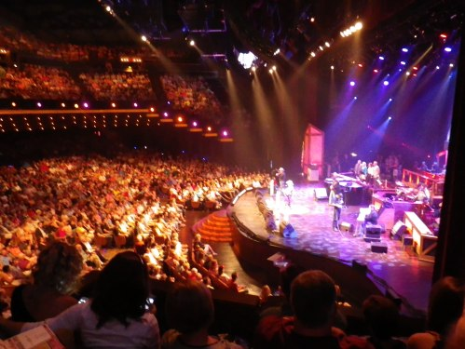
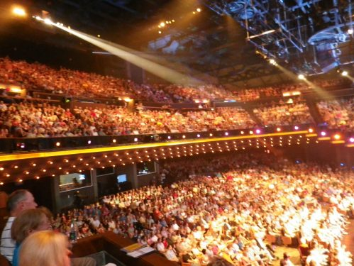
August 9, 2012 | Edit
Great pride, great respect and a dash of OCD :)
Today I just needed to get up to Louisvillle but had three great visits planned for along the way.
I crossed into Kentucky and the beautiful scenary I had been riding through already became even more exquisite. I decided that Kentucky was the land of OCD. It seemed that everyone had pretty wooded-built homes set in massive rolling lawns and every one of them was mown to the same length and all lawns merged into one! Or is Kentucky the land of the mower? Or the land that is a lawn? Whatever, I loved it! Gorgeous! Ah, maybe Kentucky should be known for the Corvette? Oops, yes, there’s where a lot of the pride will be… The Corvette is celebrated in Kentucky, and I joined in. Here’s some photos:
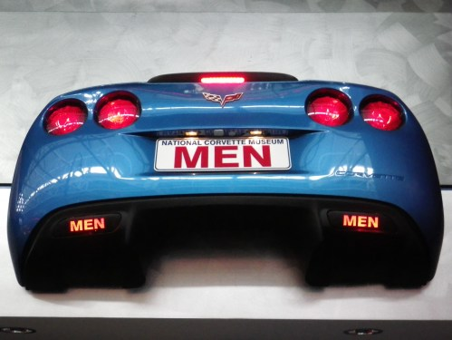
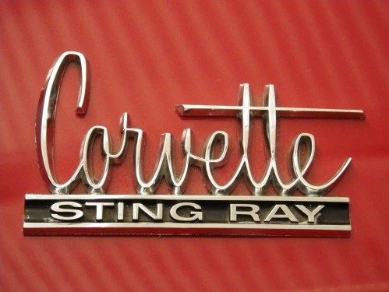
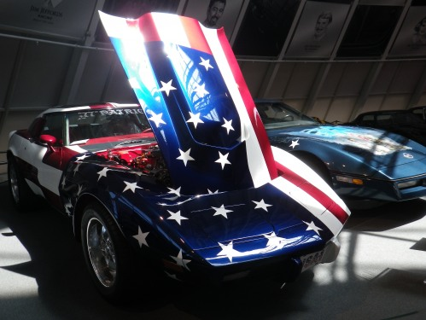
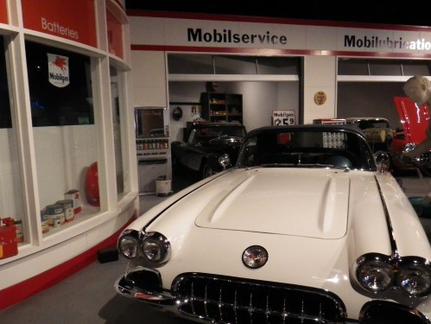
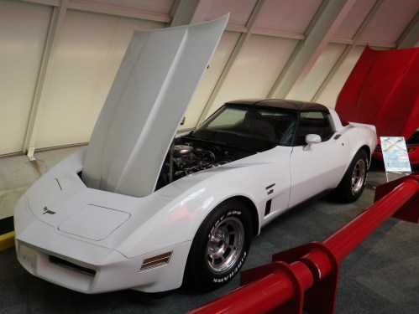
NO! Kentucky should be proud for is population of Amish people. I was delighted to see the Amish people and lifestyle in Kentucky today. I learned a little more about them and was very impressed by their ability to maintain what they believe in. There are so many distractions and temptations and alternative pressures and messaging in the USA. People that do not succumb to such really impress me. I was really glad to be about such positive thought for an alternative way to where we’re all going in the western world.
Gosh, no, Kentucky IS proud that Abraham Lincoln was born there and I was delighted to find I could go to the very spot he was born. That now is in a most beautiful setting. Another log cabin like the one he was born in, now some 100 years old, is housed in a substantial memorial structure right on the spot his own cabin-birth-place was. It’s a treasure and a very special site to visit. Its also a great place to learn more about the Lincolns. I really enjoyed my visit there and felt the respect and love that is held for this man. I feel very honored to be able to visit somewhere so special:
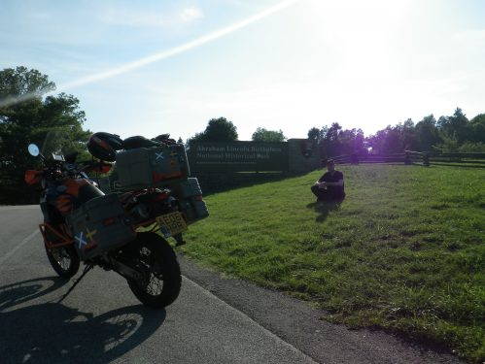
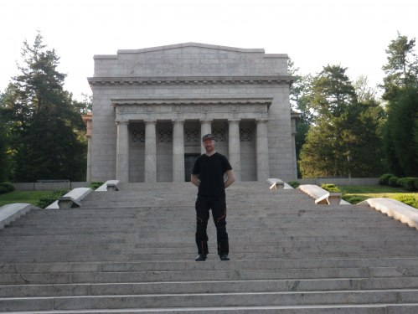
August 10, 2012 | Edit
Admin super-cool
I now feel like I am whizzing back to New York with so much speed and momentum that I’ll end up in the Atlantic! I’ve been careful to set today aside to work on all the admin that will be involved in flying the motorbike home as well as myself. I have 4 personal visits to make before I leave, too, so I needed to spend some time today trying to start the process of coordinating them!
All that talk across the USA is about how July was the hottest July ever recorded and that August looks set to be the same. Lately there has been some sign of a little cool spell right along where I will be riding to finish BikingtheUSA. The trouble is that this avenue of cool will be an avenue of severe thunder, lightning and rain! Today I felt the start of this cool. All day, its been gorgeously cool. The riding has been extremely easy. Lovely! I just needed to get to Columbus from Louisville today. That’s a relatively short day, about 225miles. With the temperature so much lower and with me having more space on the bike I was able to do the whole ride virtually non-stop, really easily without even a hint of bum-ache and no rush to get out of the heat. Lovely.
Riding through Ohio today I was back into a land with more traffic on the Interstates, lots of green, trees and busy people! It was starting to build my anticipation of the ‘Big Finish’ in New York. The riding, today, was a lot like riding back home.
So I’ve got to Columbus and done a lot of the logistics I needed to sort. There’s more to come but I’ve got the urgent things done safely now. I went out for dinner to a Mexican restaurant – got stuffed (you can see why):
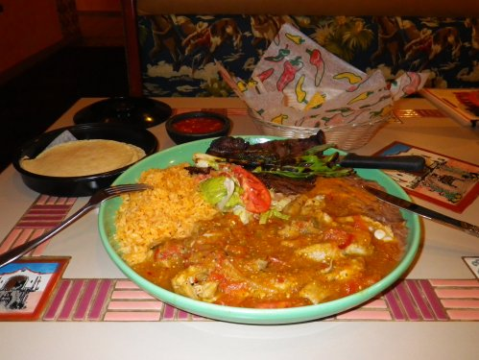
- and then when I went to leave I found myself stranded because of a severe storm. Thunder and lightning and intense heavy rain, all under a threatening black sky, creating instant rivers in the roads and sidewalks and overwhelming all drains. I might have to deal with more of that tomorrow. That’s a problem because I have arranged to meet a friend in Pittsburgh which is a long way away! I better set off super-early so I might get there before the skies go daft again. That means I better get to bed now! Goodnight!
August 11, 2012 | Edit
Cool Ohio
I could hardly sleep last night. I was too ‘wired’ excited about the prospect of the thunder and lightning storms forecast for today! Indeed I found the world soaking wet in the morning and its sky saturated with low dark clouds! The atmosphere was distinctly Scottish! I actually dressed in some clothes today!
I just had to get to Pittsburgh today. I had planned to meet a friend there and I needed to be somewhere where I could get more of the final-days planning sorted. That called for a mere 180 miles. The ride was fabulous. Ah! It was over too quick! I motorcycled in lovely cool weather, with only occasional spots of rain, through interesting lands of rolling lush green hills, and mixed healthy trees where people had populated the area with gorgeous wooden homes. Some had lost nearly all their white paint and had turned into the most interesting of relics. Some were super-smart and nearly all had the obligatory veranda and two-seater swing-chair. Brilliant!
In Pittsburgh I got on with sorting out getting the motorbike flown back to GB. Such things need a lot of ‘office’ time so I set up where I could operate efficiently. The task is straightforward if somewhat tedious and time consuming:
August 13, 2012 | Edit
Pittsburgh People
I had the most extraordinary experience of enjoying being out and about in Pittsburgh in an ambient air temperature of a mere 20C today! Pittsburgh has a big busy area with masses of shops, malls, retail outlets and restaurants and I had lots of time there today. Lucy would love it SO much! Pittsburgh itself is of course in an area of the high population density of the eastern USA. Being here is a lot like being in southern England. Even the sky had plenty low dark clouds in it and there was a cool breeze blowing. It was actually a very strange feeling to be going about in my usual jeans and tops in such an atmosphere! It felt like this should not have been here. Surely all the USA is a sparsely populated sun-trap? Like everywhere else I’ve been!?
Later in the day I had the pleasure of catching up with a friend, now a Pittsburger herself, who I have not seen for a long time. Lenka took me out to an area of massive detached restaurants, each like an IKEA site in themselves, all themed and all jam-packed. It was decidedly freaky to be driven somwhere in a posh new air-conditioned car! After all those miles controlling that motorbike! As expected the dinner we had came in epic proportions. We had plenty of laughs during the evening and we could only cope with the proportion sizes by laughing at them! Here is Lenka with her starter:

August 13, 2012 | Edit
Olympic ending, Olympic mapping and a big finish to follow
Again in Pittsburgh today, a mere 20C, and again it was a day I did not ride! I will go again tomorrow, down to Virginia so I can bet the heat-wave will return as I sleep tonight!
While the Olympics have been taking place this year back in GB I have managed to keep an eye on all the achievements and stories via America press and TV. I, like any Brit, have been totally thrilled by this giant feature in good-ol’ GB and have been overwhelmed with delight at the success the British competitors have had. The triple whammy for me has been seeing Americans also delighting in and praising the success of the games as a whole and of the GB participants. It pleases me right through to the core to see Americans so happy that the games are being so successful for GB as well as themselves. It is a tribute to this nation that that is so genuinely, positively and overtly expressed. Gosh I continually have such a lovely time here in the USA. Every day throws great welcome, encouragement and special treats at me. Fabulous, definitely in Olympic proportions.
I have just watched the closing ceremony of the Olympics (several hours after the actual London time) and have loved seeing that it was a relatively simple affair, hopefully taking the Olympic movement a step back from extraordinary overindulgence and the drive to be ‘bigger and better’ every time. Well done GB. Oh and how about Queen (the band) and John Lennon! Perfect! Spot on. I will remember this ceremony vividly forever. It is amazing what one can do in this world. What feels like Olympic proportions to me is the scale of the journey that BikingtheUSA has been, all upon a big yet tiny motorbike. Today Lenka, who is thoroughly part of big-scale American thinking, could not stop laughing at and teasing the small scale of the motorbike compared to what she knows has been the journey. I failed miserably to convince her that the bike in itself is a big machine because she insisted in posing by it, knowing her relatively large stature would help emphasis its littleness!
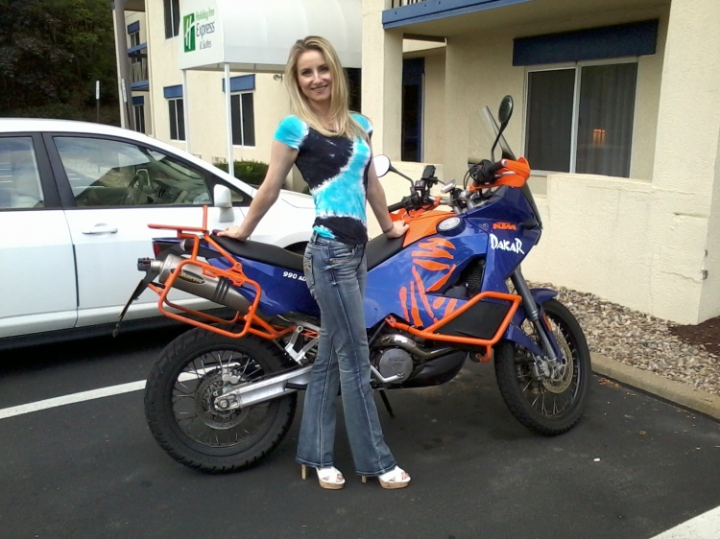
I cannot quite believe in the scale of the ride BikingtheUSA has been. Today, as I planned the final few days into New York, I made a print of the route so far:
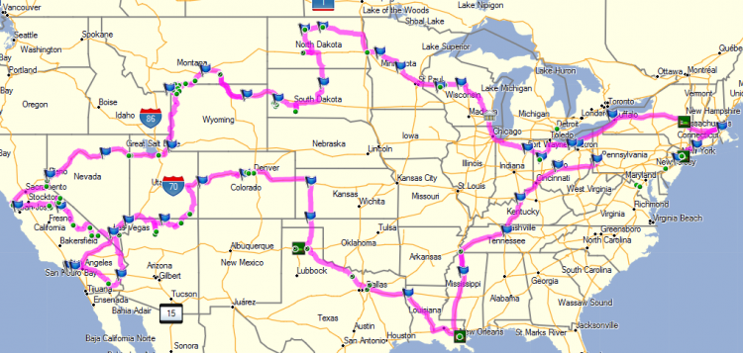
That’s 10816 miles so far.
You can see there is a little part to link up: Pittsburgh to New York. That will be via The Pentagon, Washington DC and Philadelphia. I am super excited about what has yet to come, along with the idea of riding into New York, to right where BikingtheUSA started. I am missing so many moments of my experience so far, terribly. I remember them vividly. The arrival at the Golden Gate Bridge with Lucy, our ride through Death Valley and our climb up Mt Evans… Then there was the visit to the world’s largest cow and the visit to the South Fork Ranch! Nuts!
August 16, 2012 | Edit
Facebook freaky fantastic finds friend
On June 17 2010 I was sent a message through Facebook, from someone I did not know at all:
‘Hey there. As a kid in New Jersey, I had a friend named John Goldie. I stumbled on this picture at my Mom’s house. Any chance that’s you?’
Here’s the picture:
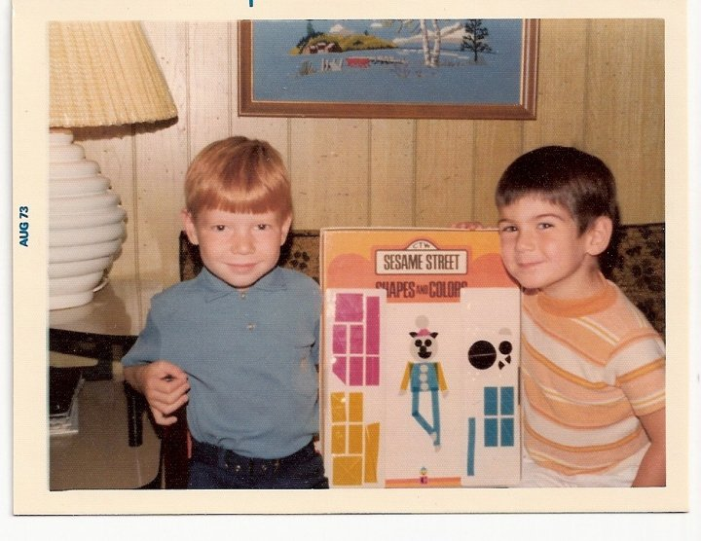
With the photo I came face-to-face with a rare sight of me when I was young, during a period of my life that passed by without it seeming to be able to be real. That’s because it was a period of only 3 years when I lived in the USA when I was very young and that I have not had any connection to in any way, ever since. That was well before the era of digital photography too, so I have next-to-nothing to look at to help me ‘picture’ my existence there. Suddenly I had a glimpse of myself and I had just heard from someone who I was a friend to, all that time ago. Amazing! I had to meet my ‘ol’ pal’ again, and BikingtheUSA was the facility to do that. Today was the day!
My old friend now lives in Virginia right near Washington DC and the plan for today was to ride right to his front door, all the way from Pittsburgh. Just as soon as I set off I remembered how much I love riding that motorbike! I had the benefit of cool weather to be really comfortable as I sped off along the busy and dense road network that fills this area of the USA, right through to New York. The ride set me in a very familiar situation. Like at home the air was cool, the sky was full of thousands of fluffy white clouds, the traffic was quite dense but fast flowing and was made up of European sized cars rather than the usual predominance of big pick-ups. I stopped at a ‘Service Plaza’ for a break and found it was just like a ‘Service Station’ back home. Across the USA I have found that ‘service’ provision on the road networks tend to be individually located fuel stations and franchise restaurants and many independent ‘Diners’. It was a lovely day riding to my old friend but I was feeling too much like BikingtheUSA was nearly finished, or at least that little more would excite and please me as much as every other day had so far. I was mighty wrong!
Meeting my friend and his family, in his own family home, having steak on the barbecue there and staying the night was absolutely fabulous. I had such a great time. It was just so lovely being with him and his family but even better I was even able to learn even more about what I had been experiencing and been curious about out here. Brilliant. Life’s surprises can be so utterly fantastic!
August 16, 2012 | Edit
Big Office, Bigus Cowus
Today I left my new friend who was an old friend, with the promise that we would meet again. I only had to ride a short distance, into Washington DC but it was still long enough to muse over the feature of friendship. He had told me that when his mum told him I was moving away, he couldn’t really get it into his head what that meant. When he finally worked it out he was very upset! It seems maybe we were really special chums all those years ago. What I was musing over is how brilliantly we had got on together all these years later and how much I wish my friend, now new, once old, was once again a neighbour of mine! I will miss him now!
I went into DC to visit what is the largest office in the world, The Pentagon, and to spend some time soaking up DC life. I expected to find access near to The Pentagon very restricted but it wasn’t at all. I really wanted to go to the memorial to those killed at that site in the attack on 11 September 2001, and to try to get a measure of the scale of the event.
The memorial is right at the wall that was hit by the airplane. It represents everyone killed, individually, in ‘waves’ that present themselves to the wall in the direction of the impact. I thought it was a really excellent way to mark the passing of those who were taken:
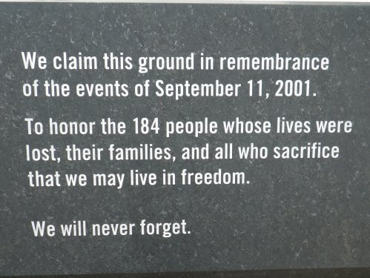
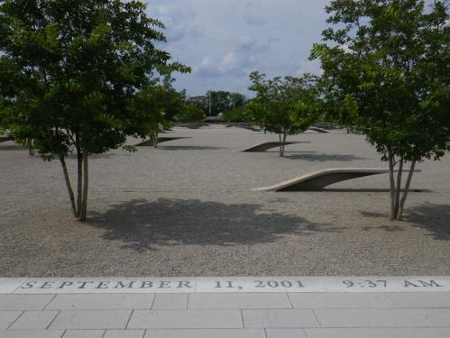
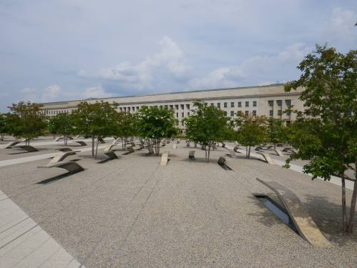
The Pentagon is surrounded by everyday life – roads, shops, businesses etc. I could not come anywhere close to being able to imagine how what happened happened and what it was like, right there, right at that place. Other people would have been walking in the area at that moment, just as I was today, and couldn’t possibly have even begun to believe what they would see – the event being so so incredulous and exceptional, and utterly devastating in the most extraordinary scale.
I am glad I visited the Pentagon and was able to see business as usual – people coming and going and ordinary life going on around, in the streets and in the malls. I could see city life as usual, ordinary city life, and it was a nice place to be.
Way back in the earlier days of BikingtheUSA Lucy and I met two Swedes who live and work in a special government capacity right here in DC. We met them while we were viewing the world’s largest cow! ‘Bigus Cowus’, we now call it! We have all travelled several thousand miles throughout the USA since and now it was time to meet and exchange all our stories of our travels! So, today was to finish with another dinner date in a very special situation. I made it there for the evening and had a fabulous time telling of how Lucy and I had managed since Bigus Cowus and I heard all about the other experiences of the similar journey to ours. We had great fun satisfying nagging curiosities we all had about each other’s respective experiences and methods! Talking out-loud about our journeys reminds oneself, dramatically, of just what one has seen and experienced. We can sense there is still a lot of ‘sinking-in’ to do! The best thing is that Lucy and I have new-found friends we will definitely meet again, and no-doubt meet in similar circumstances! Brilliant!
August 16, 2012 | Edit
Superpower provides super parking
I like to dive in at the deep end sometimes, provided I’m not diving into water, and rely on my wits to deal with anything that tries to thwart me. Today I dived into the Superpower home-city, Washington DC, without much planning, and hoped for the best. Afterall, I had hardly had any time to plan anyway!
First problem, parking… I simply aimed for The White House and expected to get as close as possible to it and then ride away from it, trying to pick out the closest parking place I could. As it happened as I arrived beside The White House I spotted what appeared to be parking specifically for motorbikes. I investigated, thinking it was too good to be true (surely it was for Police motorbike parking, or even FBI motorbike parking!?), and found I could indeed park safely there, for a mere 50cents/hour! Amazing! Right beside The White House! So, there my day in DC started. Off to a good start, too!
The rest of the day continued in the same manner. I felt completely welcome everywhere and found it very easy to get about and enjoy studying the sites that were literally everywhere. Really, I needed at least a week there, but perhaps even after a week one would know there was so much more to absorb there. Here are some photos from the day:
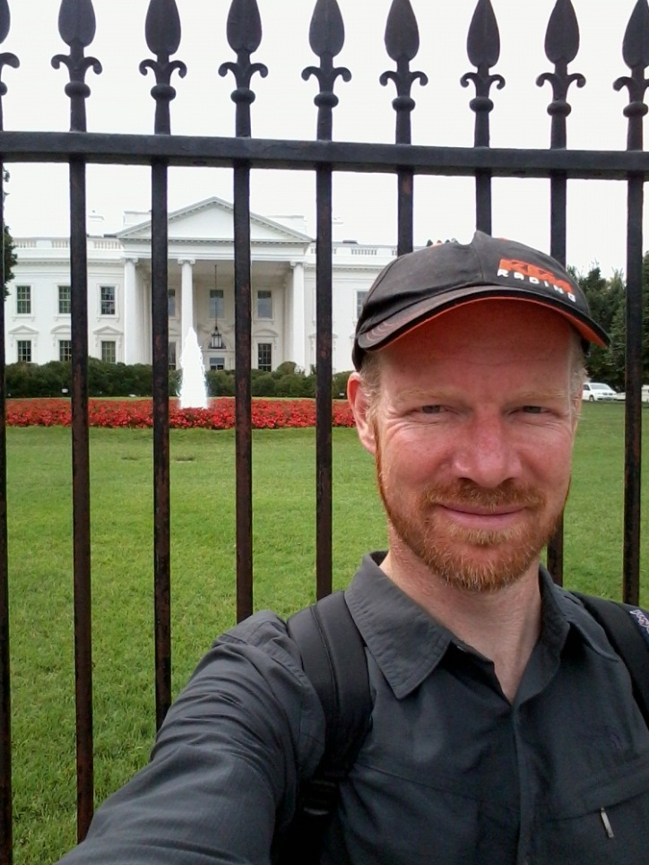
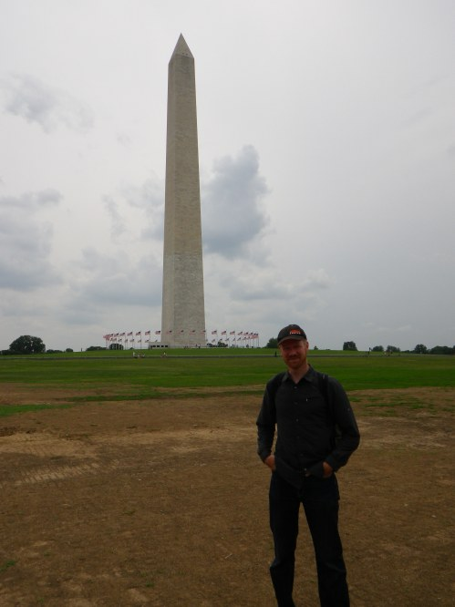
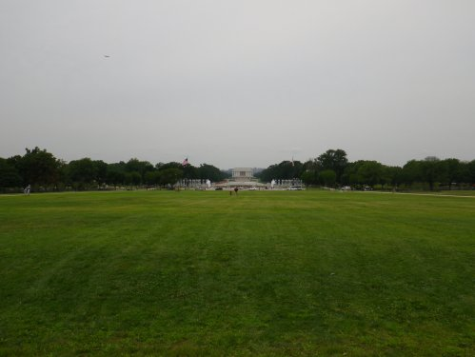
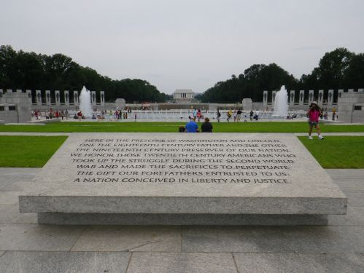
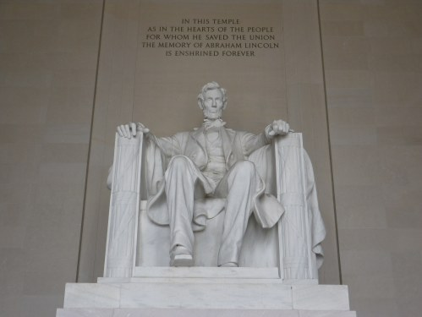
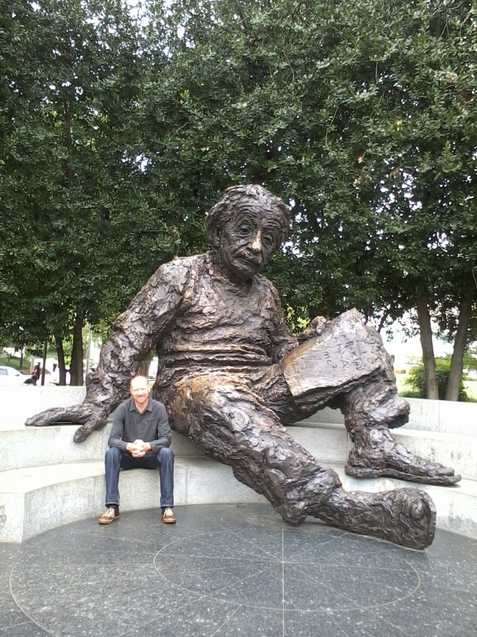
August 18, 2012 | Edit
Knockout visits noon and night
I’ve been wondering how I will feel when I arrive back in New York. Whatever that will be I knew that I would certainly have an emotional time today. I had arranged to visit a lady who was my mum’s best friend when my family lived in NJ, and on the way I wanted to get that Rocky Balboa feeling on the steps of the Philadelphia museum of art.
I went through Baltimore to get to Philadelphia and had a really fab time riding there and coming through the city. The weather was gorgeous, sunny but realtively cool, and the route was busy and gave my that sense of the complexity and density for the end-point, New York, looming fast. I loved comining into Baltimore and seeing Giant ships docked and big industry dominating the area. I know that’s not what one tends to look for on a visit but I liked it for the character and scale it gave Baltimore. It was very impressive. The scale was unexpected, to me.
Coming into Philadelphia, to the museum of art, I noticed there was a modern city look to my surroundings. It was very tidy, pretty, yet also grand and impressive. I really took to Philadelphia even just by motorcycling into it!
The museum of art really took my breath away. It is a fabulous museum, not just for its content, but also for the building that it is, and for its setting. Phew I could have spent days there, and I already knew I would love to spend lots more time seeing the city as a whole. It really said ‘welcome, take a look around and see if you can resist staying!’. I managed to spend quite a lot of time outside the museum, soaking up the atmosphere and enjoying the relaxation, but also doing the Rocky Balboa bit and watching endless processions of young and old, local and visiting people running up the steps. It was very fun, and really lovely to see so many people having a fun time of it:
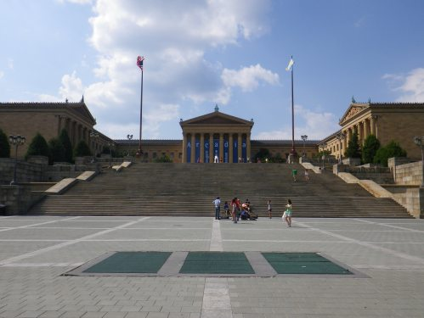
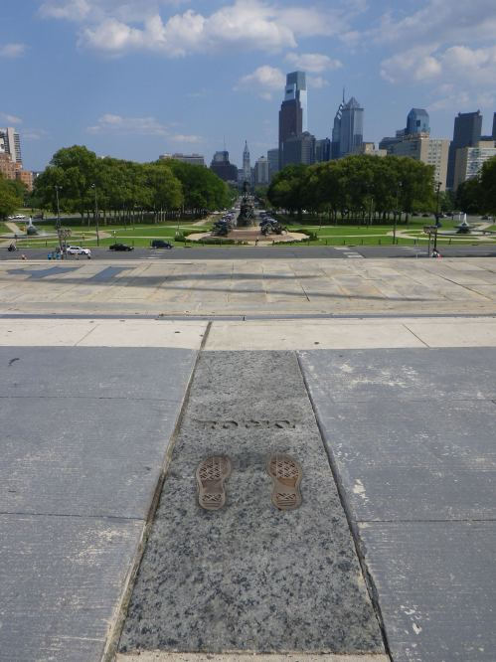
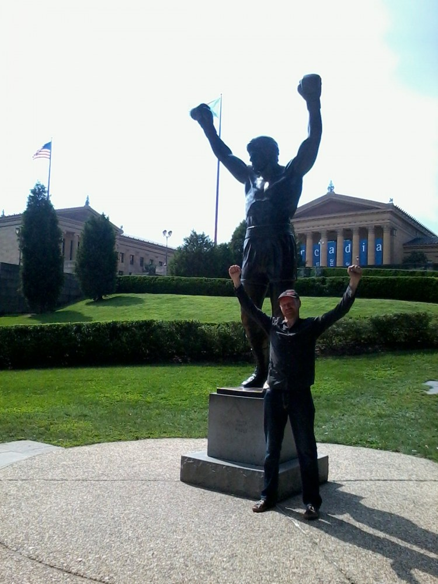
So I saw through midday in Philadelphia but was due to spend the night at the home of my mum’s friend. I got going again and spent hours and hours battling through thick thick traffic to Edison in New Jersey. I was certainly closing in on New York! It seemed that everyone that lived in the USA lived between Philadelphia and New York!
Finally in Edison I found my mum’s friend and had the enormous pleasure of meeting her, her husband and two of her daughters who used to babysit for me and my sisters when we were all under 6. Within minutes I was given a recipe hand-written by my mum that had been treasured all this time, I heard the daughters saying ‘he looks so like his mum’ and then spent the long evening hearing so much, so vividly about the days of my family’s lives over in New Jersey, when I was too young to remember any of it. It was absolutely fabulous. The most special thing was the insight into my mum, because she is not around anymore to tell me anything I have not yet known about her. It was definitely one of the best experiences of my life. I must meet the family again and again and I hope so much I can be their host in the UK sometime.
August 18, 2012 | Edit
The End
To finish BikingtheUSA I motorcycled into New York, past Ground Zero and along Broadway to 1 New York Plaza. I finished the 11445th mile on day 47 since leaving New York for BikingtheUSA by coming to a final stop squeezed into a New York elevator. I left the bike in a basement service access and sailed out to the Statue of Liberty to celebrate:
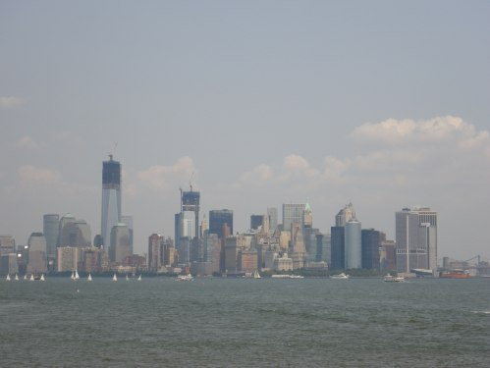
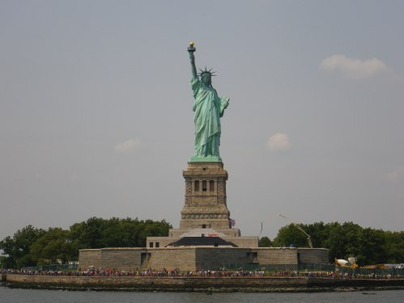
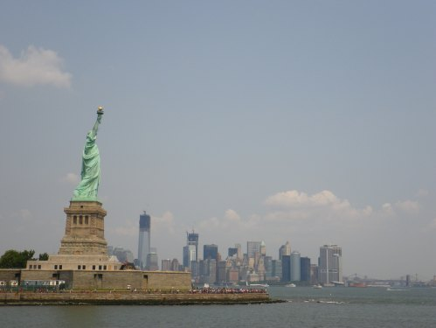
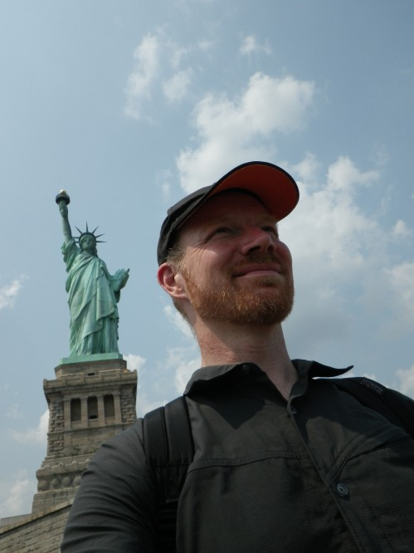
It was very special to be at the Statue of Liberty, a symbol that means so much to so many. For me it was of course the End Point of BikingtheUSA but also the most demonstrative symbol of the country and people BikingtheUSA explored. I people-watched the other visitors there and wished I could hear all their stories but there will be more tomorrow, and the next day, and the next day and the next day. The story of BikingtheUSA is now another one. Now I had to get back home, catch up with Lucy, and write it all down.

